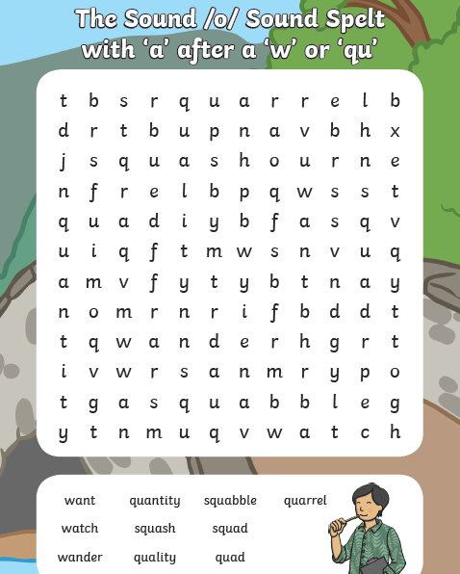
Spellings – solve the word search

Times tables
0 x 5 = | 0 x 3 = | 0 x 4 =
1 x 5 = | 1 x 3 = | 1 x 4 =
2 x 5 = | 2 x 3 = | 2 x 4 =
3 x 5 = | 3 x 3 = | 3 x 4 =
4 x 5 = | 4 x 3 = | 4 x 4 =
5 x 5 = | 5 x 3 = | 5 x 4 =
6 x 5 = | 6 x 3 = | 6 x 4 =
7 x 5 = | 7 x 3 = | 7 x 4 =
8 x 5 = | 8 x 3 = | 8 x 4 =
9 x 5 = | 9 x 3 = | 9 x 4 =
10 x 5 = | 10 x 3 = | 10 x 4 =
11 x 5 = | 11 x 3 = | 11 x 4 =
12 x 5 = | 12 x 3 = | 12 x 4 =

Comprehension – Inference
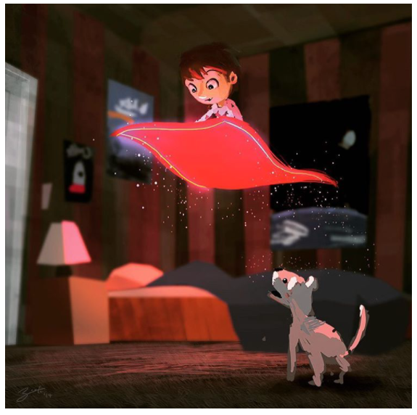

What is happening here?
________________________________________________________________________________________________________________________

Why/how is the carpet floating?
________________________________________________________________________________________________________________________

How is the boy feeling? Was he expecting this to happen?
________________________________________________________________________________________________________________________

How is the dog feeling? How do you know?
________________________________________________________________________________________________________________________

Does this bedroom belong to the boy? What makes you think that?
________________________________________________________________________________________________________________________

