 | Space Theme – Week 7 04.05.2020
 | Monday | Tuesday | Wednesday | Thursday | Friday
9-11 | WORD OF THE DAY; Introduce a new word, find out the meaning, use it in conversation, can you draw something to help you remember the word and / or how to spell it? Find out the origin, are there words which mean the same? Use it in written sentences.  Solar System – The solar system is in space and consists of the sun and everything that orbits or travels around the sun.  Reading  Complete reading comprehension.  Writing  Choose from the list. | WORD OF THE DAY; Introduce a new word, find out the meaning, can you draw something to help me remember the word and / or how to spell it? Can you use it in conversation, find out the origin, are there words which mean the same? Use it in written sentences.  Asteroid – a small rocky body orbiting the sun.  Reading  Complete 30 minutes of reading.  Writing  Choose from the list. | WORD OF THE DAY  Introduce a new word, find out the meaning, can you draw something to help me remember the word and / or how to spell it? Can you use it in conversation, find out the origin, are there words which mean the same? Use it in written sentences.  Meteor – A space rock that enters the earth’s atmosphere that appears as a streak of light.  Reading  Choose a reading activity from the list based on what you read yesterday.  Writing  Choose from the list. | WORD OF THE DAY;  Introduce a new word, find out the meaning, can you draw something to help me remember the word and / or how to spell it? Can you use it in conversation, find out the origin, are there words which mean the same? Use it in written sentences.  Orbit – the path that an object takes in space when it goes around a star, planet or moon.  Reading  Complete 30 minutes of reading.  Writing  Choose from the list. | WORD OF THE DAY;  Introduce a new word, find out the meaning, can you draw something to help me remember the word and / or how to spell it? Can you use it in conversation, find out the origin, are there words which mean the same? Use it in written sentences.  Satellite – an artificial body placed in the earth/ moon or other planet in order to collect information.  Reading  Choose a reading activity from the list based on what you read yesterday.  Writing  Choose from the list.
 | Movement  The Body Coach – YouTube – find the current day | Movement  https://www.youtube.com/user/CosmicKidsYoga  Cosmic Yoga  (YouTube) | Movement  The Body Coach – YouTube - find the current day | Movement  Go outside for a walk. | Movement  The Body Coach – YouTube on the day
11-11.15 | Break | Break | Break | Break | Break
11.15-12.15 | Maths  White Rose Maths (Home Learning Tab) Watch video and download related questions.  https://whiterosemaths.com/homelearning/ | Maths  Number gym  http://www.numbergym.co.uk/  Appropriate calculation activity linked to year group e.g. multiplication and division 2/3/4/5/6. | Maths  White Rose Maths (Home Learning Tab) Watch video and download related questions.  https://whiterosemaths.com/homelearning/ | Maths  Number gym  http://www.numbergym.co.uk/  Appropriate calculation activity linked to year group e.g. multiplication and division 2/3/4/5/6. | Maths  White Rose Maths (Home Learning Tab) Watch video and download related questions.  https://whiterosemaths.com/homelearning/
12.15-1.15 | Lunch | Lunch | Lunch | Lunch | Lunch
1.15-2.50 | Theme Work  Choose from the list. | Theme Work  Choose from the list. | Theme Work  Choose from the list. | Theme Work  Choose from the list. | Theme Work  Choose from the list.
2.50-3.15 | Reflecting Roxy 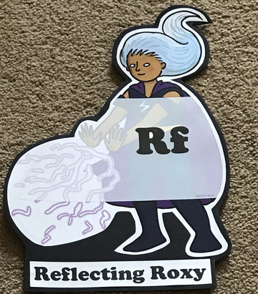  What have you learnt today and how could you have improved any of your work?  STORY TIME/  Well being calendar | Making Links Molly 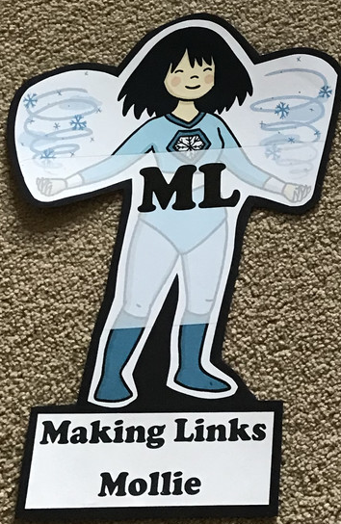  Can you use any learning that you have done today, in other parts of your life?  STORY TIME/  Well being calendar | Resilience Rex 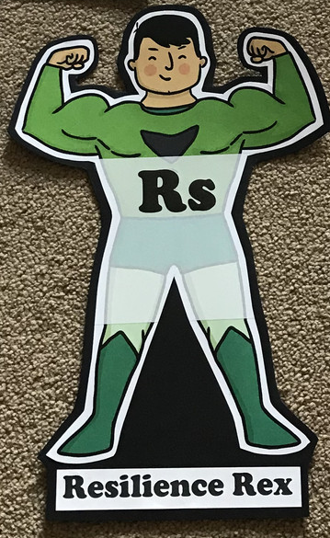  Have you found anything challenging today? How did you overcome the challenges?  STORY TIME/  Well being calendar | Collaborating Carlos 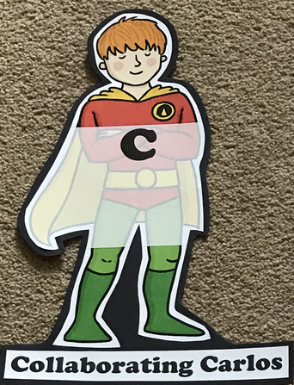  Did you work alone today or with someone else? How did that go?  STORY TIME/  Well being calendar | Motivating Melinda 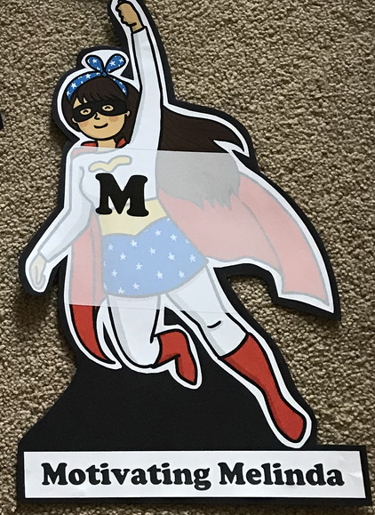  Have you encouraged someone else today? How did you motivate yourself today?  STORY TIME/  Well being calendar

Writing
- Planet fact files
- Information texts on the Earth, Sun and Moon.
- A journey story about travelling to the moon as an astronaut.
- Create a postcard to someone about your trip to Space
- Design a new planet.
- Research Tim Peak or Neil Armstrong. Create a fact file or biography about them.
- Design a new alien and then describe it.
- Create a story or a comic strip about an alien in space.
- Research a planet and create a fact file on one of your choosing.
- Imagine a UFO has landed at school or at your house! Create a newspaper report about the event.
- Write a diary entry as if you were an astronaut.
- Pobble 365 - http://www.pobble365.com/ (Choose one of the images and write a descriptive paragraph about it.)
Theme Work
- Crater experiment – drop different sized items into a bowl of flour and measure the crater. Which items leave the biggest or deepest crater and why?
- Learn about the constellations and the pattern of the moon. Create constellations using marshmallows and spaghetti. https://playteachrepeat.com/marshmallow-constellations/
- Learn the order of the planets. Can you create a mnemonic to help you remember the order? One we use at school is: My Very Excellent Mother Just Served Up Noodles (Mercury, Venus, Earth, Mars, Jupiter, Saturn, Uranus, Neptune)
- Make a planet by using papier mache.
- Make a junk rocket or alien using recyclable materials.
- Space crafts (Cardboard rocket, Alien footprints, Paper plate flying saucer, Spaceship portal or Space themed printing
- Learn about the moon landing in 1969.
- Design a spacesuit for your teddy or doll.
- Design a space meal – thinking about the challenges of eating without gravity. https://www.giftofcuriosity.com/how-do-astronauts-eat-in-space/

