 | Monday | Tuesday | Wednesday | Thursday | Friday
9-9.30 | Movement  The Body Coach – Youtube on the day | Movement  https://www.youtube.com/user/CosmicKidsYoga | Movement  BBC Move it Dance Programme  https://www.bbc.co.uk/programmes/b03g64pk/episodes/player | Movement  Go outside for a walk. | Movement  The Body Coach – Youtube on the day
9.30-10 | Phonics | Phonics | Phonics | Phonics | Phonics
10-10.30 | Reading  Read through a twinkl story  Activity sheets included  https://www.twinkl.co.uk/resource/t-l-54210-starry-eyed-stan-ebook-english | Reading  Younger readers can read or share a text with someone. Can they write or draw what they read about? Can they answer questions about the text?  https://www.oxfordowl.co.uk/for-home/find-a-book/library-page/  username- SJGreading  password- SJGreading | Reading  Younger readers can read or share a text with someone. Can they write or draw what they read about? Can they answer questions about the text?  https://www.oxfordowl.co.uk/for-home/find-a-book/library-page/  username- SJGreading | Reading  Younger readers can read or share a text with someone. Can they write or draw what they read about? Can they answer questions about the text?  https://www.oxfordowl.co.uk/for-home/find-a-book/library-page/  username- SJGreading  password- SJGreading | Reading  Read through a twinkl story  Can they write or draw what they read about? Can they answer questions about the text?  https://www.twinkl.co.uk/resource/tf-l-124-jakes-first-day-ebook
 | Word of the day  Whale | Word of the day  Octopus | Word of the day  Shark | Word of the day  Coral | Word of the day  Seaweed
11-11.15 | Break | Break | Break | Break | Break
11.15-12.15 | Maths  Number gym  http://www.numbergym.co.uk/  Appropriate calculation activity linked to year group e.g. add and subtract  See EYFS and Year 1 daily sheet. | Maths  Purple Mash  https://www.purplemash.com/login/  Shape focus – recap names of shapes. Creating your own Colour Monster shape picture.  See EYFS and Year 1 daily sheet. | Maths  Number gym  http://www.numbergym.co.uk/  Appropriate calculation activity linked to year group. EYFS/Yr1 looking at number bonds/numbers to 10  See EYFS and Year 1 daily sheet. | Maths  Purple Mash  https://www.purplemash.com/login/  See EYFS and Year 1 daily sheet. | Maths  Number gym  http://www.numbergym.co.uk/  Calculation focus – addition and subtraction  See EYFS and Year 1 daily sheet.
12.15-1.15 | Lunch | Lunch | Lunch | Lunch | Lunch
1.15-2.50 | Theme Work  See daily plan | Theme Work  See daily plan | Theme Work  See daily plan | Theme Work  See daily plan | Theme Work  See daily plan
2.50-3.15 | Reflecting Roxy 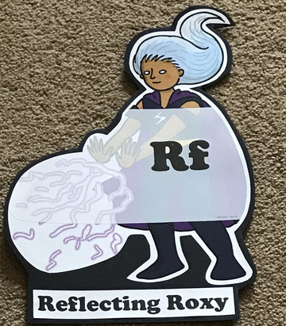  What have you learnt today and how could you have improved any of your work?  STORY TIME | Making Links Molly 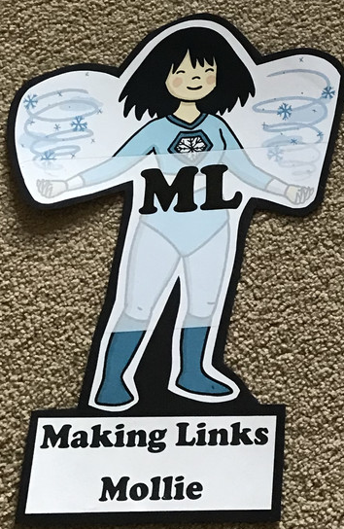  Can you use any learning that you have done today, in other parts of your life?  STORY TIME | Resilience Rex 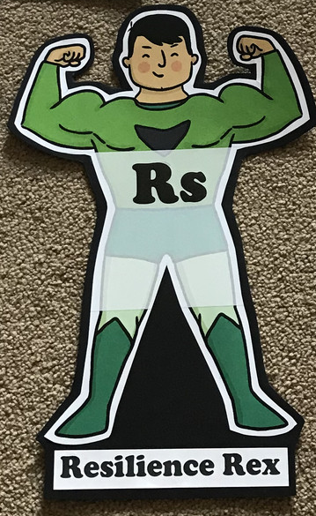  Have you found anything challenging today? How did you overcome the challenges?  STORY TIME | Collaborating Carlos 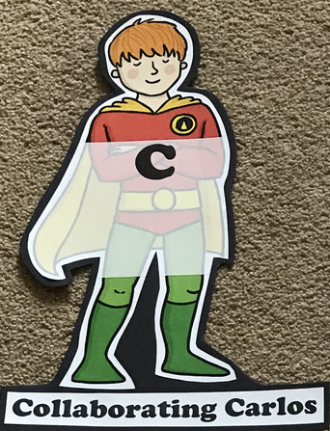  Did you work alone today or with someone else? How did that go?  STORY TIME | Motivating Melinda 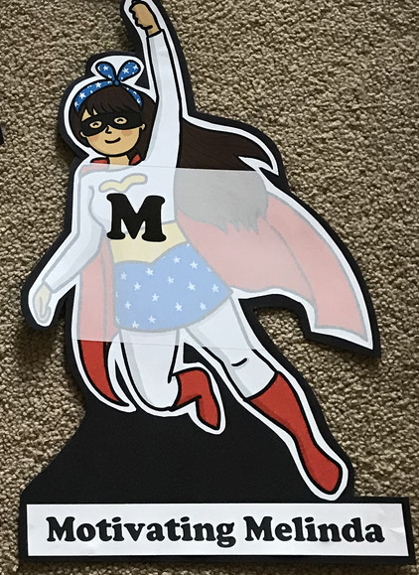  Have you encouraged someone else today? How did you motivate yourself today?  STORY TIME

Monday
Phonics
EYFS
Tricky words
Be
You
All
Are
Words to practise
Turn
Burp
Surf
Challenge
Can you write some sentences with these words in?
Phonics
Sound of day-
Ur
Nurse with a purse

Year 1
Tricky words
Their
Asked
Could
Words to practise
Fault
Jaunt
launch

Challenge
Can you write some sentences with these words in?
Phonics
Sound of day-
Au
Paul the astronaut

Maths: Addition/ Subtraction Week
Use your adding machine from creativity week EYFS
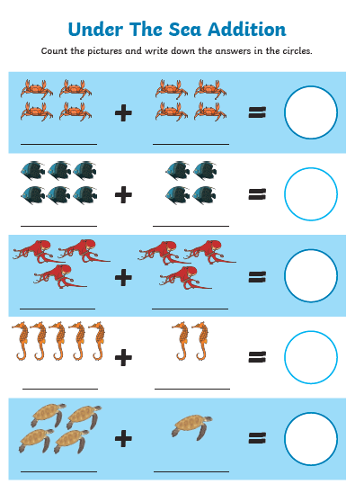

Year 1
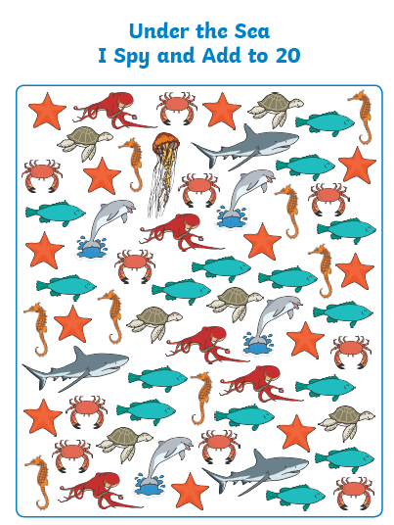

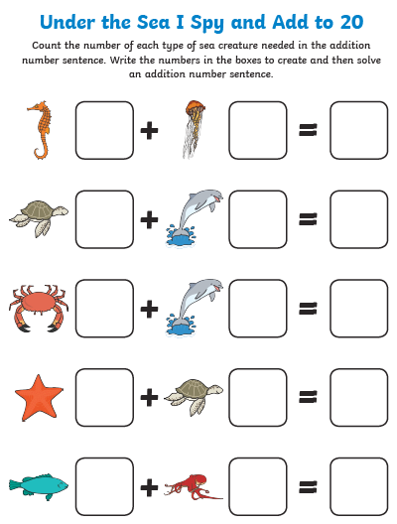

Tuesday
Phonics
EYFS
Words to practise
Food
Mood
Gloom

Tricky words
He
She
We
Me
Phonics
Sound of day-
Oo
Poo at the zoo
Challenge
Can you write some sentences with these words in?

Year 1
Phonics
Sound of day-
Wh
Wagon wheel
Words to practise
Whisk
White
Whisper

Tricky words
Looked
Mrs
People
Challenge
Can you write some sentences with these words in?

EYFS
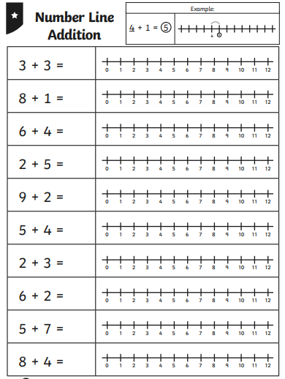

Year 1
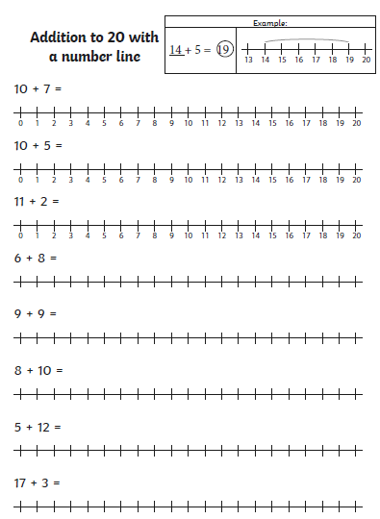

Wednesday
Phonics
EYFS
Words to practise
Soak
Goat
Float
Tricky words
He
Be
Her
She

Phonics
Sound of day-
Oa
Goat on a boat
Challenge
Can you write some sentences with these words in?

Year 1
Phonics
Sound of day-
Aw
Yawn at dawn
Tricky words
Their
Looked
People
Asked
Words to practise
Drawn
Shawl
Prawn

Challenge
Can you write some sentences with these words in?

Maths: EYFS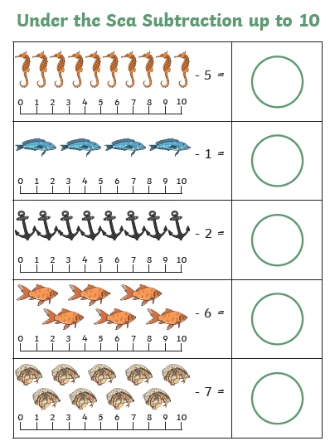
Year 1
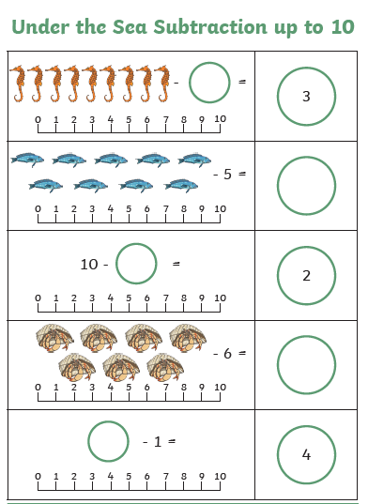

Thursday
Phonics
EYFS
Tricky words
My
Are
All
You
Words to practise
High
Flight
Fright
Challenge

Phonics
igh
fly high

Year 1
Words to practise
Pursue
Rescue
Value

Tricky words
Oh
Mr
Could
Mrs

Challenge
Can you write some sentences with these words in?
Phonics
Sound of day-
Ue
To the rescue

Maths: EYFS
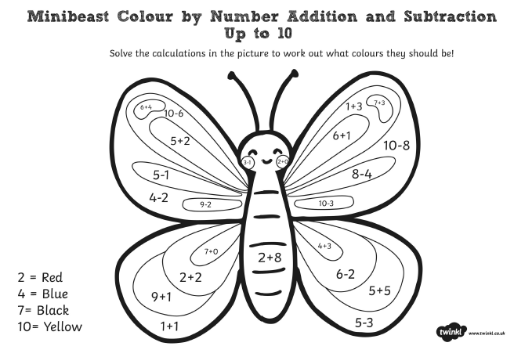

Year 1
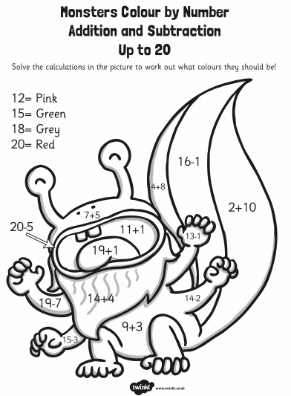

Friday
Phonics: Phonics play
https://new.phonicsplay.co.uk/resources

Maths: Top marks- Addition and Subtraction
https://www.topmarks.co.uk/addition/robot-addition

https://www.topmarks.co.uk/subtraction/subtraction-to-10

