In September I will go back to my school at St. John’s Green.

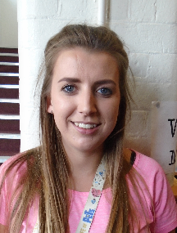I will be in a new classroom; my new class will be called Roses.

I will have a new teacher called Miss Wiggins. This is OK.

In my new class, I will have another adult to help me.

There will be some change in school. This will be OK.

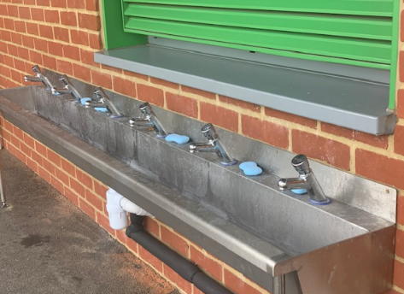

In the morning before coming into school I will wash my hands in the special sinks in the playground

I must wash my hands regularly during the day especially before and after break, after going to the toilet, before and after lunch and when I go home.

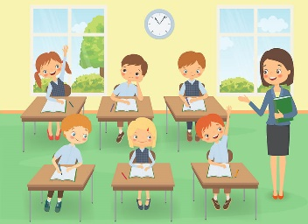My learning will take place in my new

classroom with Miss Wiggins and my friends.

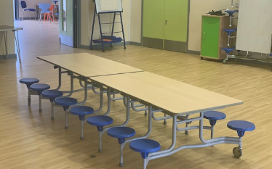

I will eat my lunch with my class in the hall.

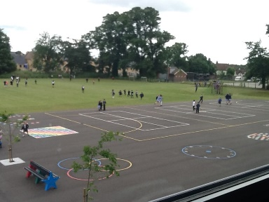After I have eaten my lunch I will go onto the playground with my class.



It will feel different in my new classroom, with my new teacher and the changes in school. This will be Ok.

It will be exciting and fun.