Friday 5th March 2021
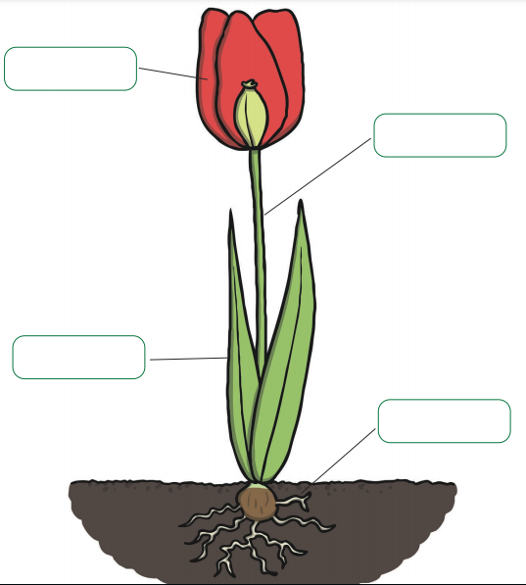
WALT: label a plant

Word bank

leaf | petal | stem | roots

Now design your own flower

