Space
This week our theme is Space. To help, we have split the activities into categories. Choose from the categories what you would like to learn about. Purple mash has lots of activities to do with space. To find it just type space into the search bar.

Don’t forget to take photos of all the different things you are doing. If you have a scrapbook, notebook or folder you can keep all your work and photos together. Remember to email pictures of your learning into school so we can see what fun you are having!
Project – Can you create our solar system?

Maths

- Measure your shadows at different times on the day. What do you notice? Can you calculate the difference between each shadow?
- Talk about how in space there is no gravity so it is weightless. Practise weighing different items in your house or garden.
- Complete the planet puzzle sheet (can be found on the school website)
- Complete the maths mosaic sheet and uncover a picture (on school website)
- Complete a whiterose activity. https://whiterosemaths.com/homelearning/year-2/
- Purple mash or numbergym to practise number facts and times tables
Reading

- Back to Earth comprehension (on school website)
- Planets Comprehension (on school website)
- Blast off comprehension (on school website)
- Read the Back to Earth E-book (school website) and discuss with an adult.
- Complete a book review on Back to Earth (template on school website)
Writing

- Create a postcard to someone about your trip to Space (You can do this on the template on the school website or on purple mash)
- Design a new planet (see school website for sheet)
- Research Tim Peak or Neil Armstrong. Create a fact file or biography about them.
- Design a new alien and then describe it.
- Create a story or a comic strip about an alien in space (see school website for a comic strip template)
- Research a planet and create a fact file on one of your choosing.
- Imagine a UFO has landed at school or at your house! Create a newspaper report about the event.
- Write a diary entry as if you were an astronaut.
Theme

- Crater experiment – drop different sized items into a bowl of flour and measure the crater. Which items leave the biggest or deepest crater and why?
- Learn about the constellations and the pattern of the moon. Create constellations using marshmallows and spaghetti. https://playteachrepeat.com/marshmallow-constellations/
- Learn the order of the planets (see school website for ordering planets sheet). Can you create a mnemonic to help you remember the order? One we use at school is: My Very Excellent Mother Just Served Up Noodles (Mercury, Venus, Earth, Mars, Jupiter, Saturn, Uranus, Neptune)
- Create a space inspired snack (Blast off smoothie, Fruit rockets, Star snacks or Cheesy moons and planets). Recipes can be found on the school website.
- Make a planet by using papier mache.
- Make a junk rocket or alien using recyclable materials.
- Space crafts (Cardboard rocket, Alien footprints, Paper plate flying saucer, Spaceship portal or Space themed printing) Instructions can be found on the school website.
- Learn about the moon landing in 1969.
- Design a spacesuit for your teddy or doll.
- Design a space meal – thinking about the challenges of eating without gravity. https://www.giftofcuriosity.com/how-do-astronauts-eat-in-space/

Below is a timetable to help you with your home learning.

 | Space Theme – Week 7 04.05.2020
 | Monday | Tuesday | Wednesday | Thursday | Friday
9-11 | WORD OF THE DAY; Introduce a new word, find out the meaning, use it in conversation, can you draw something to help you remember the word and / or how to spell it? Find out the origin, are there words which mean the same? Use it in written sentences.  Solar System – The solar system is in space and consists of the sun and everything that orbits or travels around the sun.  Reading  Complete reading comprehension.  Writing  Choose from the list. | WORD OF THE DAY; Introduce a new word, find out the meaning, can you draw something to help me remember the word and / or how to spell it? Can you use it in conversation, find out the origin, are there words which mean the same? Use it in written sentences.  Asteroid – a small rocky body orbiting the sun.  Reading  Complete 30 minutes of reading.  Writing  Choose from the list. | WORD OF THE DAY  Introduce a new word, find out the meaning, can you draw something to help me remember the word and / or how to spell it? Can you use it in conversation, find out the origin, are there words which mean the same? Use it in written sentences.  Meteor – A space rock that enters the earth’s atmosphere that appears as a streak of light.  Reading  Choose a reading activity from the list based on what you read yesterday.  Writing  Choose from the list. | WORD OF THE DAY;  Introduce a new word, find out the meaning, can you draw something to help me remember the word and / or how to spell it? Can you use it in conversation, find out the origin, are there words which mean the same? Use it in written sentences.  Orbit – the path that an object takes in space when it goes around a star, planet or moon.  Reading  Complete 30 minutes of reading.  Writing  Choose from the list. | WORD OF THE DAY;  Introduce a new word, find out the meaning, can you draw something to help me remember the word and / or how to spell it? Can you use it in conversation, find out the origin, are there words which mean the same? Use it in written sentences.  Satellite – an artificial body placed in the earth/ moon or other planet in order to collect information.  Reading  Choose a reading activity from the list based on what you read yesterday.  Writing  Choose from the list.
 | Movement  The Body Coach – YouTube – find the current day | Movement  https://www.youtube.com/user/CosmicKidsYoga  Cosmic Yoga  (YouTube) | Movement  The Body Coach – YouTube - find the current day | Movement  Go outside for a walk. | Movement  The Body Coach – YouTube on the day
11-11.15 | Break | Break | Break | Break | Break
11.15-12.15 | Maths  White Rose Maths (Home Learning Tab) Watch video and download related questions.  https://whiterosemaths.com/homelearning/ | Maths  Number gym  http://www.numbergym.co.uk/  Appropriate calculation activity linked to year group e.g. multiplication and division 2/3/4/5/6. | Maths  White Rose Maths (Home Learning Tab) Watch video and download related questions.  https://whiterosemaths.com/homelearning/ | Maths  Number gym  http://www.numbergym.co.uk/  Appropriate calculation activity linked to year group e.g. multiplication and division 2/3/4/5/6. | Maths  White Rose Maths (Home Learning Tab) Watch video and download related questions.  https://whiterosemaths.com/homelearning/
12.15-1.15 | Lunch | Lunch | Lunch | Lunch | Lunch
1.15-2.50 | Theme Work  Choose from the list. | Theme Work  Choose from the list. | Theme Work  Choose from the list. | Theme Work  Choose from the list. | Theme Work  Choose from the list.
2.50-3.15 | Reflecting Roxy 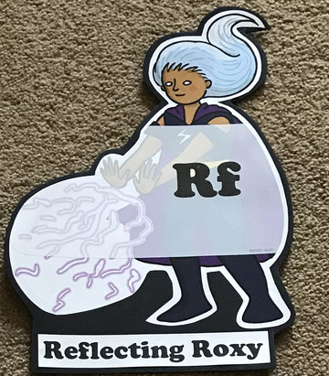  What have you learnt today and how could you have improved any of your work?  STORY TIME/  Well being calendar | Making Links Molly 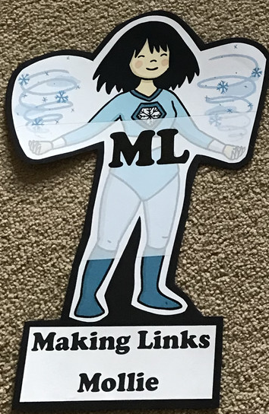  Can you use any learning that you have done today, in other parts of your life?  STORY TIME/  Well being calendar | Resilience Rex 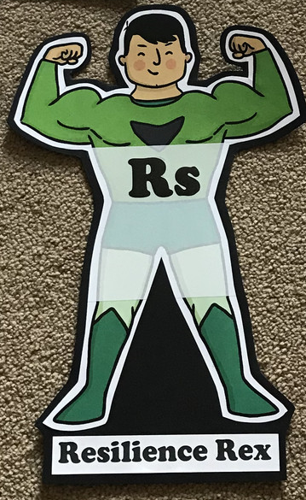  Have you found anything challenging today? How did you overcome the challenges?  STORY TIME/  Well being calendar | Collaborating Carlos 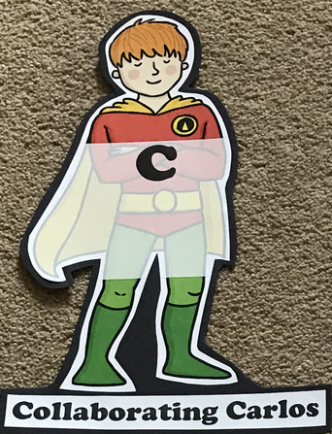  Did you work alone today or with someone else? How did that go?  STORY TIME/  Well being calendar | Motivating Melinda 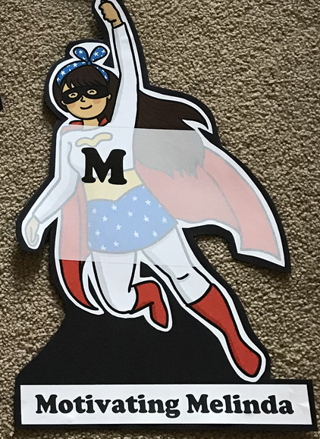  Have you encouraged someone else today? How did you motivate yourself today?  STORY TIME/  Well being calendar

