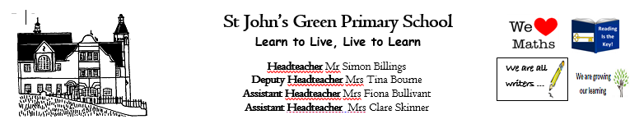

**Week 13 (W.B. 22/06/2020)**

**Theme: What’s in a Book**

**Year 4/ 5/6**

* **Create your own Mr Man/Little Miss**
* **Alternate ending – create a story map of a favourite story then give it an alternate ending**
* **Put yourself into the story – what would you do to change/alter the course of events?**
* **Use music to tell a story and to create a scene/characters within the book**
* **Draw your favourite character from a story and describe them**
* **Draw/collage/build the scene from your favourite book and describe it**
* **Put on a play acting out your favourite book**
* **Make props for the play/for character role play**
* **Jumble up a story! Take a good character from one story (Ben [Gangsta Granny]), the bad character from another story (Mr Twit) and a setting from another (Hogwarts). What happens when they meet? What could they do?**
* **Character profile of your favourite character**
* **Teacher’s choice book focus**
* **Write a letter as one character in a story to another**
* **Create a beast (Beast Quest) for Tom to battle - act it out thinking about how the beast would move, describe the beast, create and describe a habitat for the beast and write a story detailing their meeting**
* **If you had to choose 3 best friends who are characters from a story, who would you choose and why?**
* **Write a list of interview questions for a character. Extend to write answers in the style of the character**
* **Design a library/cosy reading area where you could lose yourself in a book. What would you include and why?**
* **Use Purplemash 2animate to animate a scene from a story**
* **You can invite 2 authors and their characters to dinner – who would you invite and why? Write their invitation**