1. Two matchsticks have
the same length as three bottle tops.

How many bottle tops will have
the same length as 50 matchsticks?

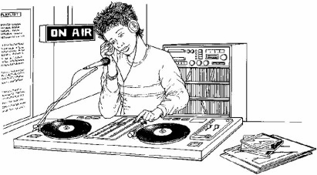
2. Mari is the presenter of a weekly radio show.
She plays five new songs for every two old songs.
Last week she played 15 new songs.
How many songs did she play altogether?

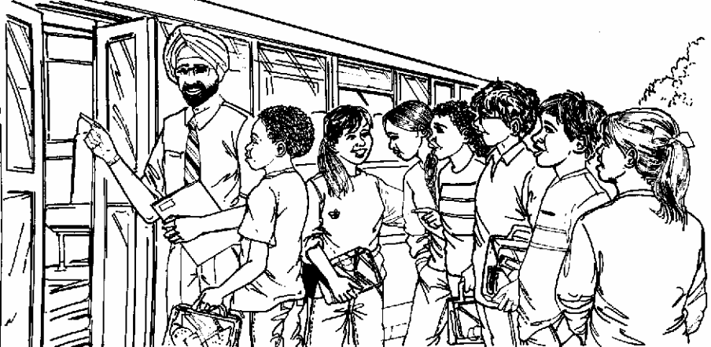
3. 30 children are going on a trip.
It costs £5 including lunch.
Some children take their own packed lunch.
They pay only £3
The 30 children pay a total of £110
How many children are taking their own packed lunch?

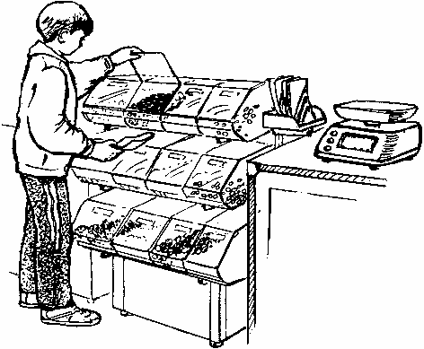
4. Peanuts cost 60p for 100 grams.
What is the cost of 350 grams of peanuts?

