Example of a character profile
My new character  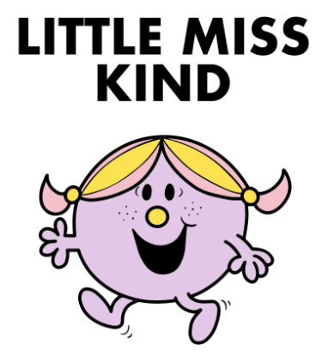 | Personality/likes/good at…  Little Miss Kind is a thoughtful and loving person. She is considerate to animals and the world around her. She is intelligent and her kind nature is underpinned by the belief that it’s important to think of others and not just yourself. She is a great friend who supports those in need, but she can stand up for herself and what she believes is right.

My new character | Personality/likes/good at…

