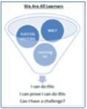
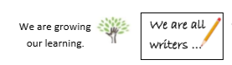
Road to Writing Class Feedback Sheet
Date: 5.3.21 | Genre/Text Type: | Class:

Spellings | Punctuation and Grammar | Presentation | Special Mention
What Went Well |  | Even Better If
Where are we as a class?

