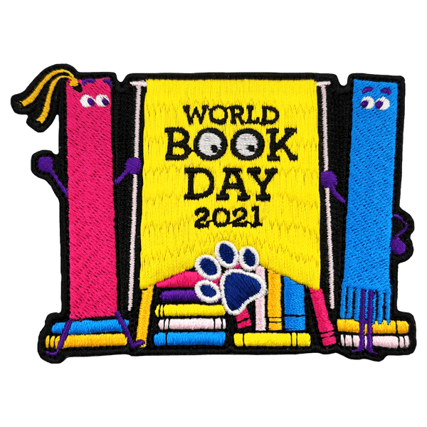
Remote Learning – EYFS Thursday 4th March 2021
Please note a change in time for today.
9.30AM LIVE Registration and Letters and Sounds
Children will need something to write with if possible.
10.15 AM LIVE Mathematical Development
Number bonds to 10
Watch Number Bonds to 10 – Jack Hartman https://www.youtube.com/watch?v=ch7KzI3n2Zk
Watch, model and join in with the 10 sleepy fingers Number Song PP
Model number bonds using multilink.
Follow up activity:
- Children to complete the Number Bond Bingo activity - Can you match the fish to the fishbowl to create the number bond?
- ** CHALLENGE – Bar Modelling to 10 Sheet **
11 AM LIVE Literacy
The Gruffalo (Key Text)
Read the story as a class.
Share the Julia Donaldson Power Point to learn facts about the author.

- Draw the front cover of The Gruffalo.

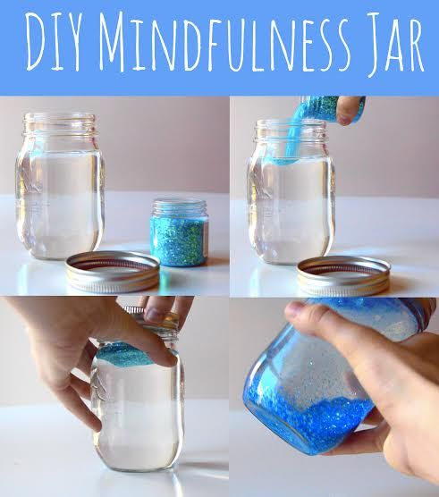
1.15 PM Colour Monsters (Key Text)
Read the story as a class and show examples of emotion jars.
- Think about what colour you are feeling today.

- Create a jar for this emotion colour (this can be a drawing, painting, collage or using a jar).

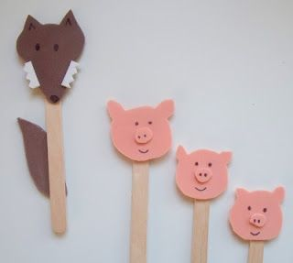
2.45 PM The Three Little Pigs (Key Text)
Read the story as a class and show examples of the puppets.
- Think about the different characters in the story.
- Create the characters as puppets and retell the story to someone in your home.

Reading week activities:
Build a Reading Den
- Children to build ‘Reading Dens’ and spend time in them during the day, reading their favourite books. Photos can be sent into school to be added to the website.
Book in a box
- The children pick one of the books from list below and design a box for this particular book.
The Three Little Pigs
Goldilocks and the 3 Bears
The Gingerbread Man
The Gruffalo's Child
Room on the Broom
The Gruffalo
Handa's Surprise
We're Going on a Bear Hunt
Stickman
Colour Monster Book

Live Links
- For KS1 https://www.worldbookday.com/share-a-story-corner/

