 | Blue Planet Theme – Week 14 Years 4/5/6 22.6.20
 | Monday | Tuesday | Wednesday | Thursday | Friday
9-11 | WORD OF THE DAY  Introduce a new word, find out the meaning, use it in conversation, can you draw something to help you remember the word and / or how to spell it? Find out the origin, are there words which mean the same? Use it in written sentences.  Ocean - 1. a large body of water constituting a principal part of the hydrosphere  2. anything apparently limitless in quantity or volume  Reading  Complete Reading Comprehension  Writing  Choose an activity from the list. | WORD OF THE DAY  Introduce a new word, find out the meaning, can you draw something to help me remember the word and / or how to spell it? Can you use it in conversation, find out the origin, are there words which mean the same? Use it in written sentences.  Maritime - 1. bordering on or living or characteristic of those near the sea  2. relating to or involving ships or shipping or navigation or seamen  Reading  Complete 30 minutes of reading or choose a reading comprehension you didn’t complete from a different week.  Writing  Choose an activity from the list. | WORD OF THE DAY  Introduce a new word, find out the meaning, can you draw something to help me remember the word and / or how to spell it? Can you use it in conversation, find out the origin, are there words which mean the same?  Transoceanic - 1. on or from the other side of an ocean  Writing  Choose an activity from the list. | WORD OF THE DAY  Introduce a new word, find out the meaning, can you draw something to help me remember the word and / or how to spell it? Can you use it in conversation, find out the origin, are there words which mean the same? Use it in written sentences.  Pelagic - relating to or occurring or living in or frequenting the open ocean  Reading  Complete 30 minutes of reading.  Writing  Choose an activity from the list. | WORD OF THE DAY  Introduce a new word, find out the meaning, can you draw something to help me remember the word and / or how to spell it? Can you use it in conversation, find out the origin, are there words which mean the same? Use it in written sentences.  Thalassic -  . relating to the seas, especially smaller or inland seas  Reading  Complete 30 minutes of reading.  Writing  Choose an activity from the list.
 | Movement  The Body Coach – YouTube – find the current day | Movement  https://www.youtube.com/user/CosmicKidsYoga  Cosmic Yoga  (YouTube) | Movement  The Body Coach – YouTube - find the current day | Movement  Go outside for a walk/bike ride. | Movement  The Body Coach – YouTube on the day
11-11.15 | Break | Break | Break | Break | Break
11.15-12.15 | Maths  White Rose (Home Learning Tab)  https://whiterosemaths.com/homelearning/  Watch video and answer questions. | Maths  Number gym  http://www.numbergym.co.uk/  Calculation activity linked to year group e.g. multiplication and division, addition and subtraction | Maths  White Rose (Home Learning Tab) https://whiterosemaths.com/homelearning/  Watch video and answer questions. | Maths  Number gym  http://www.numbergym.co.uk/  Table Trainer, Bond Builder | Maths  White Rose (Home Learning Tab) https://whiterosemaths.com/homelearning/  Watch video and answer questions.
12.15-1.15 | Lunch | Lunch | Lunch | Lunch | Lunch
1.15-2.50 | Theme Work  Choose an activity from the list. | Theme Work  Choose an activity from the list. | Theme Work  Choose an activity from the list. | Theme Work  Choose an activity from the list. | Theme Work  Choose an activity from the list.
2.50-3.15 | Reflecting Roxy 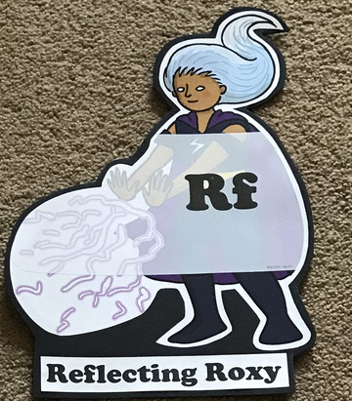  What have you learnt today and how could you have improved any of your work?  STORY TIME | Making Links Molly 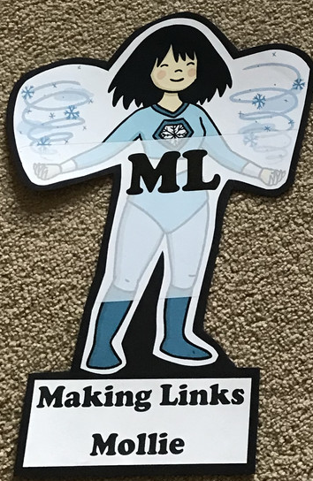  Can you use any learning that you have done today, in other parts of your life?  STORY TIME/ | Resilience Rex 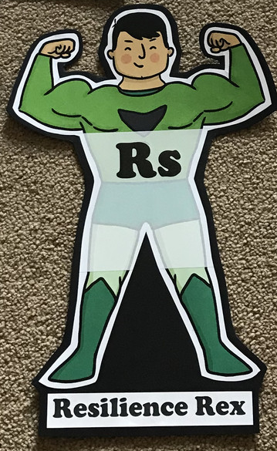  Have you found anything challenging today? How did you overcome the challenges?  STORY TIME/ | Collaborating Carlos 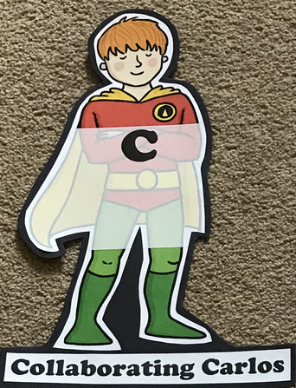  Did you work alone today or with someone else? How did that go?  STORY TIME/ | Motivating Melinda 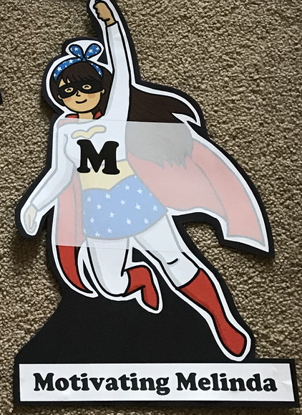  Have you encouraged someone else today? How did you motivate yourself today?  STORY TIME/

Writing

- Look at the Plastic in the Ocean PowerPoint. List the new and key vocabulary- ensure you find out what the words mean and use them in context.
- Make notes from the PowerPoint (think about note taking; only record the important parts).
- Imagine you are going to be called to talk in Government about the crisis linked to pollution in our oceans. What is the crisis? Why has it happened? What are the facts? Why do we need to prevent further pollution in our seas? How can people help? Plan a persuasive speech, where you explain your point of view, back your points up with facts and evidence. Remember to use persuasive language (see attached sheets to help you with ideas and language).
- Present your speech…read it aloud to a family member, your pet, a friend…Did you persuade them?
- Research an animal from the ocean. What is the species? What is its habitat? What is its diet? Is it endangered? Create a fact file or information book about this animal. Think about audience and purpose- who will read it? A child? A teacher? A scientist? Use the Ocean Predators sheet to record some facts if this helps you, before you choose one creature .https://www.bbcearth.com/shows/blue-planet https://www.youtube.com/channel/UCVmsA2WYy9e0wf4KaSwVY-Q (This is the YouTube link for Shark Man Dan who some of the children met when he visited us last year).

Theme
- https://www.bbc.co.uk/teach/class-clips-video/science-ks2-blue-planet-live/zd9y7nb (This link takes you to lots of video clips and factual information)
- 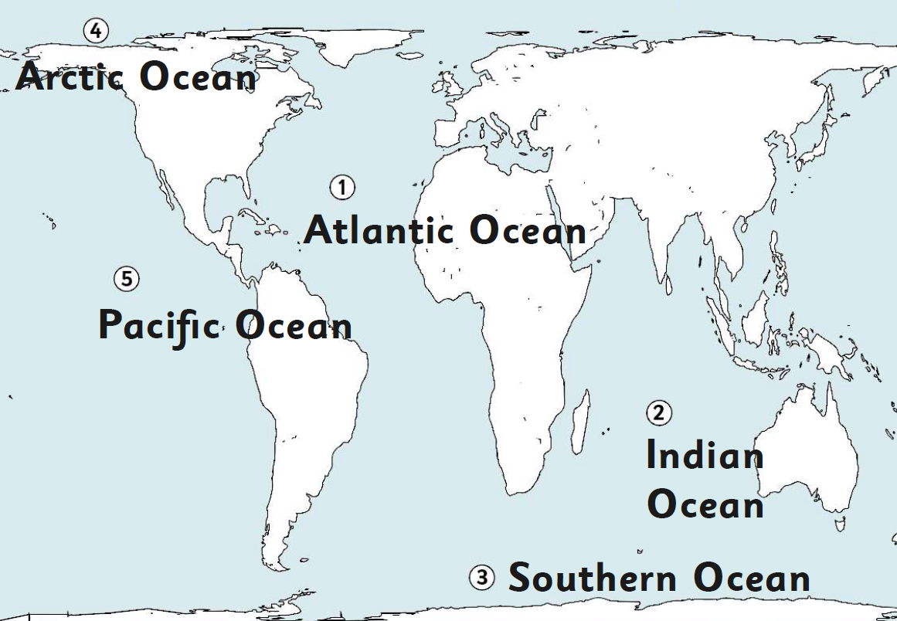Locate the oceans of the world. What other large areas of water are there? What facts can you find out about all of them?
- https://www.natgeokids.com/uk/discover/geography/general-geography/ocean-facts/ Look at this website for facts about our oceans. Can you create a poster all about our oceans? Include as many facts as possible. Add diagrams, drawings and captions to add extra details. Think about WHO the poster is for (audience and purpose).
- Create a painting or piece of art of an underwater scene. Use water colours for the background and add the creatures and plant life with pastels or crayons for depth.
- https://www.youtube.com/watch?v=599Ctm4vxB0 HOW TO DRAW SEA CREATURES; have a go and try some of these!

