Our rubric for a fictional character
Audience: Your teacher and class Purpose: To compose a fictional character in the style of Roald Dahl.
 | Objective | Towards | At | Above
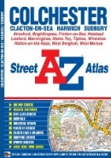 | Spellings | I can use at least one key word in my writing and spell it correctly. | I can use 3 key words in my writing and spell them correctly.  I can spell a range of high frequency words correctly. | I can use a range of key words from our class list.  I can spell high frequency words consistently and accurately.
 | Grammar | I can sometimes use compound sentences.  I am sometimes using adjectives to describe my characters. | I am beginning to use past tense in my story writing.  I am beginning to use adjectives and adverbs to describe my characters and their actions. | I use past tense in my story writing.  I can use compound and complex sentences accurately.  I can use adjectives and adverbs to describe my characters and their actions.
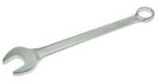 | Punctuation | I can use a capital letter and full stop. | I can consistently use capital letters, full stops and sometimes use exclamation marks. | I can punctuate my sentences accurately.
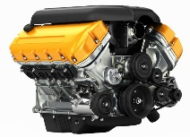 | Genre | I can create an imaginative character. | I can create an imaginative character and put them in a setting.  I can avoid list sentences in my description that will turn the reader off. | I can create an imaginative character, put them in a setting and make them react to type.  I can avoid adjective stodgy list sentences in my description that will turn the reader off.
 | Handwriting | I can write legibly and join some of the time. | I can write neatly and join up my writing. | I can write neatly, joined and with increasing speed throughout my text.

