JUMP INTO THE PAST Theme – Week 15 Years 4/5/6
ANCIENT EGYPT

 | Monday | Tuesday | Wednesday | Thursday | Friday
9-11 | WORD OF THE DAY  Introduce a new word, find out the meaning, use it in conversation, can you draw something to help you remember the word and / or how to spell it? Find out the origin, are there words which mean the same? Use it in written sentences.  Obelisk  a tall, slender, four-sided stone pillar shaped from a single stone  https://www.bbc.co.uk/bitesize/topics/zg87xnb INTRODUCTION TO ANCIENT EGYPT  Reading  Choose one of the READING COMPREHENSIONS  Writing  Choose an activity from the list. | WORD OF THE DAY  Introduce a new word, find out the meaning, can you draw something to help me remember the word and / or how to spell it? Can you use it in conversation, find out the origin, are there words which mean the same? Use it in written sentences.  Papyrus  a water-loving plant that is best known for making paper  https://www.bbc.co.uk/bitesize/topics/zg87xnb/articles/zr7qy9q WHAT REMAINS OF ANCIENT EGYPT  Reading  Complete 30 minutes of reading.  Writing  Choose an activity from the list. | WORD OF THE DAY  Introduce a new word, find out the meaning, can you draw something to help me remember the word and / or how to spell it? Can you use it in conversation, find out the origin, are there words which mean the same?  Hieroglyph  a picture used to write something  https://www.bbc.co.uk/bitesize/topics/zg87xnb/articles/zvw3mfr  WHAT WERE ANCIENT EGYPTIAN HIEROGLYPICS?  Reading  Choose one of the READING COMPREHENSIONS  Writing  Choose an activity from the list. | WORD OF THE DAY  Introduce a new word, find out the meaning, can you draw something to help me remember the word and / or how to spell it? Can you use it in conversation, find out the origin, are there words which mean the same? Use it in written sentences.  Sarcophagus  a stone coffin  https://www.bbc.co.uk/bitesize/topics/zg87xnb/articles/z4m8pg8 WHAT DID THE ANCIENT EGYPTIANS BELIEVE IN?  Reading  Complete 30 minutes of reading.  Writing  Choose an activity from the list. | WORD OF THE DAY  Introduce a new word, find out the meaning, can you draw something to help me remember the word and / or how to spell it? Can you use it in conversation, find out the origin, are there words which mean the same? Use it in written sentences.  Pharaoh  an ancient Egyptian ruler  https://www.bbc.co.uk/bitesize/topics/zg87xnb/articles/zvqjf4j TAKE THE ANCIENT EGYPT QUIZ  Reading  Choose one of the READING COMPREHENSIONS  Writing  Choose an activity from the list.
 | Movement  The Body Coach – YouTube – find the current day | Movement  https://www.youtube.com/user/CosmicKidsYoga  Cosmic Yoga  (YouTube) | Movement  The Body Coach – YouTube - find the current day | Movement  Go outside for a walk. | Movement  The Body Coach – YouTube on the day
11-11.15 | Break | Break | Break | Break | Break
11.15-12.15 | Maths  White Rose (Home Learning Tab)  https://whiterosemaths.com/homelearning/  Watch video and answer questions.  Or… find ouit about the Egyptian number system on…  https://discoveringegypt.com/egyptian-hieroglyphic-writing/egyptian-mathematics-numbers-hieroglyphs/ | Maths  Number gym  http://www.numbergym.co.uk/  Calculation activity linked to year group e.g. multiplication and division, addition and subtraction | Maths  White Rose (Home Learning Tab) https://whiterosemaths.com/homelearning/  Watch video and answer questions. | Maths  Number gym  http://www.numbergym.co.uk/  Table Trainer, Bond Builder | Maths  White Rose (Home Learning Tab) https://whiterosemaths.com/homelearning/  Watch video and answer questions.
12.15-1.15 | Lunch | Lunch | Lunch | Lunch | Lunch
1.15-2.50 | Theme Work  Choose an activity from the list. | Theme Work  Choose an activity from the list. | Theme Work  Choose an activity from the list. | Theme Work  Choose an activity from the list. | Theme Work  Choose an activity from the list.
2.50-3.15 | Reflecting Roxy 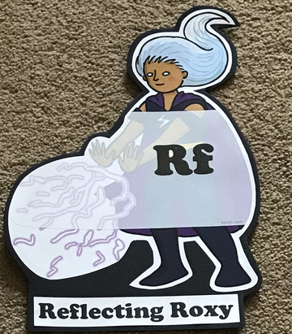  What have you learnt today and how could you have improved any of your work?  STORY TIME | Making Links Molly 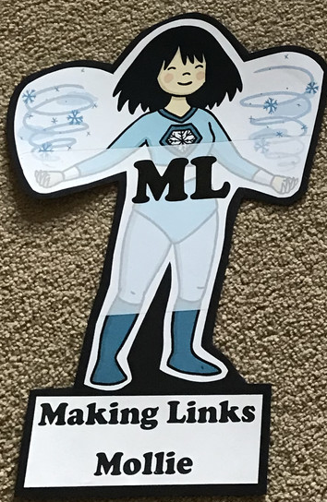  Can you use any learning that you have done today, in other parts of your life?  STORY TIME/ | Resilience Rex 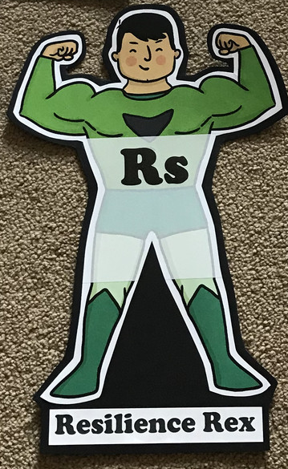  Have you found anything challenging today? How did you overcome the challenges?  STORY TIME/ | Collaborating Carlos 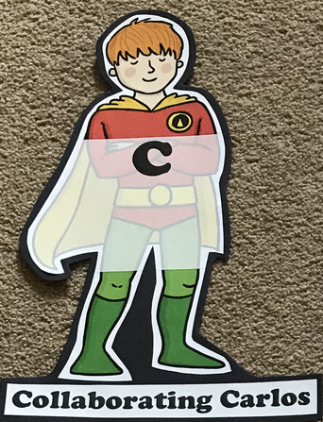  Did you work alone today or with someone else? How did that go?  STORY TIME/ | Motivating Melinda 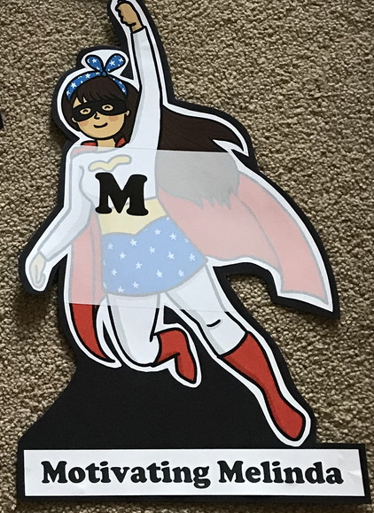  Have you encouraged someone else today? How did you motivate yourself today?  STORY TIME/

Writing

- https://www.literacyshed.com/the-egyptian-pyramids.html THE LITERACY SHED (TADEO JONES) Use this short clip, to begin a story about an archaeologist. What happens when he goes into the tomb? What is he looking for? Plan the story on one day and write it the next day.
- Use the PowerPoint/s to help you write a story about entering a tomb.
- Write a report about Egyptian beliefs about the afterlife.
- Write a diary entry for a pyramid worker.
- Write some instructions on how to mummify a person.
- Write a newspaper report about the discovery of Tutankhamun’s tomb.

Theme
- https://www.ducksters.com/history/ancient_egypt.php https://www.natgeokids.com/uk/discover/history/egypt/ten-facts-about-ancient-egypt/ - find out lots of facts about Ancient Egypt…create a project!
- Who was Tutankhamun? https://www.historyextra.com/period/ancient-egypt/8-things-you-probably-didnt-know-about-tutankhamun/
- Try writing in hieroglyphs. (see the attached sheet…can you write your name?)
- Make a fact file about the Egyptian gods.
- Paint Tutankhamun’s headdress 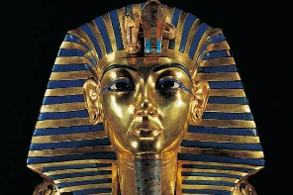
- Lots of fantastic art activities!

