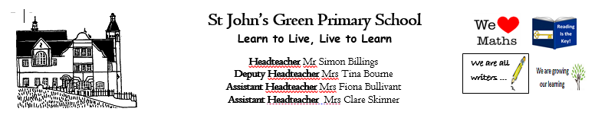

**Week 14 (W.B. 29/06/2020)**

**Theme: Blue Planet**

**Year 2/3**

* **Watch Dan the Shark Man Ted Talk (5mins onwards) Create an information poster about what you have learnt.**
* **Write a fact file on sharks**
* **Write a persuasive speech to persuade people to start recycling to save the oceans**
* **Read through Plastic Pollution powerpoint and research how a certain country is dealing with plastic pollution. Record it in the plastic pollution booklet.**
* **Write a diary entry as a marine explorer who has just discovered a new marine creature.**
* **Research a sea creature from the Starry-Eyed Stan story and fill in the research sheet**
* **Label the oceans of the world and draw some of the marine animals you would find in those oceans**
* **Create a ‘Save the Ocean’ picture with any recycling you have eg. Old bottle tops, milk cartons.**
* **Film a David Attenborough style nature documentary. Can you find some nature to film or create your own with pictures and models**
* **Watch the Blue Planet Live Lesson on BBC. 3 activity sheets along with it.**
* **Draw your discovered marine creature**
* **Watch clips from BBC’s Blue Planet.**
* **Create Blue Planet Top Trumps**
* **Sharks reading comprehension**
* **Code breakers**
* **Addition and Subtraction**
* **Create an advertisement for Starry-Eyed Stan’s Singing school**
* **Layers of the Ocean reading comprehension**
* **Learn the meaning of Blue Planet based vocabulary**
* **Research and learn about ocean creatures**