|  |  |  |
| --- | --- | --- |
| **Shape** | **Name** | **Number of vertices** |
|  |  |  |
|  |  |  |
| Image result for 3d cone shape |  |  |
|  |  |  |
|  |  |  |

1. **Fill in the empty boxes**
2. 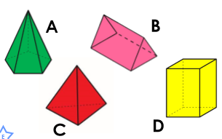**Which two shapes have the same number of vertices?**

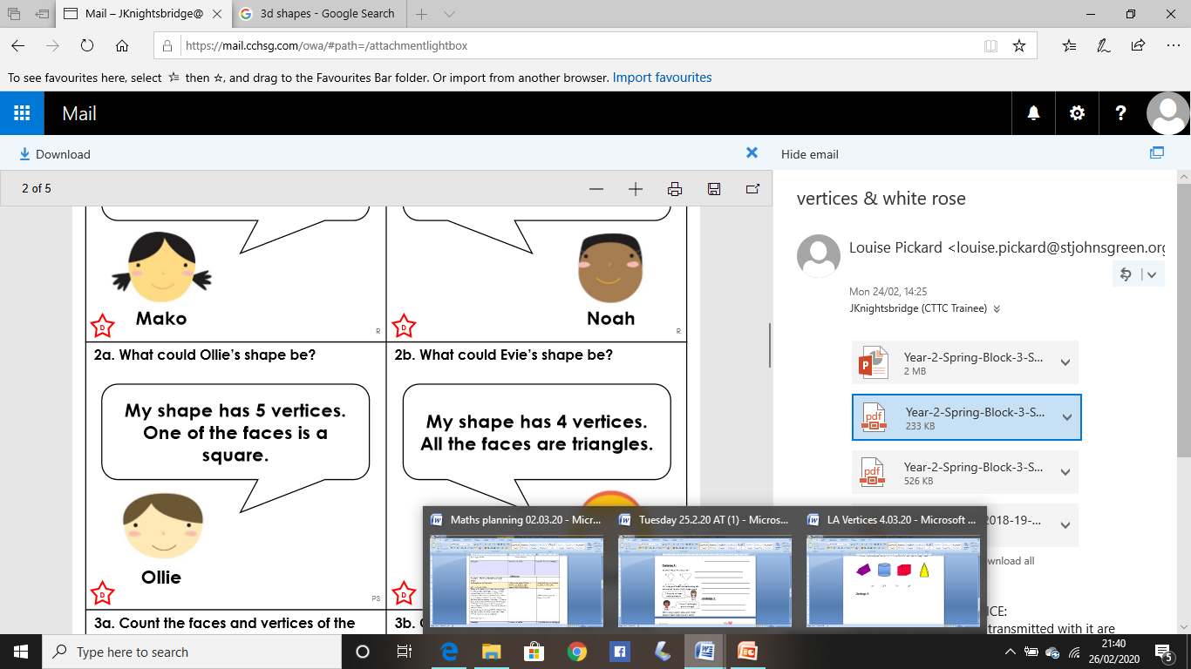**Challenge 1:**

**How many vertices do Joshua and Mary have altogether?**

**Who has the least vertices?**

Mary says:

I have 2 triangular based pyramids

Joshua says:

I have a cone and a cube

**Challenge 2:**

Barney says:

I’m thinking of a 3D shape. It has 6 vertices.

**What shape could Barney be thinking of?**

**Can you think of any other 3D shapes with 6 vertices?**



**Challenge 3:**

**Which shapes have fewer than 7 vertices?**

**What is this shape called?**

