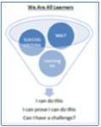
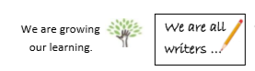
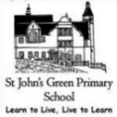
Road to Writing
Writing Reflection
Date 5.3.21 | Genre/Text Type:

What I had to focus on in my learning… | What went well in my learning… | What I need to focus on next…
Where am I in my learning?

