 | Monday | Tuesday | Wednesday | Thursday | Friday
9-9.30 | Movement  The Body Coach – Youtube on the day | Movement  https://www.youtube.com/user/CosmicKidsYoga | Movement  BBC Move it Dance Programme  https://www.bbc.co.uk/programmes/b03g64pk/episodes/player | Movement  Go outside for a walk. | Movement  The Body Coach – Youtube on the day
9.30-10 | Phonics | Phonics | Phonics | Phonics | Phonics
10-10.30 | Reading  Younger readers can read or share a text with someone. Can they write or draw what they read about? Can they answer questions about the text?  https://www.oxfordowl.co.uk/for-home/find-a-book/library-page/  username- SJGreading  password- SJGreading | Reading  Younger readers can read or share a text with someone. Can they write or draw what they read about? Can they answer questions about the text?  https://www.oxfordowl.co.uk/for-home/find-a-book/library-page/  username- SJGreading  password- SJGreading | Reading  Younger readers can read or share a text with someone. Can they write or draw what they read about? Can they answer questions about the text?  https://www.oxfordowl.co.uk/for-home/find-a-book/library-page/  username- SJGreading  password- SJGreading | Reading  Younger readers can read or share a text with someone. Can they write or draw what they read about? Can they answer questions about the text?  https://www.oxfordowl.co.uk/for-home/find-a-book/library-page/  username- SJGreading  password- SJGreading | Reading  Younger readers can read or share a text with someone. Can they write or draw what they read about? Can they answer questions about the text?  https://www.oxfordowl.co.uk/for-home/find-a-book/library-page/  username- SJGreading  password- SJGreading
 | Word of the day  Speed | Word of the day  Height | Word of the day  Team work | Word of the day  Skills | Word of the day  Positivity
11-11.15 | Break | Break | Break | Break | Break
11.15-12.15 | Maths  Number gym  http://www.numbergym.co.uk/  Appropriate calculation activity linked to year group e.g. add and subtract  See EYFS and Year 1 daily sheet. | Maths  Purple Mash  https://www.purplemash.com/login/  Shape focus – recap names of shapes. Creating your own Colour Monster shape picture.  See EYFS and Year 1 daily sheet. | Maths  Number gym  http://www.numbergym.co.uk/  Appropriate calculation activity linked to year group. EYFS/Yr1 looking at number bonds/numbers to 10  See EYFS and Year 1 daily sheet. | Maths  Purple Mash  https://www.purplemash.com/login/  See EYFS and Year 1 daily sheet. | Maths  Number gym  http://www.numbergym.co.uk/  Calculation focus – addition and subtraction  See EYFS and Year 1 daily sheet.
12.15-1.15 | Lunch | Lunch | Lunch | Lunch | Lunch
1.15-2.50 | Theme Work  See daily plan | Theme Work  See daily plan | Theme Work  See daily plan | Theme Work  See daily plan | Theme Work  See daily plan
2.50-3.15 | Reflecting Roxy 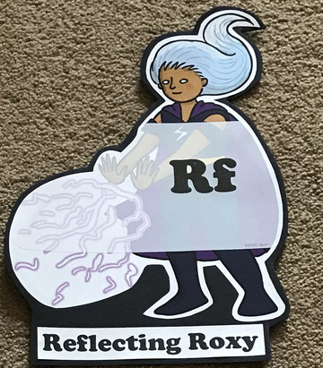  What have you learnt today and how could you have improved any of your work?  STORY TIME | Making Links Molly 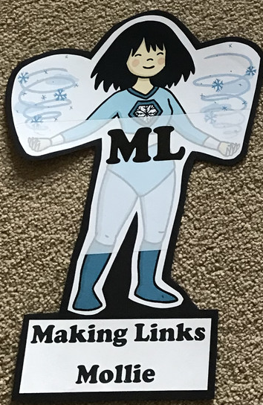  Can you use any learning that you have done today, in other parts of your life?  STORY TIME | Resilience Rex 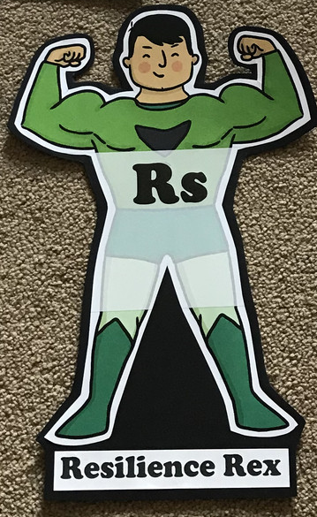  Have you found anything challenging today? How did you overcome the challenges?  STORY TIME | Collaborating Carlos 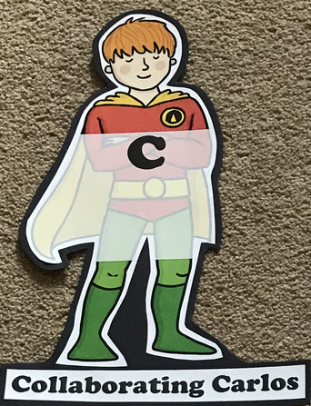  Did you work alone today or with someone else? How did that go?  STORY TIME | Motivating Melinda 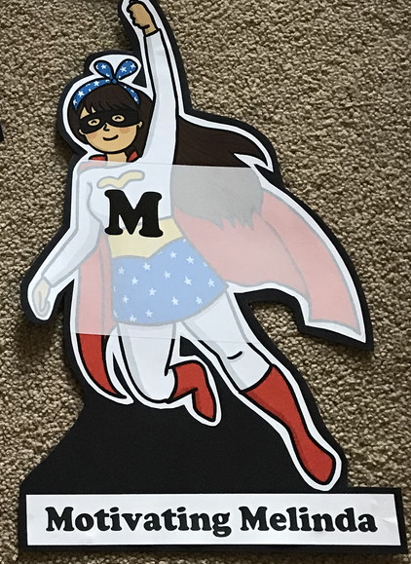  Have you encouraged someone else today? How did you motivate yourself today?  STORY TIME

Monday
Phonics
EYFS
Tricky words
Me
Be
You
Words to practise
Bench
Chop
Chick
Challenge
Can you write some sentences with these words in?
Phonics
Sound of day-
ch
ch-ch-ch chicken

Year 1
Tricky words
People
Called
Their
Words to practise
June
Flute
Strume

Challenge
Can you write some sentences with these words in?
Phonics
Sound of day-
u_e
u_e huge brute

Maths
Subtraction - Using bowls to clearly separate the numbers, work out the following questions:
EYFS Year 1
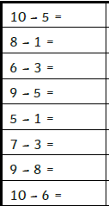
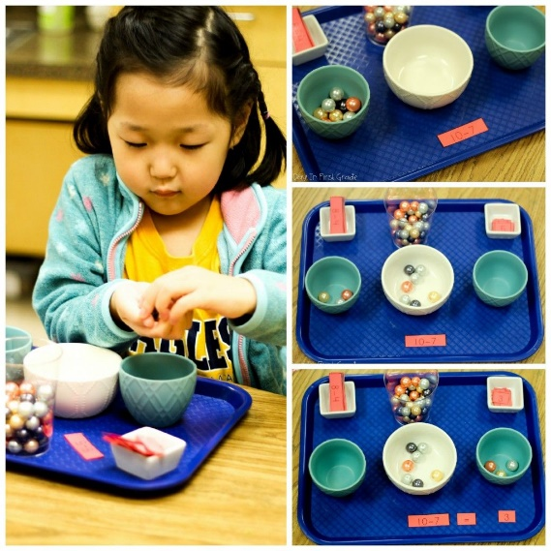
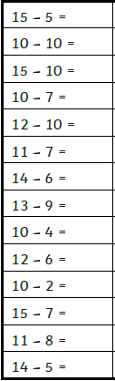

Tuesday
Phonics
EYFS
Tricky words
Was
Her
Are
Words to practise

Shed
Ship
Shorts

Phonics
Sound of day-
Sh
Sh she’s sleeping
Challenge
Can you write some sentences with these words in?

Year 1
Phonics
Sound of day-
Au
Paul the astronaut

Tricky words
People
Mrs
Oh
Words to practise
August
Author
Audit

Challenge
Can you write some sentences with these words in?

Maths
Subtraction - Using bowls to clearly separate the numbers, work out the following questions:
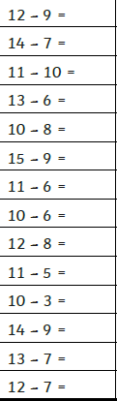
EYFS Year 1
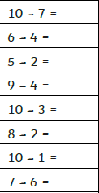

Wednesday
Phonics
EYFS
Tricky words
was
her
are
Words to practise
Think
Thank
Theft
Phonics
Sound of day-
Th

Think a thought
Challenge
Can you write some sentences with these words in?

Year 1
Phonics
Sound of day-
oe
touch your toes

Tricky words
Mr
Called
Their
Words to practise
Ploem
Toe
droeb

Challenge
Can you write some sentences with these words in?

Maths
Subtraction - Using bowls to clearly separate the numbers, work out the following questions:
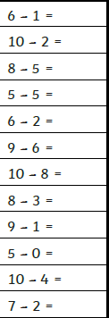
EYFS Year 1
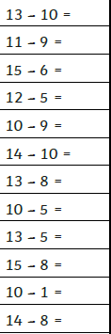

Thursday
Phonics
EYFS
Tricky words
My
They
All
Words to practise
Thing
Bring
String
Challenge
Can you write some sentences with these words in?

Phonics
Ng
Thing on a string

Year 1
Tricky words
Could
Asked
Looked

Words to practise
Blew
Threw
Plewm

Challenge
Can you write some sentences with these words in?
Phonics
Sound of day-
Ew
Chew the stew

Maths
Find attached colour by subtraction images differentiated per year group.

Friday
Phonics: Phonics play
https://new.phonicsplay.co.uk/resources

Maths: Top marks- ordering and sequencing shapes games
https://www.topmarks.co.uk/ordering-and-sequencing/shape-patterns

