 | Animal Planet Theme – Week 9 18.05.20
 | Monday | Tuesday | Wednesday | Thursday | Friday
9-11 | WORD OF THE DAY  Introduce a new word, find out the meaning, use it in conversation, can you draw something to help you remember the word and / or how to spell it? Find out the origin, are there words which mean the same? Use it in written sentences.  PRODUCER/PREDATOR/ PREY  Reading  Complete Reading Comprehension – Doorstep Wildlife  Writing  Choose an activity from the list. | WORD OF THE DAY  Introduce a new word, find out the meaning, can you draw something to help me remember the word and / or how to spell it? Can you use it in conversation, find out the origin, are there words which mean the same? Use it in written sentences.  HERBIVORE/CARNIVORE/ OMNIVORE  Reading  Complete 30 minutes of reading.  Writing  Choose an activity from the list. | WORD OF THE DAY  Introduce a new word, find out the meaning, can you draw something to help me remember the word and / or how to spell it? Can you use it in conversation, find out the origin, are there words which mean the same?  MAMMAL  Reading  Choose a reading activity from the list based on what you read yesterday.  Writing  Choose an activity from the list. | WORD OF THE DAY  Introduce a new word, find out the meaning, can you draw something to help me remember the word and / or how to spell it? Can you use it in conversation, find out the origin, are there words which mean the same? Use it in written sentences.  PRIMATE  Reading  Complete 30 minutes of reading.  Writing  Choose an activity from the list. | WORD OF THE DAY  Introduce a new word, find out the meaning, can you draw something to help me remember the word and / or how to spell it? Can you use it in conversation, find out the origin, are there words which mean the same? Use it in written sentences.  HABITAT  Reading  Choose a reading activity from the list based on what you read yesterday.  Writing  Choose an activity from the list.
 | Movement  The Body Coach – Youtube – find the current day | Movement  https://www.youtube.com/user/CosmicKidsYoga  Cosmic Yoga  (YouTube) | Movement  The Body Coach – Youtube - find the current day | Movement  Go outside for a walk. | Movement  The Body Coach – Youtube on the day
11-11.15 | Break | Break | Break | Break | Break
11.15-12.15 | Maths  White Rose (Home Learning Tab)  https://whiterosemaths.com/homelearning/  Watch video and answer questions. | Maths  Number gym  http://www.numbergym.co.uk/  Calculation activity linked to year group e.g. multiplication and division, addition and subtraction | Maths  White Rose (Home Learning Tab) https://whiterosemaths.com/homelearning/  Watch video and answer questions. | Maths  Number gym  http://www.numbergym.co.uk/  Table Trainer, Bond Builder | Maths  White Rose (Home Learning Tab) https://whiterosemaths.com/homelearning/  Watch video and answer questions.
12.15-1.15 | Lunch | Lunch | Lunch | Lunch | Lunch
1.15-2.50 | Theme Work  Choose an activity from the list. | Theme Work  Choose an activity from the list. | Theme Work  Choose an activity from the list. | Theme Work  Choose an activity from the list. | Theme Work  Choose an activity from the list.
2.50-3.15 | Reflecting Roxy 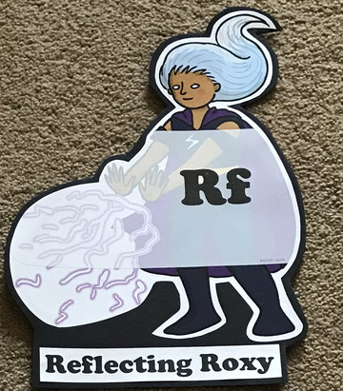  What have you learnt today and how could you have improved any of your work?  STORY TIME/  Well being calendar | Making Links Molly 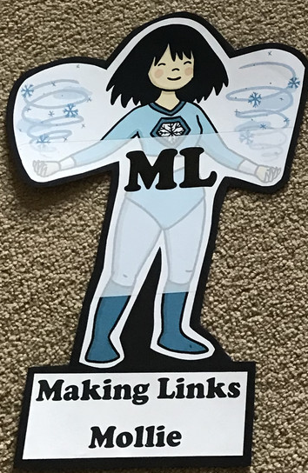  Can you use any learning that you have done today, in other parts of your life?  STORY TIME/  Well being calendar | Resilience Rex 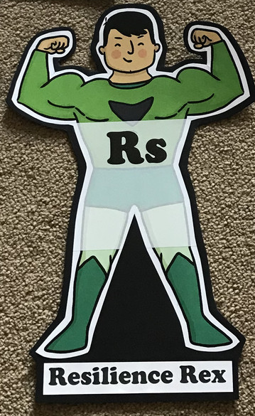  Have you found anything challenging today? How did you overcome the challenges?  STORY TIME/  Well being calendar | Collaborating Carlos 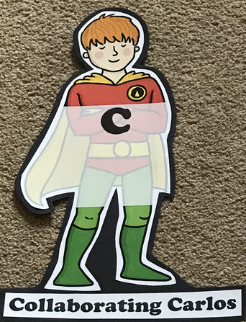  Did you work alone today or with someone else? How did that go?  STORY TIME/  Well being calendar | Motivating Melinda 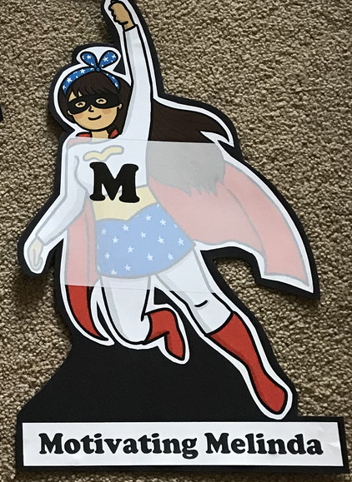  Have you encouraged someone else today? How did you motivate yourself today?  STORY TIME/  Well being calendar

Writing
- POBBLE 365 http://www.pobble365.com/ Choose one of the images and write a descriptive paragraph about it.
- Steve Backshall lessons/live learning https://www.youtube.com/channel/UCm-URP49TgSgyIU1rgh2m7A/videos OR choose a Deadly 60 video. Write 5 questions to interview Steve Backshall. Answer them as if you were him.
- Write a speech for a charity raising money for orang-utans.
- Watch David Attenborough’s video on the Amur Leopard https://www.youtube.com/watch?v=dXAmEDFFero Choose one of the ‘cone’ animals to make and research it habitat. Now write a voiceover for your animal in its ‘habitat’ (the garden, in a tree, the bath, the fridge, bed) in the style of David Attenborough!
- Create a leaflet persuading people to come to visit your zoo. Who would you like to come? Why should they visit?
- Complete the reading comprehension about David Attenborough. Create a poster to show what you have learnt about him.

Theme
- Complete the food chain worksheet. Could you draw and label your own food chain?
- Food chain game – using the pictures, make as many food chains as possible!
- Create a collage of your chosen animal – use a variety of resources you can find including recycled items or things you find outside.
- Design a zoo – which animals would you have? Why? Think about space/enclosures for the animals, paths, places to eat/drink. If you would like more of a challenge, complete the booklet which includes area of enclosures, budgets and advertising your zoo!
- Look at various food chains and play the games! https://www.bbc.co.uk/bitesize/topics/zbnnb9q
- Look at how animals are adapted to their environment http://www.primaryhomeworkhelp.co.uk/adaptation.htm
- Watch Madagascar, Rio, Zootropolis, We Bought A Zoo, The Jungle Book

