Remote Learning - EYFS
Monday 1st March 2021
Below is a timetable guide of what we will be teaching today and the follow up activities for you to complete. The chat function will be available for any questions related to the learning
9.30AM LIVE Registration and Letters and Sounds
Children will need something to write with if possible.
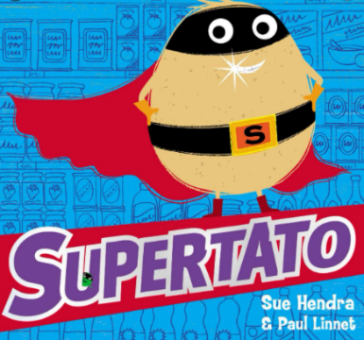
Following onto LIVE Literacy
SUPERTATO
Follow up activity:
ABC

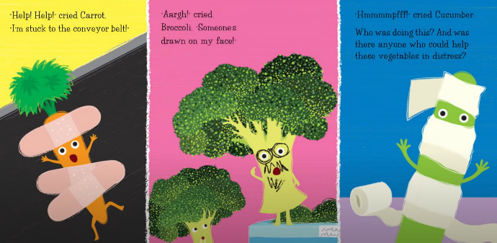
Encourage children to write a simple sentence using their phonic knowledge about the picture below.

- Think of your sentence.
- Say the sentence aloud.
- Use your sounds to write the sentence.
- Put a capital letter at the start of your sentence.
- Use Finger spaces in-between every word.
- Put a full stop at the end of your sentence.
- Check your sentence using the Writers Toolkit.

Short brain break videos
Move and Freeze: https://www.youtube.com/watch?v=388Q44ReOWE
Boom Chicka Boom: https://www.youtube.com/watch?v=F2XVfTzel8E
11.30 AM LIVE Mathematical Development
Number Bonds to 10
Watch the number bonds song (If you are feeling brave you can sing along) https://www.youtube.com/watch?v=nyH9pvMn76o
Model writing the sums.
Ten frame bonds to 10 PP
Follow up activity:
- Print or draw some tens frames.
- Using 10 resources around the house can you make the number bonds.
- Complete the ten frames sheet.
Short brain break videos
Cosmic Yoga: https://cosmickids.com/watch/ (choose a clip that you would like to participate in).
1.15 PM LIVE registration

Please bring any learning from this morning that you would like share with everyone.

Follow onto LIVE afternoon activity Understanding the World.
Watch the clip - What do you do https://www.youtube.com/watch?v=ckKQclquAXU

Go through the People who help us PP

Follow up activity:

- Watch the clip about Occupations https://www.youtube.com/watch?v=r6Oxqyd5qUw
- Complete the people who help us cut and stick sheet.
- ** CHALLENGE **
  - Can you write a who am I (Sheet in files) with a parent and post on earwig so the teachers can have a guess?

  - LIVE Story

- Bring a teddy, a blanket and a drink to listen to the story, to end the day calmly.

* Throughout the week individual Team calls for a short 1:1 reading session will happen *

