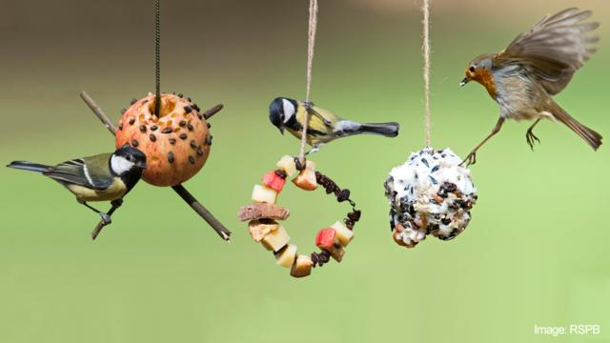

Make a bird feeder
Scroll or swipe down to find out how to make a feast for the birds in your garden. There are three different bird feeders you can make with your grown-up. Take a look below, you might want to make all three!

Apple Bird Feeder
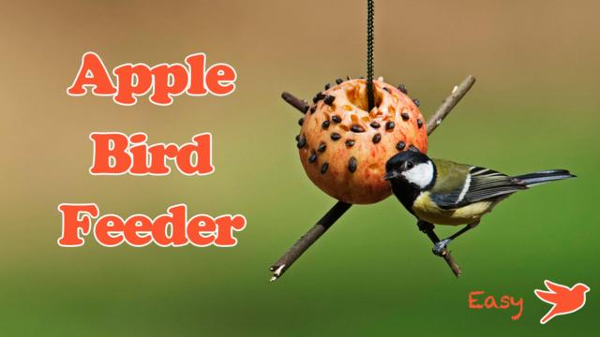
This make is easy and fun but you'll need a grown-up to core the apple for you.
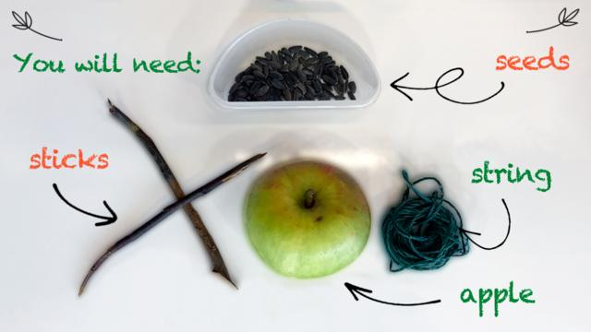

Step 1
Thread the string through the hole in the apple.

Step 2
Make an 'X' with the sticks and tie them to the string so the apple sits on top.

Step 3
Make a pattern by pushing the seeds into the apple, then it's ready to hang up!

Pine Cone Feeder
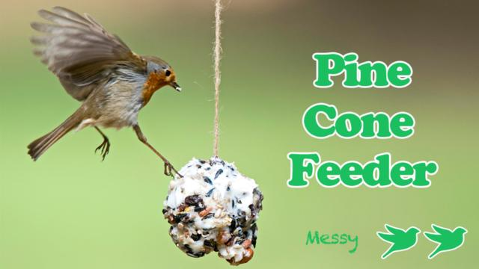

Have some warm, soapy water ready once you finish as the mix can be messy!
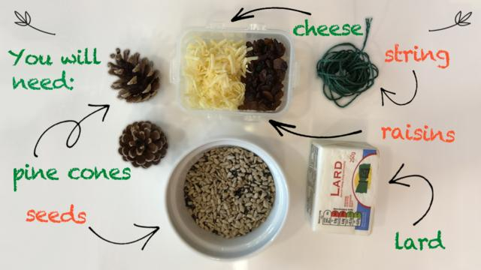

Step 1
Mush together the seeds, lard, cheese and raisins in a mixing bowl.

Step 2
Tie a string to your pine cone then cover it with the mix. Don't forget to fill the holes!

Step 3
Pop it in the fridge until set, then it's ready for the birds!

Fruit Hoops
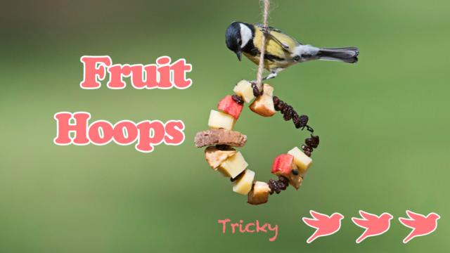

You'll need a grown-up to help with this one!
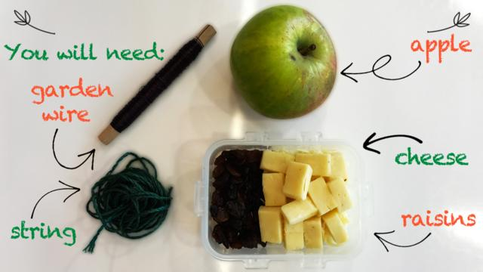

Step 1
Ask a grown-up to cut cubes of apple and cheese.

Step 2
Be very careful and ask a grown-up to help you thread fruit and cheese onto the wire like a necklace.

Step 3
Make a hoop with the wire and tie it to some string. Ready!

