 | Community Theme – Week 10 25.05.20
 | Monday | Tuesday | Wednesday | Thursday | Friday
9-11 | WORD OF THE DAY  Introduce a new word, find out the meaning, use it in conversation, can you draw something to help you remember the word and / or how to spell it? Find out the origin, are there words which mean the same? Use it in written sentences.  Community - a group of people living in the same place or having a particular characteristic in common.  Reading  Complete Reading Comprehension  Writing  Choose an activity from the list. | WORD OF THE DAY  Introduce a new word, find out the meaning, can you draw something to help me remember the word and / or how to spell it? Can you use it in conversation, find out the origin, are there words which mean the same? Use it in written sentences.  Teamwork - Teamwork is the collaborative effort of a group to achieve a common goal or to complete a task in the most effective and efficient way.  Reading  Complete 30 minutes of reading.  Writing  Choose an activity from the list. | WORD OF THE DAY  Introduce a new word, find out the meaning, can you draw something to help me remember the word and / or how to spell it? Can you use it in conversation, find out the origin, are there words which mean the same?  Responsibility - the state or fact of having a duty to deal with something or of having control over someone.  Reading  Choose a reading activity from the list based on what you read yesterday.  Writing  Choose an activity from the list. | WORD OF THE DAY  Introduce a new word, find out the meaning, can you draw something to help me remember the word and / or how to spell it? Can you use it in conversation, find out the origin, are there words which mean the same? Use it in written sentences.  Human Rights - Human rights are moral principles or norms that describe certain standards of human behaviour and are regularly protected as natural and legal rights for every person.  Reading  Complete 30 minutes of reading.  Writing  Choose an activity from the list. | WORD OF THE DAY  Introduce a new word, find out the meaning, can you draw something to help me remember the word and / or how to spell it? Can you use it in conversation, find out the origin, are there words which mean the same? Use it in written sentences.  Neighbour - a person living next door to or very near to the speaker or person referred to.  Reading  Choose a reading activity from the list based on what you read yesterday.  Writing  Choose an activity from the list.
 | Movement  The Body Coach – Youtube – find the current day | Movement  https://www.youtube.com/user/CosmicKidsYoga  Cosmic Yoga  (YouTube) | Movement  The Body Coach – Youtube - find the current day | Movement  Go outside for a walk. | Movement  The Body Coach – Youtube on the day
11-11.15 | Break | Break | Break | Break | Break
11.15-12.15 | Maths  White Rose (Home Learning Tab)  https://whiterosemaths.com/homelearning/  Watch video and answer questions. | Maths  Number gym  http://www.numbergym.co.uk/  Calculation activity linked to year group e.g. multiplication and division, addition and subtraction | Maths  White Rose (Home Learning Tab) https://whiterosemaths.com/homelearning/  Watch video and answer questions. | Maths  Number gym  http://www.numbergym.co.uk/  Table Trainer, Bond Builder | Maths  White Rose (Home Learning Tab) https://whiterosemaths.com/homelearning/  Watch video and answer questions.
12.15-1.15 | Lunch | Lunch | Lunch | Lunch | Lunch
1.15-2.50 | Theme Work  Choose an activity from the list. | Theme Work  Choose an activity from the list. | Theme Work  Choose an activity from the list. | Theme Work  Choose an activity from the list. | Theme Work  Choose an activity from the list.
2.50-3.15 | Reflecting Roxy 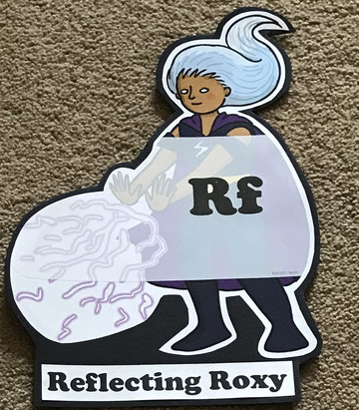  What have you learnt today and how could you have improved any of your work?  STORY TIME/  Well being calendar | Making Links Molly 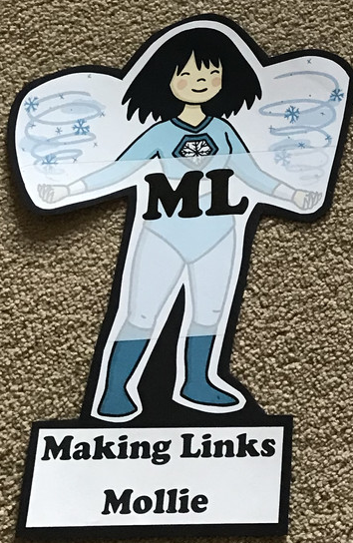  Can you use any learning that you have done today, in other parts of your life?  STORY TIME/  Well being calendar | Resilience Rex 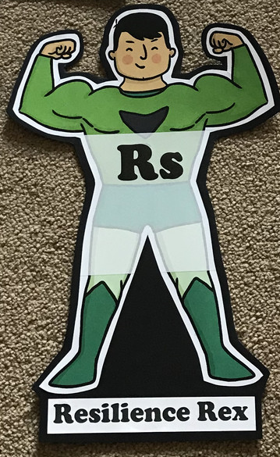  Have you found anything challenging today? How did you overcome the challenges?  STORY TIME/  Well being calendar | Collaborating Carlos 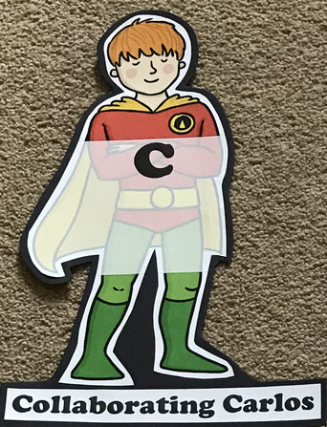  Did you work alone today or with someone else? How did that go?  STORY TIME/  Well being calendar | Motivating Melinda 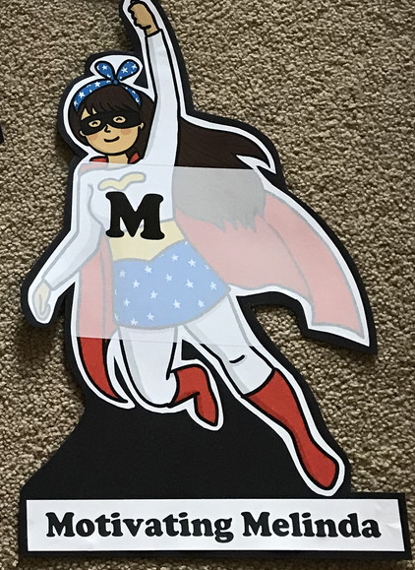  Have you encouraged someone else today? How did you motivate yourself today?  STORY TIME/  Well being calendar

Writing
- Write an explanation of why someone is a ‘hero’ (key worker)
- Nurses through time (Florence Nightingale/Mary Seacole). Research and compare to nurses and their jobs today.
- Write a postcard to a care home.
- Create a community newsletter
- Write community pledges for your local area
- Look at the pictures given imagining they are taken in your local area. Write a newspaper report to share all of the community efforts and the positive effect it is having. Maybe you could interview one of the photographed residents (make it up!) and include what they have said using speech punctuation.

Theme
- Design a superhero to look like a key worker of your choice. (template available)
- Draw your favourite place in your local area and label it with reasons why.
- Create a poster encouraging people on how to look after a local nature area.
- Create a bug hotel https://www.redtedart.com/simple-bug-hotel-for-kids/
- Make a bird feeder to hang in your garden/on a balcony or on a tree in your local area.
- Design and create a neighbourhood rosette to display/wear with pride!

