 | Monday | Tuesday | Wednesday | Thursday | Friday
9-9.30 | Movement  The Body Coach – Youtube on the day | Movement  https://www.youtube.com/user/CosmicKidsYoga | Movement  BBC Move it Dance Programme  https://www.bbc.co.uk/programmes/b03g64pk/episodes/player | Movement  Go outside for a walk. | Movement  The Body Coach – Youtube on the day
9.30-10 | Phonics | Phonics | Phonics | Phonics | Phonics
10-10.30 | Reading  Read through a twinkl story  Can they write or draw what they read about? Can they answer questions about the text?  https://www.twinkl.co.uk/resource/the-old-toy-room-ebook-t-or-1122 | Reading  Younger readers can read or share a text with someone. Can they write or draw what they read about? Can they answer questions about the text?  https://www.oxfordowl.co.uk/for-home/find-a-book/library-page/  username- SJGreading  password- SJGreading | Reading  Younger readers can read or share a text with someone. Can they write or draw what they read about? Can they answer questions about the text?  https://www.oxfordowl.co.uk/for-home/find-a-book/library-page/  username- SJGreading  password- SJGreading | Reading  Younger readers can read or share a text with someone. Can they write or draw what they read about? Can they answer questions about the text?  https://www.oxfordowl.co.uk/for-home/find-a-book/library-page/  username- SJGreading  password- SJGreading | Reading  Younger readers can read or share a text with someone. Can they write or draw what they read about? Can they answer questions about the text?  https://www.oxfordowl.co.uk/for-home/find-a-book/library-page/  username- SJGreading  password- SJGreading
 | Word of the day  Pyramid | Word of the day  Pharaoh | Word of the day  Mummy | Word of the day  Dessert | Word of the day  Ancient
11-11.15 | Break | Break | Break | Break | Break
11.15-12.15 | Maths  Number gym  http://www.numbergym.co.uk/  Appropriate calculation activity linked to year group e.g. add and subtract  See EYFS and Year 1 daily sheet. | Maths  Purple Mash  https://www.purplemash.com/login/  Shape focus – recap names of shapes. Creating your own Colour Monster shape picture.  See EYFS and Year 1 daily sheet. | Maths  Number gym  http://www.numbergym.co.uk/  Appropriate calculation activity linked to year group. EYFS/Yr1 looking at number bonds/numbers to 10  See EYFS and Year 1 daily sheet. | Maths  Purple Mash  https://www.purplemash.com/login/  See EYFS and Year 1 daily sheet. | Maths  Number gym  http://www.numbergym.co.uk/  Calculation focus – addition and subtraction  See EYFS and Year 1 daily sheet.
12.15-1.15 | Lunch | Lunch | Lunch | Lunch | Lunch
1.15-2.50 | Theme Work  See daily plan | Theme Work  See daily plan | Theme Work  See daily plan | Theme Work  See daily plan | Theme Work  See daily plan
2.50-3.15 | Reflecting Roxy 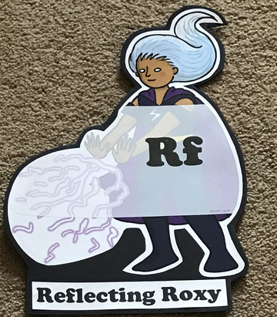  What have you learnt today and how could you have improved any of your work?  STORY TIME | Making Links Molly 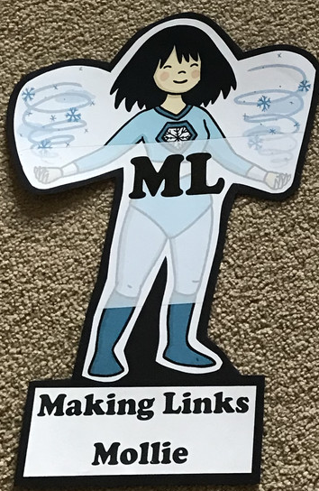  Can you use any learning that you have done today, in other parts of your life?  STORY TIME | Resilience Rex 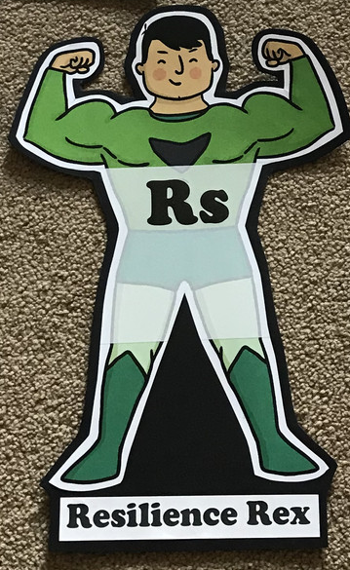  Have you found anything challenging today? How did you overcome the challenges?  STORY TIME | Collaborating Carlos 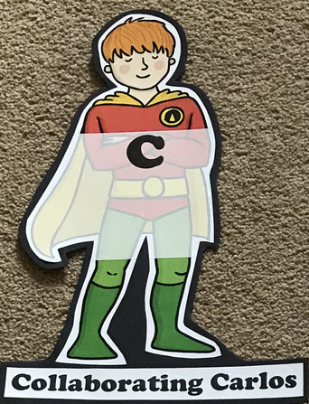  Did you work alone today or with someone else? How did that go?  STORY TIME | Motivating Melinda 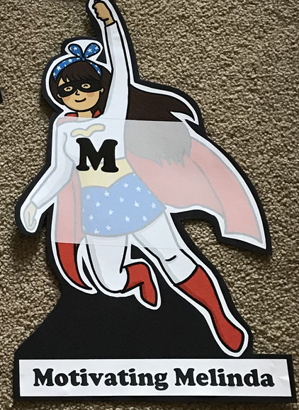  Have you encouraged someone else today? How did you motivate yourself today?  STORY TIME

Monday
Phonics
EYFS
Tricky words
He
Be
Her
Words to practise
Cheek
Queen
Sheep
Challenge
Can you write some sentences with these words in?
Phonics
Sound of day-
ee
What can you see?

Year 1
Tricky words
Oh
Mr
Could
Words to practise
Toes
Alien words
Phloem
Sploed
Challenge
Can you write some sentences with these words in?
Phonics
Sound of day-
Oe
Touch your toes

Maths: money
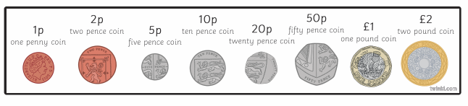
Using the above strip of coins to help you calculate how much the ice creams cost.

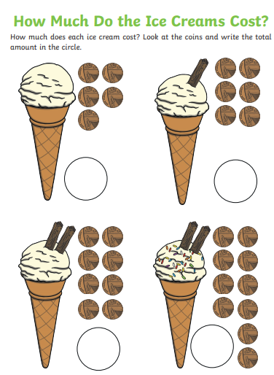
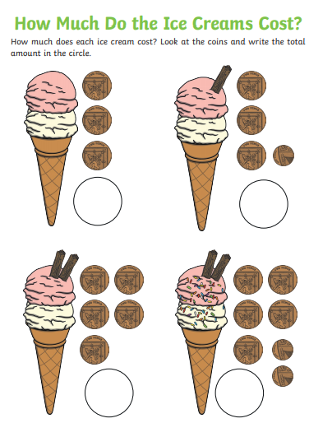

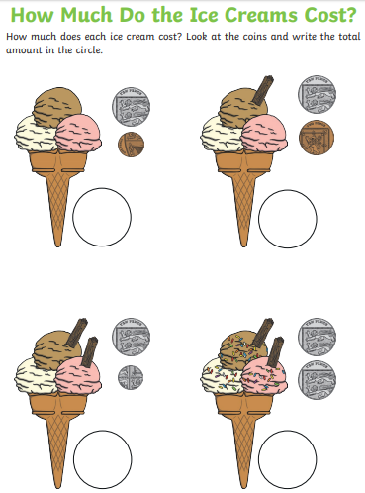
Tuesday
Phonics
EYFS
Tricky words
She
You
Was
Words to practise
Waist
Paint
Faint

Phonics
Sound of day-
ai
Snail in the rain
Challenge
Can you write some sentences with these words in?

Year 1
Phonics
Sound of day-
Ue
To the rescue
Tricky words
Mrs
Called
Asked
Words to practise
Rescue
Issue
Statue

Challenge
Can you write some sentences with these words in?

Maths: Money
Order the coins from smallest value to largest value. Discuss how many pennies make up £1 etc.
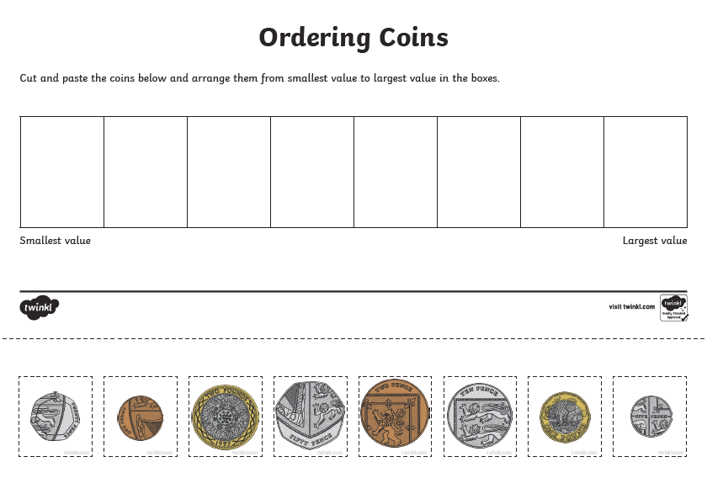

Wednesday
Phonics
EYFS
Tricky words
We
All
They
Words to practise
Thing
String
King
Phonics
Sound of day-
ng
Thing on a string
Challenge
Can you write some sentences with these words in?

Year 1
Phonics
Sound of day-
Ir
Whirl and twirl
Tricky words
People
Looked
Their
Words to practise
Shirt
Circus
Thirty

Challenge
Can you write some sentences with these words in?

Maths: Money
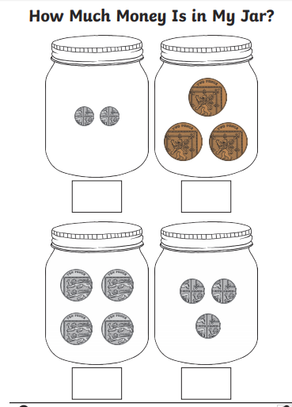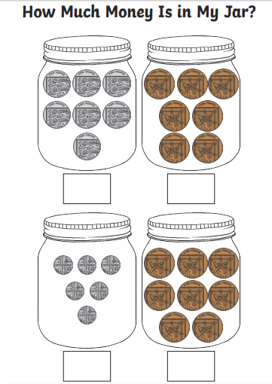

Thursday
Phonics
EYFS
Tricky words
Me
Are
My
Words to practise
Bath
Tenth
Throat
Challenge
Can you write some sentences with these words in?

Phonics
th
Think a thought

Year 1
Tricky words
Could
Asked
People
Words to practise
Royal
Oyster
Enjoy

Challenge
Can you write some sentences with these words in?
Phonics
Sound of day-
Oy
Royal boy

Maths: What is the total value of money in each purse

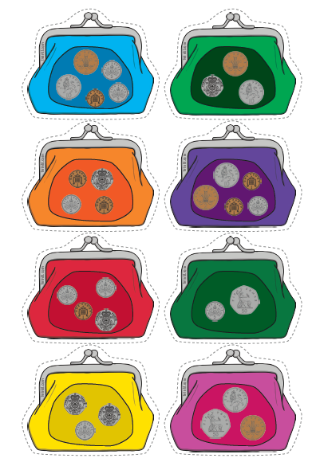

Friday
Phonics: Phonics play
https://new.phonicsplay.co.uk/resources

Maths: Top marks- Money game
https://www.topmarks.co.uk/money/toy-shop-money

