What would happen to materials close or far from the sun?
Material | Prediction |  | What happened?
 | Close to the sun | Far from the sun
Chocolate
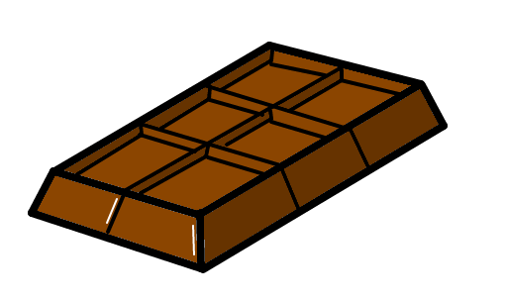
Ice cube
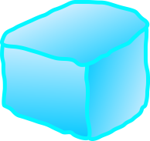
Water
Stone/Pebble
