 | Monday | Tuesday | Wednesday | Thursday | Friday
9-11 | WORD OF THE DAY;  character - a person in a novel, play, or film.  Reading  Adult’s focus book – Teacher/adult to bring in their favourite book, read an extract and discuss with the children. Ask chn to choose/bring in their favourite books for tomorrow  PE  Joe Wicks  Maths  White Rose Home learning activity for today https://whiterosemaths.com/homelearning/ | WORD OF THE DAY;  genre - a style or category of art, music, or literature  Reading  Share favourite books with each other and read a short extract. Create a book review for your favourite book  PE  Dance – Choreograph a short movement piece to a piece of music from a film  OR BBC Move It Dance  Maths  Fractions – Recap numerator, denominator and what they mean.  Find ½, ¼ 1/3 of a shape.  What happens if the numerator is more than one?  Stained glass window fraction sheets | WORD OF THE DAY;  fiction writing, especially novels, that describes imaginary events and people  Reading  Complete reading comprehension challenge cards for your favourite book/a book you are reading  PE  Cosmic Kids yoga – Moana/Frozen/Star Wars  Maths  Fraction Word Problem Cards | WORD OF THE DAY;  non-fiction - writing that is informative or factual.  Reading  Read ‘The Tale of Peter Rabbit’ ebook on Twinkl. https://www.twinkl.co.uk/resource/t-t-19808-the-tale-of-peter-rabbit-ebook  Discuss as you read together. Then complete Beatrix Potter Reading comprehension  PE  Choose a team sport  Maths  White Rose Home Learning activity for today  https://whiterosemaths.com/homelearning/ | WORD OF THE DAY;  author - a writer of a book, article, or document.  Reading  Pair up and read a story to each other.  PE  Choose a team sport  Maths  Number gym – Times tables  timestables.co.uk speed test  Quick fire times tables  Using counters/numicon/ diennes to create ‘groups of’ for times tables
11-11:15 | Break | Break | Break | Break | Break
11:15-12:15 | Writing  Choose a writing activity from the list | Writing  Choose a writing activity from the list | Writing  Choose a writing activity from the list | Writing  Choose a writing activity from the list | Writing  Choose a writing activity from the list
12:15-1:15 | Lunch | Lunch | Lunch | Lunch | Lunch
1:15-2:50 | Theme Work  Choose an activity from the list | Theme Work  Choose an activity from the list | Theme Work  Choose an activity from the list | Theme Work  Choose an activity from the list | Theme Work  Choose an activity from the list
2:50-3:15 | Reflecting Roxy 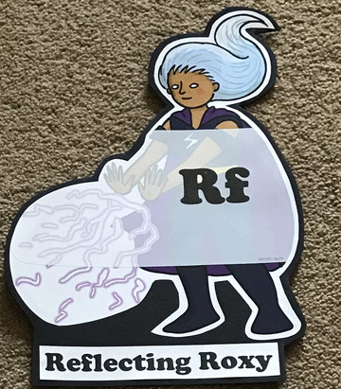  What have you learnt today and how could you have improved any of your work? | Making Links Molly 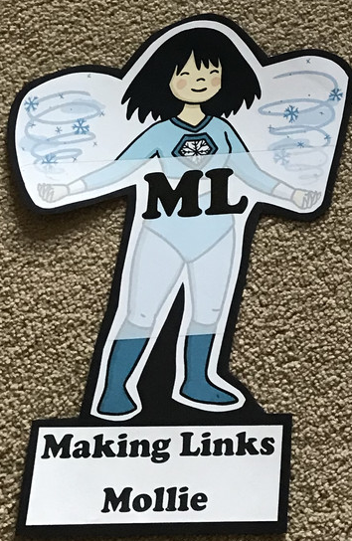  Can you use any learning that you have done today, in other parts of your life? | Resilience Rex 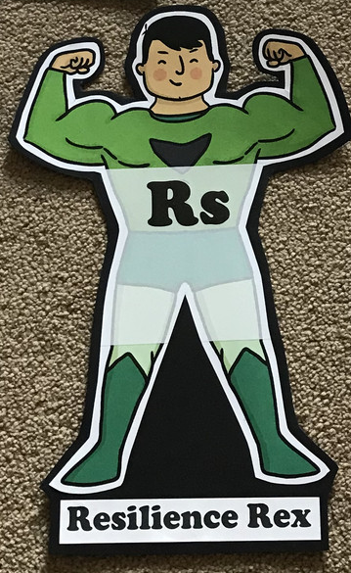  Have you found anything challenging today? How did you over come the challenges? | Collaborating Carlos 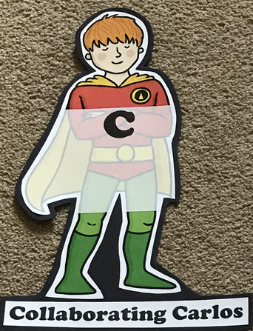  Did you work alone today or with someone else? How did that go? | Motivating Melinda 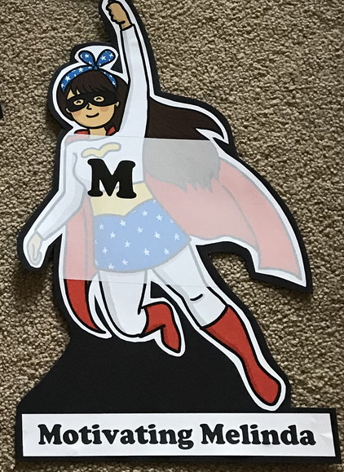  Have you encouraged someone else today? How did you motivate yourself today?

Writing

- Create your own Mr Man/Little Miss
- Alternate ending – create a story map of a favourite story then give it an alternate ending
- Jumble up a story! Take a good character from one story (Ben [Gangsta Granny]), the bad character from another story (Mr Twit) and a setting from another (Hogwarts). What happens when they meet? What could they do?
- Character profile of your favourite character
- Write a letter as one character in a story to another
- Create a beast (Beast Quest) for Tom to battle - act it out thinking about how the beast would move, describe the beast, create and describe a habitat for the beast and write a story detailing their meeting
- Write a list of interview questions for a character.
- You can invite 2 authors and their characters to dinner – who would you invite and why? Write their
Theme
- Draw your favourite character from a story and describe them
- Use music to tell a story and to create a scene/characters within the book
- Draw/collage/build the scene from your favourite book and describe it
- Put on a play acting out your favourite book or an extract from a class book
- Make props for the play/for character role play
- If you had to choose 3 best friends who are characters from a story, who would you choose and why?
- Design a library/cosy reading area where you could lose yourself in a book. What would you include and why?
- Use Purplemash 2animate to animate a scene from a story

