Colchester SSP ‘Activity at home Challenges’

Over the next few weeks it will be more important than ever for young people to keep fit and active. The SSP would like to provide you with some challenges and resources for you to try at home.

- All young people should aim to be physically active for 60 minutes each day.
- Print off these sheets and keep a log or how active you have been.
- We would encourage you to do as many of these activities in your gardens, benefiting from the fresh air, as possible.
- Please ensure you have enough room to do these activities and perform them in a safe manner.

Fitness Fun Activities | Date | Completed
Skip for 1 minute continuously x 5
Squat X 10
Hop for 30 seconds on each leg x 5
Hold plank position for 30 seconds
10 press ups on knees
Shuttle runs for 1 minute x 5
Crunch sit ups x 10
Sprint on the spot for 30 seconds x 5
Stand on one leg, eyes shut (time yourself) – perform on both legs
Jump as high as you can, then crouch down to floor x 10

Personal Challenge Skills | Date | Completed
Bounce a ball with one hand, as many times as possible, whilst on the move – perform with both left and right
Stand 2 metres from a wall, throw a ball against the wall and try to catch before it touches the floor – both hands x 10 / right hand x 10 / left hand x 10
Stand in a star shape / get a family member to stand in front of you / they must roll a ball through your legs / turn and collect the ball as quickly as possible
Keepie uppie challenge using either a racket and a ball or a football – time how long you can keep the ball in the air without dropping it
Rotate a hoop on your hand / waist / neck / leg / foot – time how long you keep it moving
Juggling challenge – use either 2 or 3 scarves or 2 or 3 balls – time how long you keep it moving
Place 6 small objects around you / stand on one leg and reach to pick them up, without falling or putting your foot on the floor
Using whatever you have at home (tiled floor, chalk, tape, etc) make a hopscotch grid and play
Using a ball, pass the ball from one hand to another around legs in a figure of eight –
x 10 one way then the other
Create your own game, which raises your heartrate and is fun to play! Teach this to your family

We have put together a list of recommended links of videos which can be followed (all are free of charge);

Change4life Activities for Children
https://www.nhs.uk/change4life

Cosmic Kids Yoga – Youtube
https://www.youtube.com/results?search_query=cosmic+yoga+

Joe Wicks Kids Workouts – Youtube
https://www.youtube.com/results?search_query=joe+wicks+kids+workout

Imoves Activities
https://imoves.com/

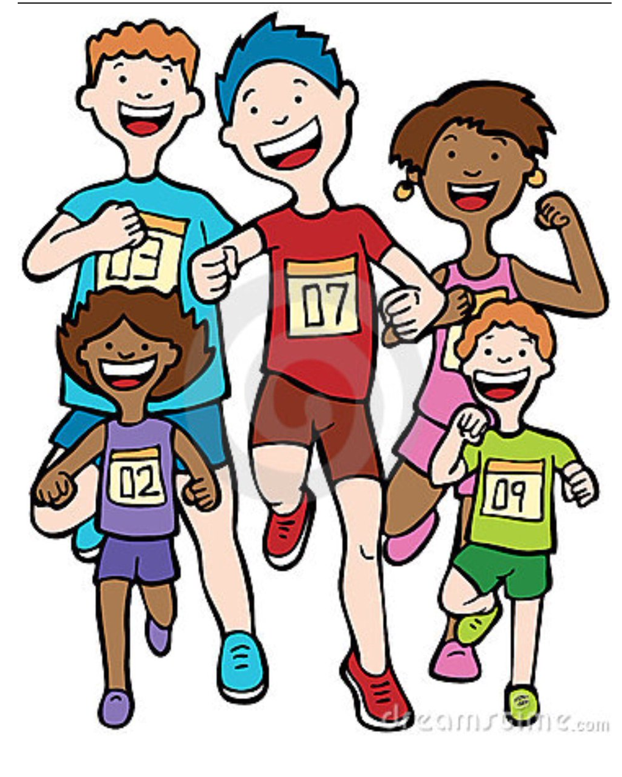
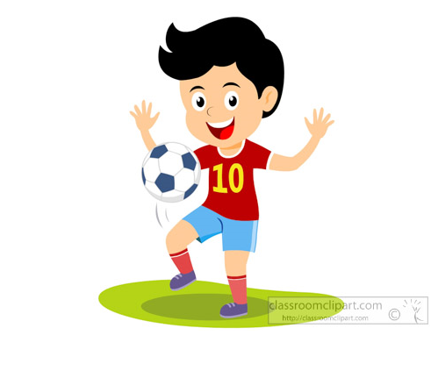
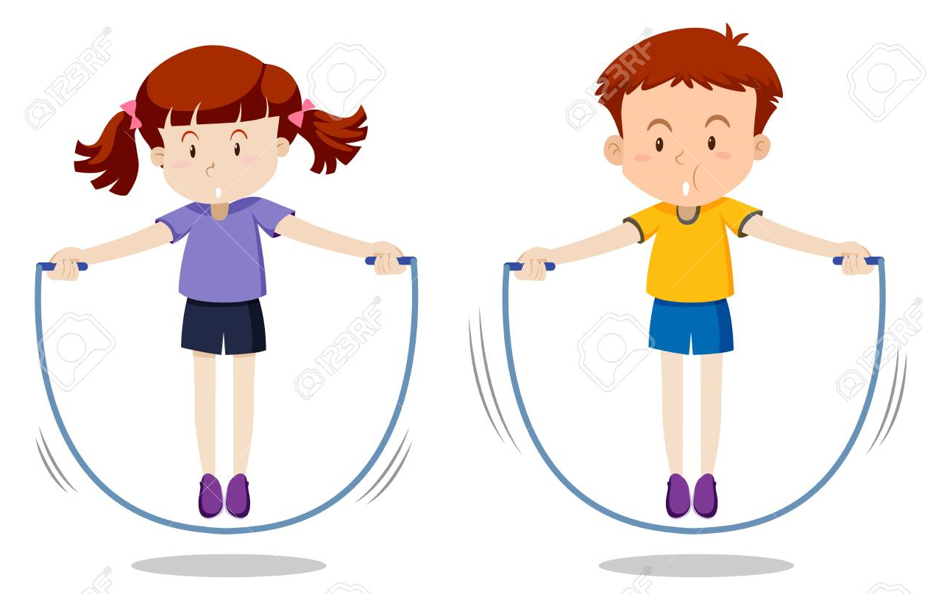
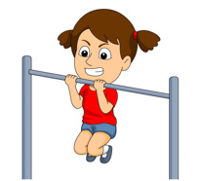
Have Fun and stay active!

