 | Monday | Tuesday | Wednesday | Thursday | Friday
9-11 | WORD OF THE DAY;  creativity - the use of imagination or original ideas to create something; inventiveness  Reading  Read ‘ The Dot’ by Peter H. Reynolds (page 6 – 23 of the document)  Discuss the story as you read then answer comprehension questions  PE  Dance – Choose a piece of music and create a movement piece to it. Think about how the music makes you feel and how you should move to it.  Maths  Insect symmetry. Draw one half of an insect. Then using a mirror or by looking carefully, reflect your drawing to create a symmetrical insect. Use examples symmetry bugs to practise. | WORD OF THE DAY;  abstract - art that seeks to achieve its effect using shapes, colours, and textures.  Reading  Use internet and books to research and read about an abstract artist (Kandinsky, Paul Klee, Miro). Share the facts you have learnt with your peers, ready to write a fact file about them.  PE  Gymnastics – Create different shapes using different point balances. Can you make a picture using your body/your groups balances?  Maths  Times tables – Number gym table trainer. Times table loop cards. Ultimate times table challenge. | WORD OF THE DAY;  unique - being the only one of its kind; unlike anything else  Reading  Read a book of your choice and share what you have read with someone. Why do you like/dislike the book? Have you learnt any new words?  PE  Joe Wicks  Maths  Sit back to back with a partner. Draw a shape, don’t show them what you are drawing, then describe it to your partner. Can they create the same drawing? Think about shapes, sizes, angles and direction. | WORD OF THE DAY;  invention - creative ability, a process or device created  Reading  Complete The Wright Brothers reading comprehension.  PE  Sports Day style activities; egg and spoon, three legged race, throwing and catching, dribbling a ball  Maths  Purple Mash – Position and Direction – 2Go and Logo programs. | WORD OF THE DAY;  craft - an activity involving skill in making things by hand  Reading  Kandinsky Reading Comprehension  PE  Cosmic Kids Yoga  Maths  Properties of 2D Shapes
11-11:15 | Break | Break | Break | Break | Break
11:15-12:15 | Writing  Choose a writing activity from the list | Writing  Choose a writing activity from the list | Writing  Choose a writing activity from the list | Writing  Choose a writing activity from the list | Writing  Choose a writing activity from the list
12:15-1:15 | Lunch | Lunch | Lunch | Lunch | Lunch
1:15-2:50 | Theme Work  Choose an activity from the list | Theme Work  Choose an activity from the list | Theme Work  Choose an activity from the list | Theme Work  Choose an activity from the list | Theme Work  Choose an activity from the list
2:50-3:15 | Reflecting Roxy 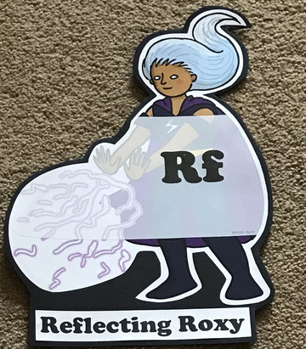  What have you learnt today and how could you havwe improved any of your work? | Making Links Molly 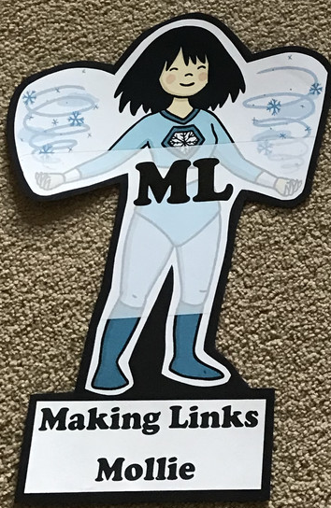  Can you use any learning that you have done today, in other parts of your life? | Resilience Rex 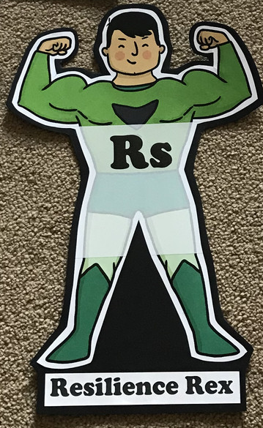  Have you found anything challenging today? How did you over come the challenges? | Collaborating Carlos 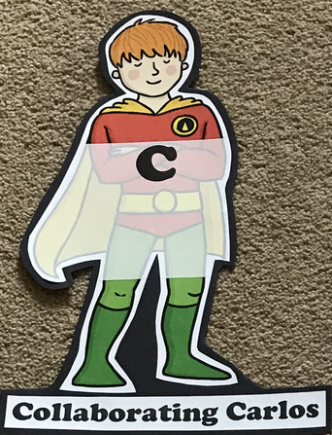  Did you work alone today or with someone else? How did that go? | Motivating Melinda 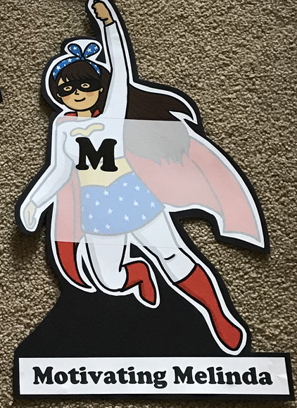  Have you encouraged someone else today? How did you motivate yourself today?

Writing

- Write a letter to Vashti from ‘The Dot’ . Share with her how you feel about being creative. Do you find it difficult or enjoyable? What’s your favourite piece of Art you’ve created? Has she inspired you to create more?
- Write an explanation text for your flying machine.
- Create a biography for yourself to be displayed with your art work. What is it important people know about you and your art?
- Write an acrostic poem using your name to describe yourself and your unique features/personality. Share it with someone else.
- Create a fact file for the abstract artist you have read about.
Theme
- Draw a self portrait. Draw a portrait of other members of your family/class and combine them together to display as a group collage. What different mediums and resources could you use to create your self portrait? Eg. Paint, collage, pastel, watercolour, sketching.
- Create a ‘abstract splatter painting’. Put a big sheet of white paper on the ground outside and gather different coloured paints. Then use your paintbrush to splatter them onto the paper. You could also use tape to mark out a shape or picture in your splatter painting.
- Invent a flying machine of any kind. Draw and label a diagram explaining how your invention works.
- Create a junk modelling piece of art to represent you or your family.
- Origami

