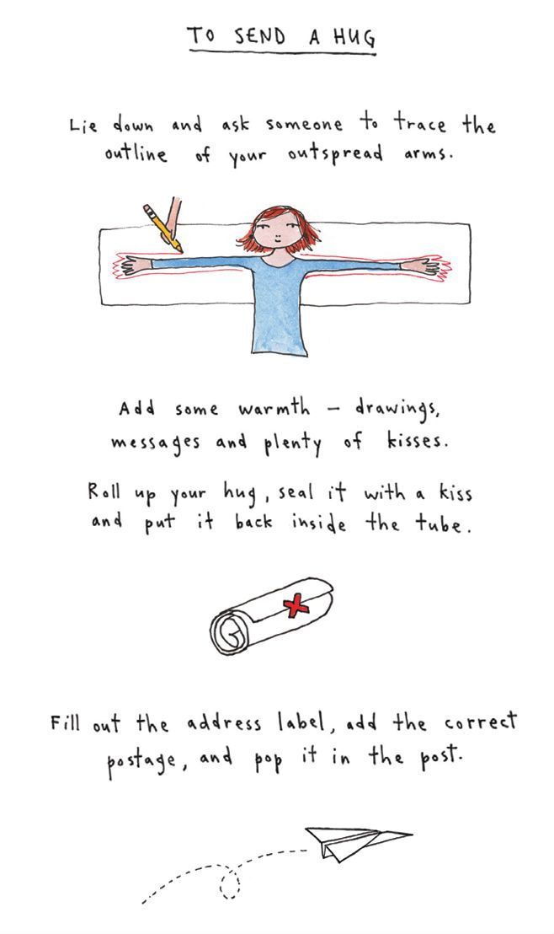

Or post it through someone’s letterbox!