 | Community Theme – Week 10 25.05.20
 | Monday | Tuesday | Wednesday | Thursday | Friday
9-9.30 | Movement  The Body Coach – Youtube on the day | Movement  https://www.youtube.com/user/CosmicKidsYoga | Movement  BBC Move it Dance Programme  https://www.bbc.co.uk/programmes/b03g64pk/episodes/player | Movement  Go outside for a walk. | Movement  The Body Coach – Youtube on the day
9.30-10 | Phonics | Phonics | Phonics | Phonics | Phonics
10-10.30 | Reading  Younger readers can read or share a text with someone. Can they write or draw what they read about? Can they answer questions about the text?  https://www.oxfordowl.co.uk/for-home/find-a-book/library-page/  username- SJGreading  password- SJGreading | Reading  Younger readers can read or share a text with someone. Can they write or draw what they read about? Can they answer questions about the text?  https://www.oxfordowl.co.uk/for-home/find-a-book/library-page/  username- SJGreading  password- SJGreading | Reading  Younger readers can read or share a text with someone. Can they write or draw what they read about? Can they answer questions about the text?  https://www.oxfordowl.co.uk/for-home/find-a-book/library-page/  username- SJGreading  password- SJGreading | Reading  Younger readers can read or share a text with someone. Can they write or draw what they read about? Can they answer questions about the text?  https://www.oxfordowl.co.uk/for-home/find-a-book/library-page/  username- SJGreading  password- SJGreading | Reading  Younger readers can read or share a text with someone. Can they write or draw what they read about? Can they answer questions about the text?  https://www.oxfordowl.co.uk/for-home/find-a-book/library-page/  username- SJGreading  password- SJGreading
11-11.15 | Break | Break | Break | Break | Break
11.15-12.15 | Maths  Number gym  http://www.numbergym.co.uk/  Appropriate calculation activity linked to year group e.g. add and subtract  See EYFS and Year 1 daily sheet. | Maths  Purple Mash  https://www.purplemash.com/login/  Shape focus – recap names of shapes. Creating your own Colour Monster shape picture.  See EYFS and Year 1 daily sheet. | Maths  Number gym  http://www.numbergym.co.uk/  Appropriate calculation activity linked to year group. EYFS/Yr1 looking at number bonds/numbers to 10  See EYFS and Year 1 daily sheet. | Maths  Purple Mash  https://www.purplemash.com/login/  See EYFS and Year 1 daily sheet. | Maths  Number gym  http://www.numbergym.co.uk/  Calculation focus – addition and subtraction  See EYFS and Year 1 daily sheet.
12.15-1.15 | Lunch | Lunch | Lunch | Lunch | Lunch
1.15-2.50 | Theme Work  See daily plan | Theme Work  See daily plan | Theme Work  See daily plan | Theme Work  See daily plan | Theme Work  See daily plan
2.50-3.15 | Reflecting Roxy 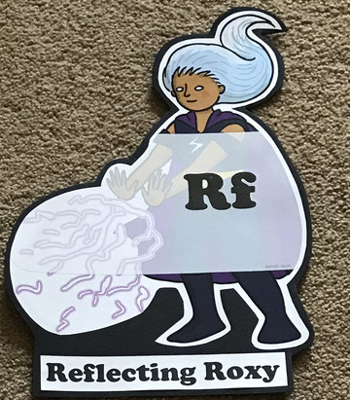  What have you learnt today and how could you have improved any of your work?  STORY TIME | Making Links Molly 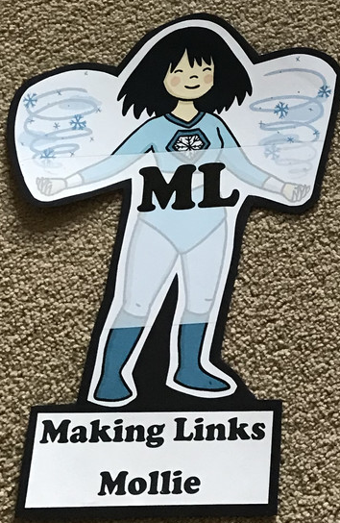  Can you use any learning that you have done today, in other parts of your life?  STORY TIME | Resilience Rex 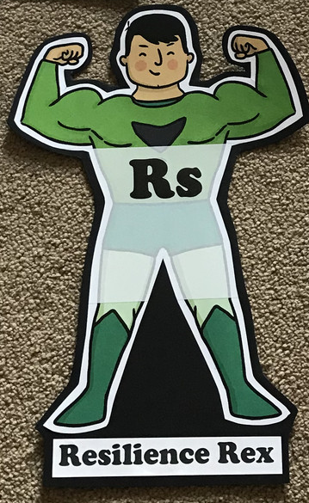  Have you found anything challenging today? How did you overcome the challenges?  STORY TIME | Collaborating Carlos 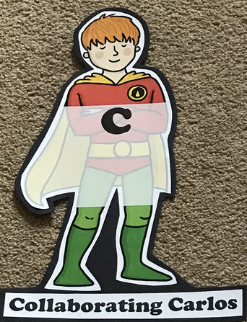  Did you work alone today or with someone else? How did that go?  STORY TIME | Motivating Melinda 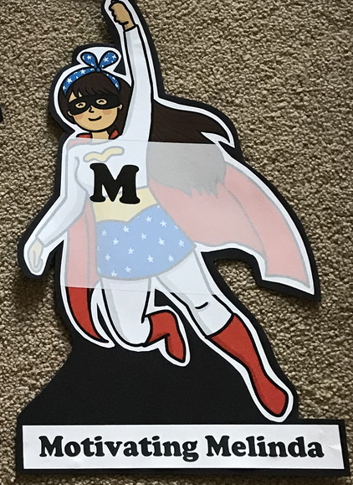  Have you encouraged someone else today? How did you motivate yourself today?  STORY TIME

Theme Ideas
Community- here are some ideas of what the children could learn/discover about their community.
- Where do you live? Children could create a poster, map or fact file about Colchester- Year 1 could talk about some of the historical landmarks we have visited.
- Who helps us in the community?- we have attached some sheets to support this.
- Learn about Florence Nightingale linked to nurses and the NHS
- Create your own emergency vehicle
- Create a community board game to play
- Create a piece of writing on Colchester Zoo- how can we help support the zoo?
Maths
This week, we would like the children to focus on measurement. Here are some ideas and resources to help you.
- Make a cake and record how much of an ingredient you used.
- Find some different bowls, jugs etc and see how many cups of water fit into them.
- Weigh some items around your house and guess whether something is lighter or heavier.
- Compare two/three objects in your house and see which one is longer or shorter.
- Measure each other or objects around the house using a ruler.

EYFS/YEAR 1- WEEK 10- Community
Monday
Phonics
EYFS
Words to practise
fair, hair, chair, Pair, stair
Tricky words
They, all, her

Challenge
Can you write some sentences with these words in?
Phonics
Sound of day-
Air
That’s not fair

YEAR 1
Words to practise
Hide, stride, spike, hike
Alien words
Blibe , yide, kile, nife

Phonics
Sound of day-
i-e
nice smile
Tricky words
They, all, her

Challenge
Can you write some sentences with these words in?

Tuesday
Phonics
EYFS
Phonics
Sound of day-
Ure
Sure it’s pure
Words to practise

Sure, pure, manure, cure

Tricky words
They, all, her

Challenge
Can you write some sentences with these words in?

YEAR 1
Words to practise
Bone, tone, alone, prone, stone
Alien words
Blone, krone, done, ballone

Phonics
Sound of day-
o-e
phone home
Tricky words
They, all, her

Challenge
Can you write some sentences with these words in?

Wednesday
Phonics
EYFS
Words to practise
Better, letter, mermaid, person
Tricky words
They, all, her

Challenge
Can you write some sentences with these words in?
Phonics
Sound of day-
Er
A better letter

YEAR 1
Words to practise
Huge, mute, flute

Alien words
Jute, prute, shute

Tricky words
They, all, her

Challenge
Can you write some sentences with these words in?
Phonics
Sound of day-
u-e
huge brute

Thursday
Phonics
EYFS
Phonics
Recap all of the sounds from phase 3
Focus on sounds they find tricky
Tricky words
They, all, her
Words to practise
Use words from previous weeks
Challenge
Can you write some sentences with these words in?

YEAR 1
Words to practise
Grow, show, mow, flowing, blown

Tricky words
They, all, her
Challenge
Can you write some sentences with these words in?
Phonics
Sound of day-
Ow
Blow the snow

