How to upload your work to assignments

1) Click on assignments at the top of your page and click the assignment you need to do.
2) Click on the link to see your work and download if you are printing otherwise you can click on it to see it and write on a piece of paper.

3) When you are finished, click add work.

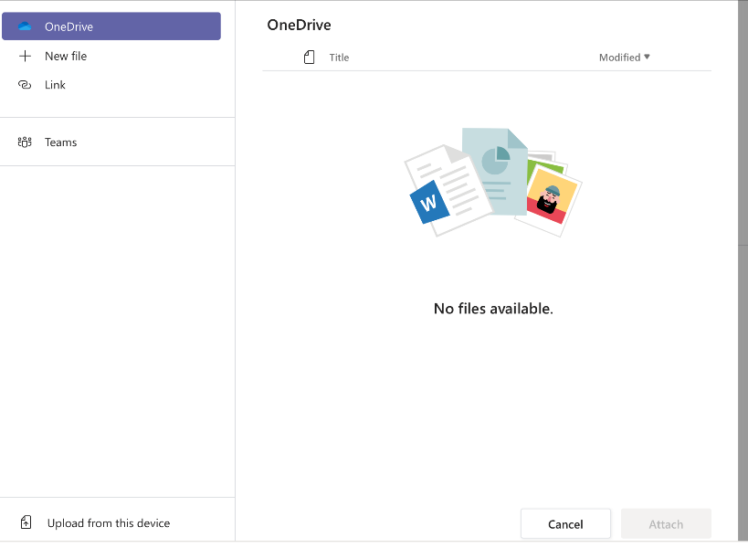
4) Then click on upload from this device.

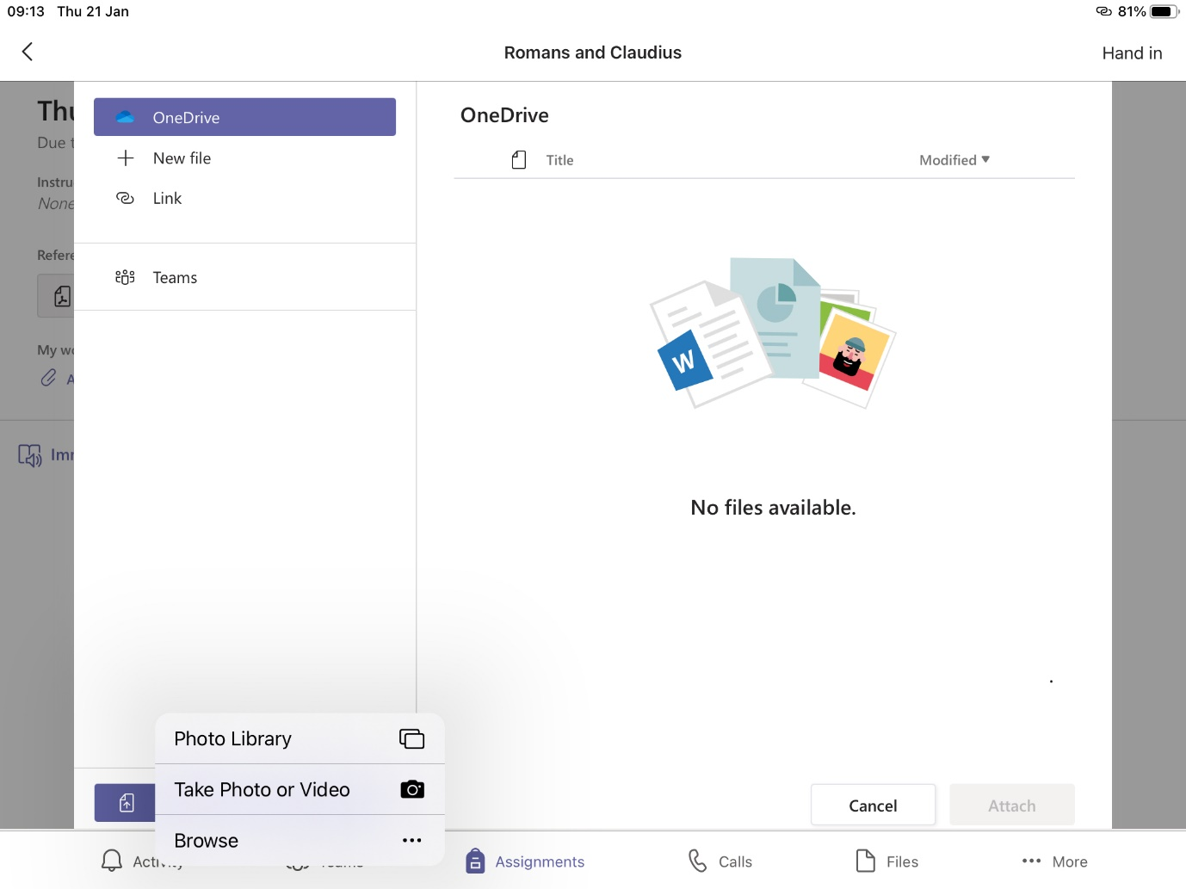
5) Either upload file, or take a picture of your work.

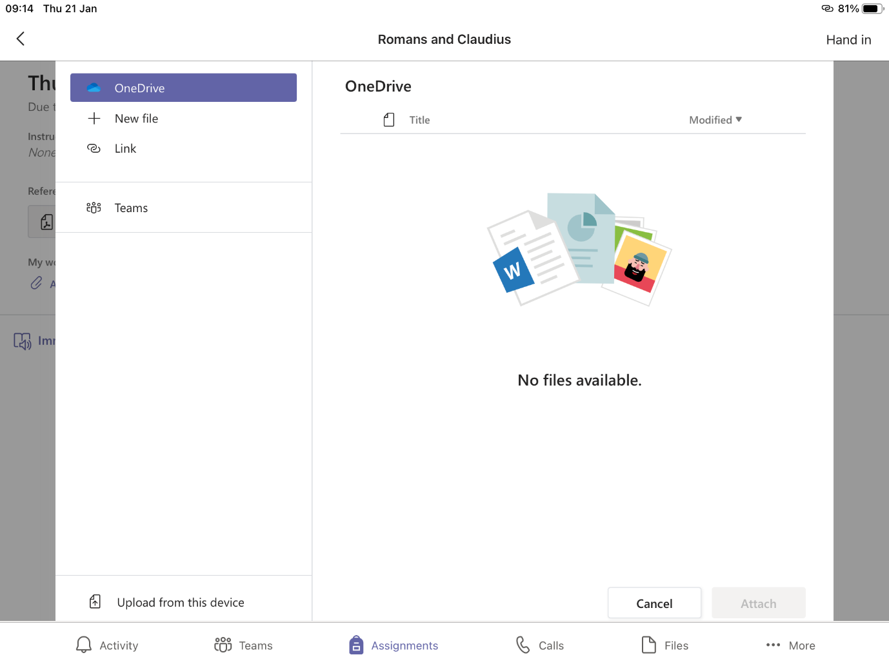
6) When you have chosen the picture or file click attach.

6) Finally click hand in.

