 | Discovery Theme – Week 8 11.05.2020
 | Monday | Tuesday | Wednesday | Thursday | Friday
9-11 | WORD OF THE DAY; Introduce a new word, find out the meaning, use it in conversation, can you draw something to help you remember the word and / or how to spell it? Find out the origin, are there words which mean the same? Use it in written sentences.  Discovery - The act of detecting something new, or something previously unrecognized as meaningful.  Reading  Read Deep Sea Explorers and answer questions.  Writing  Choose from the list. | WORD OF THE DAY; Introduce a new word, find out the meaning, can you draw something to help me remember the word and / or how to spell it? Can you use it in conversation, find out the origin, are there words which mean the same? Use it in written sentences.  Locate – Discover the exact place or position of.  Reading  Complete 30 minutes of reading.  Writing  Choose from the list. | WORD OF THE DAY  Introduce a new word, find out the meaning, can you draw something to help me remember the word and / or how to spell it? Can you use it in conversation, find out the origin, are there words which mean the same? Use it in written sentences.  Identify - Establish or indicate who or what (someone or something) is.  Reading  Read Christopher Columbus and answer questions  Writing  Choose from the list. | WORD OF THE DAY;  Introduce a new word, find out the meaning, can you draw something to help me remember the word and / or how to spell it? Can you use it in conversation, find out the origin, are there words which mean the same? Use it in written sentences.  Describe - Give a detailed account in words of something or someone.  Reading  Read Ernest Shackleton and answer questions  Writing  Choose from the list. | WORD OF THE DAY;  Introduce a new word, find out the meaning, can you draw something to help me remember the word and / or how to spell it? Can you use it in conversation, find out the origin, are there words which mean the same? Use it in written sentences.  Compare - To examine (two or more objects, ideas, people, etc.) in order to note similarities and differences.  Reading  Visit Mary Rose Website and read information on ships  Maryrose.org  Writing  Choose from the list.
 | Movement  The Body Coach – YouTube – find the current day | Movement  https://www.youtube.com/user/CosmicKidsYoga  Cosmic Yoga  (YouTube) | Movement  The Body Coach – YouTube - find the current day | Movement  Go outside for a walk. | Movement  The Body Coach – YouTube on the day
11-11.15 | Break | Break | Break | Break | Break
11.15-12.15 | Maths  White Rose Maths (Home Learning Tab) Watch video and download related questions.  https://whiterosemaths.com/homelearning/ | Maths  Number gym  http://www.numbergym.co.uk/  Appropriate calculation activity linked to year group e.g. multiplication and division 2/3/4/5/6. | Maths  White Rose Maths (Home Learning Tab) Watch video and download related questions.  https://whiterosemaths.com/homelearning/ | Maths  Number gym  http://www.numbergym.co.uk/  Appropriate calculation activity linked to year group e.g. multiplication and division 2/3/4/5/6. | Maths  White Rose Maths (Home Learning Tab) Watch video and download related questions.  https://whiterosemaths.com/homelearning/
12.15-1.15 | Lunch | Lunch | Lunch | Lunch | Lunch
1.15-2.50 | Theme Work  Choose from the list. | Theme Work  Choose from the list. | Theme Work  Choose from the list. | Theme Work  Choose from the list. | Theme Work  Choose from the list.
2.50-3.15 | Reflecting Roxy 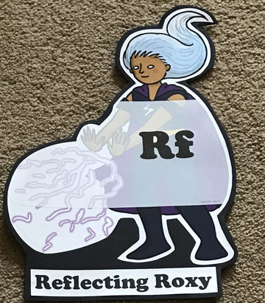  What have you learnt today and how could you have improved any of your work?  STORY TIME | Making Links Molly 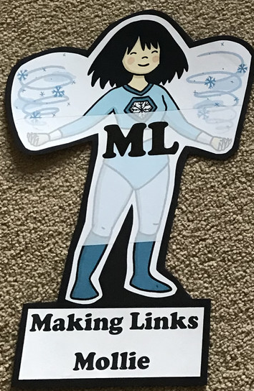  Can you use any learning that you have done today, in other parts of your life?  STORY TIME | Resilience Rex 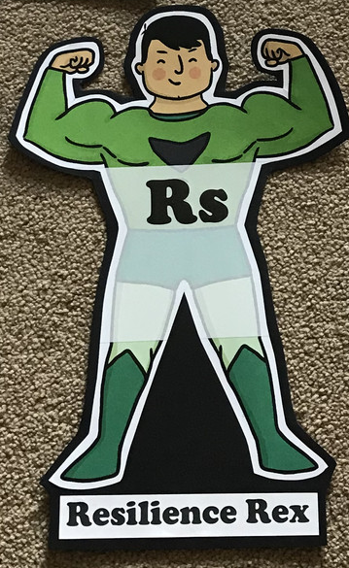  Have you found anything challenging today? How did you overcome the challenges?  STORY TIME | Collaborating Carlos 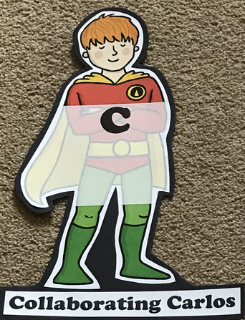  Did you work alone today or with someone else? How did that go?  STORY TIME | Motivating Melinda 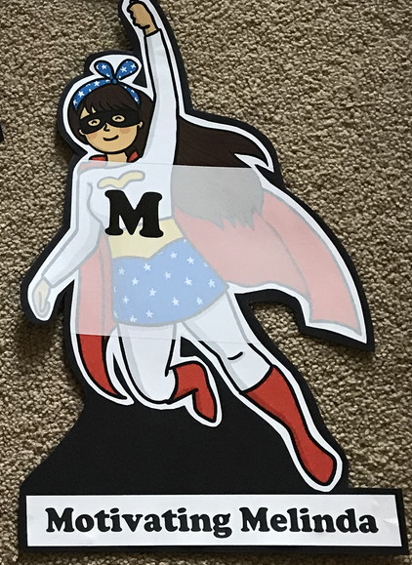  Have you encouraged someone else today? How did you motivate yourself today?  STORY TIME

