Week 1 | WEEK 2 | Week 3 | Week 4 | Week 5
Theme;  Family and Friends | Theme; Aspirations | Theme;  Money and Enterprise | Theme; Nature | Theme; Fantasy
- Look at and create your family tree  - Heritage  - History of your home  - Make an information poster about your culture and family traditions  - Look at your links with the wider world; where have I visited in the world? Who do I know around the world?  - Cooking from your culture, try different cultural recipes, weigh and measure ingredients… | - Create a VISION BOARD  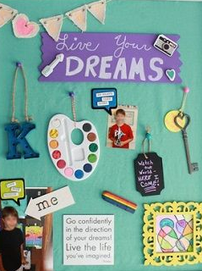  - What are my dreams and goals?  - What do I want? How will I get there? What does that look like?  - Ask family and friends for inspirational stories.  - A day in the life of a… | - What is a budget?  - Where is money kept?  - What are wages?  - What is tax?  - Write out a family meal plan- make the shopping list- estimate and work out costs.  - Plan a party…what will I need? What will it cost?  - https://www.j2e.com/j2data/  - Purple Mash has ‘budget’ activities  - Enterprise ideas to try at home…  - Create an invention/business idea (think Dragon’s Den)  - Find out what enterprise is • Why teamwork is important in business and with business ideas • How to develop business ideas • How to check whether the idea will work • Running a Dragons Den • How to market and sell | - Go outside  - Look at the changing season  - What wildlife do you see?  - Tally chart or plants/animals  - Identify different plants  - Sketch what you see; plants, scenery…  - Collect interesting items and make a piece of art work  - Take photos and make collages | - Pobble http://www.pobble365.com/  has many fantastical images; recreate one using art work, write a fantasy story based on a familiar narrative (book, film, music video, computer game (age appropriate) …  Build a den (inside or outside)  - Plan it first  - Draw a map on how to get there  - Use a coordinate grid for your den/home  - Which characters live in your den?  - Are there any rules in your den?  Create a fantasy character; where do they live? What do they look like? Personality traits? Wanted poster?  Make a comic strip which has a fantasy theme…
ON-GOING LEARNING
Use this time to teach life skills!
- How to cook…
- How to do the washing/laundry…
- Can you help tidy the home?
- Can your child make a chores rota for the home?
- Teach your child/children skills that you were taught as a child (knitting, sewing, baking, art, playing music, chess, board games, fixing a flat type, gardening…)

