Choose a couple of these activities to do at home independently or with a family member.
Fantasy – Describe the fantasy character
Remember your FANTASTICs: feeling, asking, noticing, touching, action, smelling, tasting, imagining, checking.
When complete, read it to a member of the family and get them to draw it using your written description. Was your description accurate enough for your audience to see the correct image in their head and draw it correctly?
Consider the diet and habitat of your character.
Design the fantasy world
Design a fantasy world for your character to live in and write a description of what it is like, use the following link for inspiration
https://www.twinkl.co.uk/go/resource/creative-writing-stimulus-fantasy-hotspots-tg2-e-55

Plot the layout of the town/ island where the character lives (a bird’s eye view)
Consider …
Where your character goes to get food?
Where does it sleep?
Are there any unusual features to your town?

Read some fantasy stories and draw your favourite characters
Find WAGOLL attached, link or read any fantasy stories you may have from home.
https://www.twinkl.co.uk/resource/t2-e-4535-the-wyrmstooth-crown-ebook

Create a magic spell – write the ingredients, instructions and describe the effects

Write an acrostic poem for FANTASY
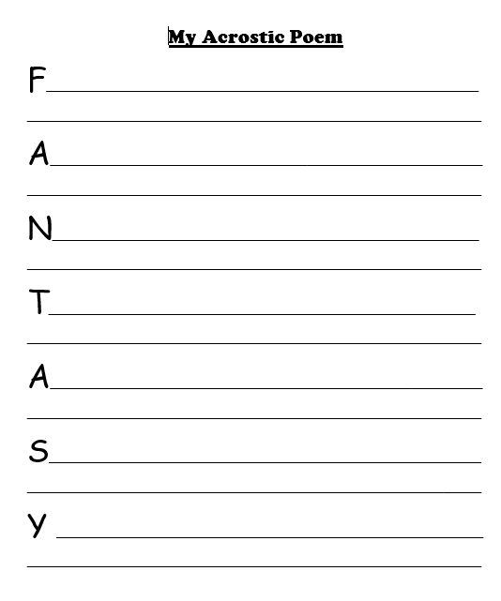

Write a story involving your character using the following story map and resources
