Spellings

Practise your spellings, ready for your test tomorrow

valley
chimney
donkey
journey
monkey
trolley
turkey
hockey

Try different ways to practise your spellings
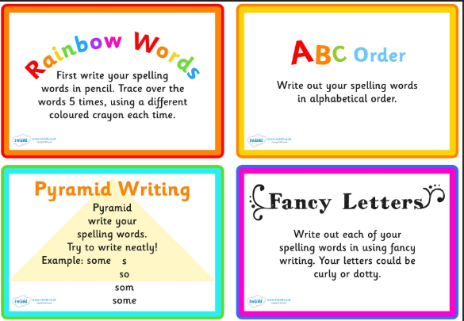

Times tables

0 x 2 =  1 x 2 =  2 x 2 =  3 x 2 =  4 x 2 =  5 x 2 =  6 x 2 =  7 x 2 =  8 x 2 =  9 x 2 =  10 x 2 =  11 x 2 =  12 x 2 = | 0 x 3 =  1 x 3 =  2 x 3 =  3 x 3 =  4 x 3 =  5 x 3 =  6 x 3 =  7 x 3 =  8 x 3 =  9 x 3 =  10 x 3 =  11 x 3 =  12 x 3 = | 0 x 4 =  1 x 4 =  2 x 4 =  3 x 4 =  4 x 4 =  5 x 4 =  6 x 4 =  7 x 4 =  8 x 4 =  9 x 4 =  10 x 4 =  11 x 4 =  12 x 4 =

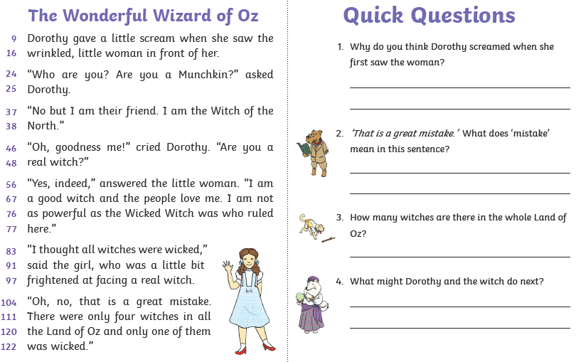
Comprehension

