Wellbeing Theme – Week 6 27.04.20
Don’t forget to take photos of all the different things you are doing. If you have a scrapbook, notebook or folder you can keep all your work and photos together. Remember to email pictures of your learning into school so we can see what fun you are having!
Project – Can you create a Time capsule?
 | Monday | Tuesday | Wednesday | Thursday | Friday
9-11 | WORD OF THE DAY  Introduce a new word, find out the meaning, use it in conversation, can you draw something to help you remember the word and / or how to spell it? Find out the origin, are there words which mean the same? Use it in written sentences.  WELLBEING  Reading  Read ‘Coronavirus for Children story  https://nosycrow.com/blog/released-today-free-information-book-explaining-coronavirus-children-illustrated-gruffalo-illustrator-axel-scheffler/  Writing  Choose an activity from the list. | WORD OF THE DAY  Introduce a new word, find out the meaning, can you draw something to help me remember the word and / or how to spell it? Can you use it in conversation, find out the origin, are there words which mean the same? Use it in written sentences.  FIXED MINDSET  Reading  Reader’s choice- Complete 15 minutes of reading.  Writing  Choose an activity from the list. | WORD OF THE DAY  Introduce a new word, find out the meaning, can you draw something to help me remember the word and / or how to spell it? Can you use it in conversation, find out the origin, are there words which mean the same?  GROWTH MINDSET  Reading  Read ‘The Colour Monster’  https://www.storyjumper.com/book/read/34461616/The-colour-Monster#  Writing  Write a diary entry about how you are feeling today. Which colours are you? Why? | WORD OF THE DAY  Introduce a new word, find out the meaning, can you draw something to help me remember the word and / or how to spell it? Can you use it in conversation, find out the origin, are there words which mean the same? Use it in written sentences.  HEALTHY  Reading  Reading comprehension  ‘Children’s Mental Health Week’  Writing  Choose an activity from the list. | WORD OF THE DAY  Introduce a new word, find out the meaning, can you draw something to help me remember the word and / or how to spell it? Can you use it in conversation, find out the origin, are there words which mean the same? Use it in written sentences.  HAPPINESS  Reading  Reader’s Choice- Complete 15 minutes of reading.  Writing  Write a thanks you letter to a key worker or someone else who has inspired you these last few weeks.
 | Movement  https://www.youtube.com/user/CosmicKidsYoga  Cosmic Yoga  (YouTube) | Movement  https://www.youtube.com/user/CosmicKidsYoga  Cosmic Yoga  (YouTube) | Movement  https://www.youtube.com/user/CosmicKidsYoga  Cosmic Yoga  (YouTube) | Movement  https://www.youtube.com/user/CosmicKidsYoga  Cosmic Yoga  (YouTube) | Movement  Go outside for a walk or bike ride.
11-11.15 | Break | Break | Break | Break | Break
11.15-12.15 | Maths  Complete a whiterose maths activity-Week 1. https://whiterosemaths.com/homelearning/year-3/ | Maths  Number gym  http://www.numbergym.co.uk/  Table Trainer, Bond Builder | Maths  Purple mash- Multiplication Monster- times table practise. | Maths  Purple Mash- Bond Bubbles- number bond practise. | Maths  Purple Mash- Funky Platform- calculation practise.
12.15-1.15 | Lunch | Lunch | Lunch | Lunch | Lunch
1.15-2.50 | Theme Work  Choose an activity from the list. | Theme Work  Choose an activity from the list. | Theme Work  Choose an activity from the list. | Theme Work  Choose an activity from the list. | Theme Work  Choose an activity from the list.
2.50-3.15 | Reflecting Roxy 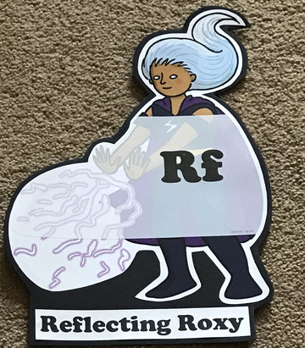  What have you learnt today and how could you have improved any of your work?  STORY TIME/  Wellbeing calendar | Making Links Molly 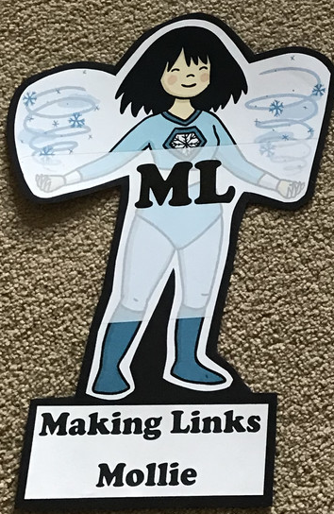  Can you use any learning that you have done today, in other parts of your life?  STORY TIME/  Wellbeing calendar | Resilience Rex 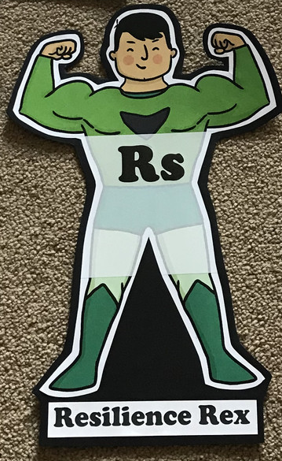  Have you found anything challenging today? How did you overcome the challenges?  STORY TIME/  Wellbeing calendar | Collaborating Carlos 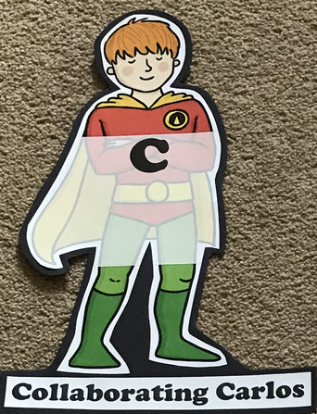  Did you work alone today or with someone else? How did that go?  STORY TIME/  Wellbeing calendar | Motivating Melinda 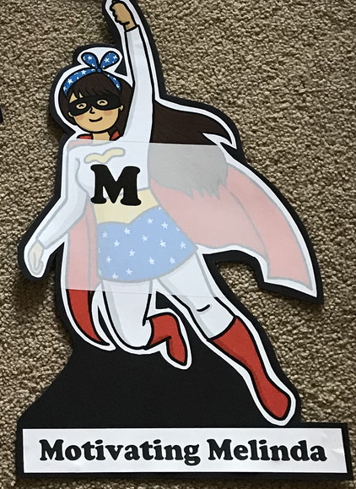  Have you encouraged someone else today? How did you motivate yourself today?  STORY TIME/  Wellbeing calendar

Reading
Read ‘The Colour Monster’ by Silvia Goni & Sarai Ruano https://www.storyjumper.com/book/read/34461616/The-colour-Monster#
- Reading comprehension- Children’s Mental Health Week
- Complete an activity from the Reading Activity booklet about the book which you are reading

Writing
- POBBLE 365 http://www.pobble365.com/ Choose one of the images and write a descriptive paragraph about it.
- Keep a positive thoughts journal for everyday of the week. Try to focus on 3 positive things that have happened in your day.
- Describe the colour monster- write as if you are the monster
- Create an acrostic poem using the word RAINBOW or choose a keyworker to write an acrostic poem about like NURSE.
- Write a letter to a family member or friend you are missing or thanking Key workers for their efforts
- Write a letter of thanks/draw a picture for a Key worker or inspirational person (e.g. Joe Wicks)

Theme
- Create your own colour monster! Choose colours that might represent them (e.g. frustration, disgust, envy). You could use the template provided, draw your own or even make it out of playdough or recycled materials!
- Go for a walk and collect some rocks/ large pebbles. Decorate it with a positive message. When you go for a walk again, leave the rock in a special place for someone to find. Whilst on the walk, have a look around for things that make you happy and fill a discovery jar with interesting and beautiful things.
- ‘Things to look forward to’ jar
- Cosmic Yoga
- Making Negative thoughts into positive thoughts
- Mindfulness challenge cards
- Mindfulness breathing
- Make a Covid-19 time capsule - what will people in the future think of this unique situation?

