Remote Learning - EYFS
Wednesday 3rd March 2021
Below is a timetable guide of what we will be teaching today and the follow up activities for you to complete. The chat function will be available for any questions related to the learning
9.30AM LIVE Registration and Letters and Sounds
Children will need something to write with if possible.
Following onto LIVE Literacy
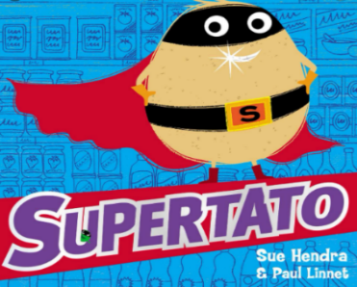
Follow up activity:
ABC

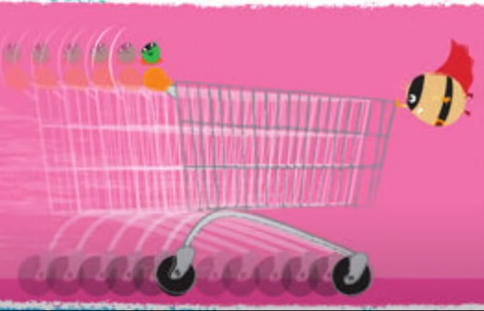
Encourage children to write a simple sentence using their phonic knowledge about the picture below.

- Think of your sentence.
- Say the sentence aloud.
- Use your sounds to write the sentence.
- Put a capital letter at the start of your sentence.
- Use Finger spaces in-between every word.
- Put a full stop at the end of your sentence.
- Check your sentence using the Writers Toolkit.

Short brain break videos
I am the Music Man: https://www.youtube.com/watch?v=22kqia2ibVU
Get Funky: https://www.youtube.com/watch?v=w6YbSxMhsQ0
11.30 AM LIVE Mathematical Development
Number bonds to 10
Watch number bond to 10 Astronaut song https://www.youtube.com/watch?v=YdPA2YHIdqU
Go through the Numicom Number Bonds PP
Model using Numicom how to find the missing number by placing the Numicom pieces over the 10 piece.

Follow up activity:
- Complete the Numicom Challenge Sheet.
Short brain break videos
Cosmic Yoga: https://cosmickids.com/watch/ (choose a clip that you would like to participate in).
** Supertato Yoga - https://www.youtube.com/watch?v=Zo5fCFgGPpg **
1.15 PM LIVE registration

Please bring any learning from this morning that you would like share with everyone.

Follow onto LIVE afternoon activity Expressive Art and Design
Watch - Lets be Superheroes - https://www.youtube.com/watch?v=Py4fhsx3Ct4
Today we are going to make our masks and cuffs to carry on our personal superhero uniform for our dress up day.

Model using toilet rolls for cuffs and planning and designing masks.

Follow up activity:
- Design own superhero cuff and mask using templates.
- Watch the clip on how to create a mask. https://www.youtube.com/watch?v=-5dvnCJcFDg
- *** When you can ask your parents to help you make your mask. (If you could do this parents this would be lovely for our dress up day) ***

  - LIVE Story

- Bring a teddy, a blanket, and a drink to listen to the story, to end the day calmly.

* Throughout the week individual Team calls for a short 1:1 reading session will happen *

