1) Complete the table
Shape | Name | Number of faces | Draw the faces | Edges
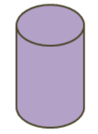
2) Can you name some real life shapes for the following 3D shape?

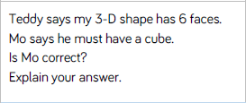
3)
I think he is ____________because I know that____________________________________________________________________________________________.

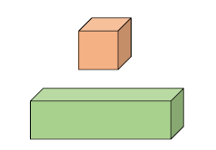
4) What is the same and what is different about these two shape? Use faces and edges in your explanation.
Different
____________________________________________________________________________________________________

Same
____________________________________________________________________________________________________

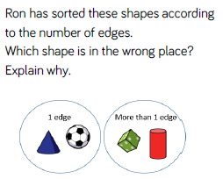
Challenge 1
____________________________________________________________________________________________________________________________________________________

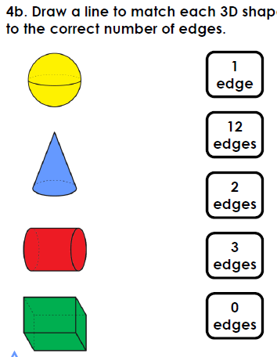
Challenge 2

Challenge 4:
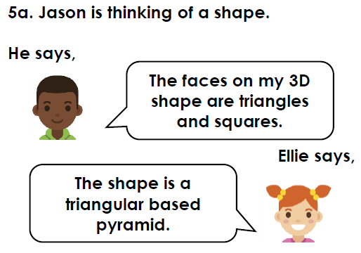
____________________________________________________________________________________________________________________________________________________________________________________________________
Is Ellie correct? How do you know?

