 | Sport Theme – Week 12 Years 4/5/6 15.6.20
 | Monday | Tuesday | Wednesday | Thursday | Friday
9-11 | WORD OF THE DAY  Introduce a new word, find out the meaning, use it in conversation, can you draw something to help you remember the word and / or how to spell it? Find out the origin, are there words which mean the same? Use it in written sentences.  opponent  Roger Federer's opponent in the Wimbledon final was Rafael Nadal.  the person one competes against in a contest or a game; rival Reading  Complete a reading comprehension from the pack  Writing  Choose an activity from the list. | WORD OF THE DAY  Introduce a new word, find out the meaning, can you draw something to help me remember the word and / or how to spell it? Can you use it in conversation, find out the origin, are there words which mean the same? Use it in written sentences.  athlete  Most professional athletes spend hours every day in training.  a person who trains for and competes in a sport  Reading  Complete 30 minutes of reading.  Writing  Choose an activity from the list. | WORD OF THE DAY  Introduce a new word, find out the meaning, can you draw something to help me remember the word and / or how to spell it? Can you use it in conversation, find out the origin, are there words which mean the same?  champion  The boxer Muhammad Ali was World Heavyweight Champion three times.  a top-rated, highly successful player  Reading  Choose another reading comprehension from the pack.  Writing  Choose an activity from the list. | WORD OF THE DAY  Introduce a new word, find out the meaning, can you draw something to help me remember the word and / or how to spell it? Can you use it in conversation, find out the origin, are there words which mean the same? Use it in written sentences.  compete  Over 10,000 athletes will compete in the Olympic Games.  to take part in a contest or a competition  Reading  Complete 30 minutes of reading.  Writing  Choose an activity from the list. | WORD OF THE DAY  Introduce a new word, find out the meaning, can you draw something to help me remember the word and / or how to spell it? Can you use it in conversation, find out the origin, are there words which mean the same? Use it in written sentences.  strategy  One of the jobs of the manager or coach is to develop a strategy for winning each game.  a plan to achieve an objective  Reading  Choose another reading comprehension from the pack.  Writing  Choose an activity from the list.
 | Movement  The Body Coach – YouTube – find the current day | Movement  https://www.youtube.com/user/CosmicKidsYoga  Cosmic Yoga  (YouTube) | Movement  The Body Coach – YouTube - find the current day | Movement  Go outside for a walk. | Movement  The Body Coach – YouTube on the day
11-11.15 | Break | Break | Break | Break | Break
11.15-12.15 | Maths  White Rose (Home Learning Tab)  https://whiterosemaths.com/homelearning/  Watch video and answer questions. | Maths  Number gym  http://www.numbergym.co.uk/  Calculation activity linked to year group e.g. multiplication and division, addition and subtraction | Maths  White Rose (Home Learning Tab) https://whiterosemaths.com/homelearning/  Watch video and answer questions. | Maths  Number gym  http://www.numbergym.co.uk/  Table Trainer, Bond Builder | Maths  White Rose (Home Learning Tab) https://whiterosemaths.com/homelearning/  Watch video and answer questions.
12.15-1.15 | Lunch | Lunch | Lunch | Lunch | Lunch
1.15-2.50 | Theme Work  Choose an activity from the list. | Theme Work  Choose an activity from the list. | Theme Work  Choose an activity from the list. | Theme Work  Choose an activity from the list. | Theme Work  Choose an activity from the list.
2.50-3.15 | Reflecting Roxy 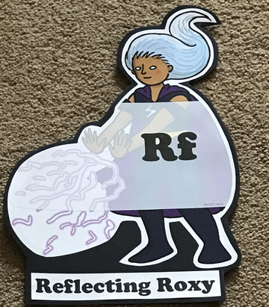  What have you learnt today and how could you have improved any of your work?  STORY TIME | Making Links Molly 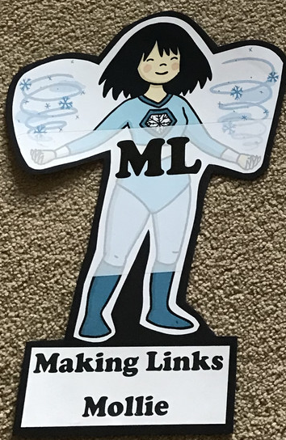  Can you use any learning that you have done today, in other parts of your life?  STORY TIME | Resilience Rex 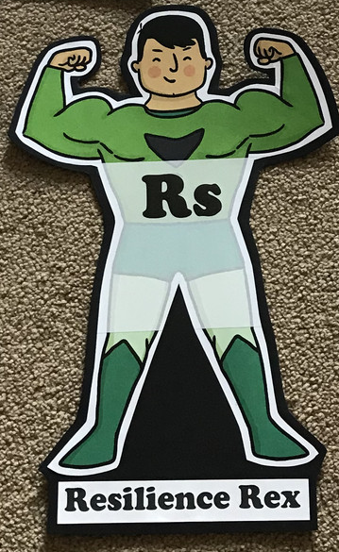  Have you found anything challenging today? How did you overcome the challenges?  STORY TIME | Collaborating Carlos 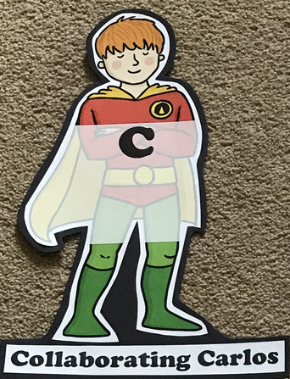  Did you work alone today or with someone else? How did that go?  STORY TIME | Motivating Melinda 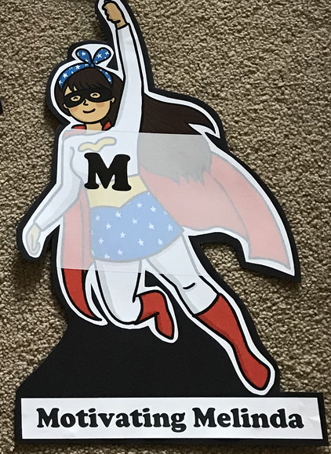  Have you encouraged someone else today? How did you motivate yourself today?  STORY TIME

Writing
- Write a newspaper report based on a famous sporting event. Use some of the following clips, to inspire you… https://www.youtube.com/watch?v=kE7D7qFayVg Greatest Sports Moments
- Write a biography about a sports person who your find inspirational
- Write instructions for a new sports / game
- 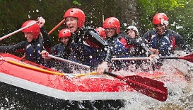Use an image like this, write a recount as one of the people.
- Write a response to this question;
“ Do the Paralympics give the message that disabled athletes should not compete in the 'real' Olympics: is this discriminatory?”
- Write a factual report about the origins and history of the Olympics and /or Paralympics
Theme
- Invent a new sport and write the rules
- Write/an imaginary sport e.g. Quidditch in Harry Potter
- Research a famous sportsperson that you admire; write a fact file
- Find out about a sport that you are unfamiliar with
- Film yourself doing a Joe Wicks-style workout
- Measure the impact that sport has on your heartbeat
- Find out about how the heart works
- Create a poster encouraging people to stay fit
- Find someone who likes a different sport to you and hold a debate/write an argument
- Find out about the history of the Olympics
- Create an obstacle course and time your family completing it – compare your times, can you get faster?

