Snow animals
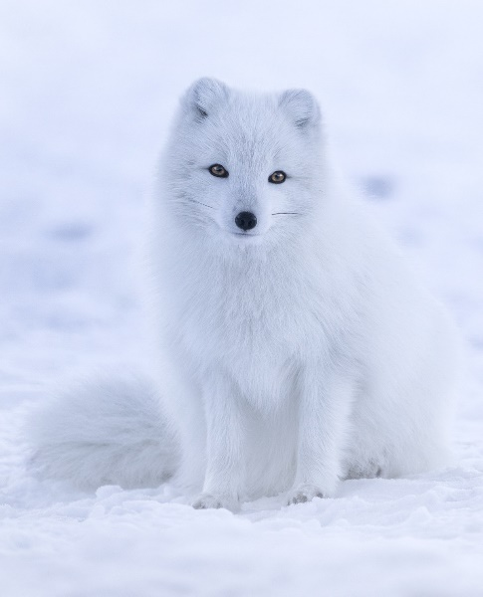
Have you ever wanted to learn more about snow animals and the secrets behind them? Well, this factual text is for you. It has all the fascinating facts that you will need to impress anyone.

Artic foxes
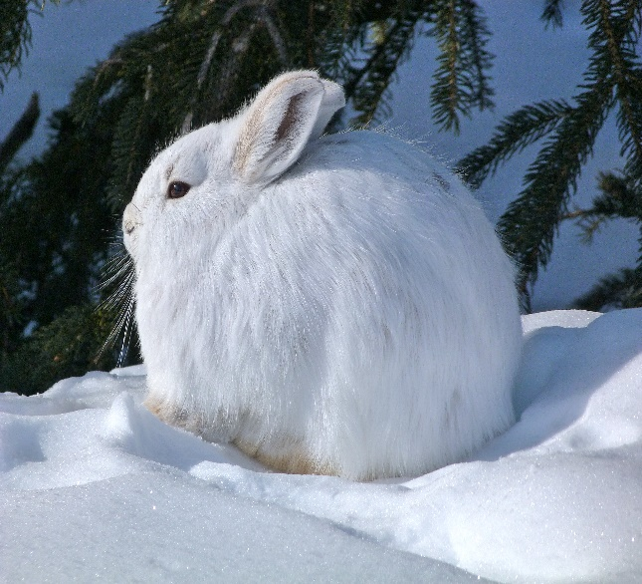
Artic foxes are amazing animals. How they survive a snowy season is incredible. You might spot one if you travel to Alaska. When it is not winter, Artic foxes feed off of Lemmings and Voles but when chilly weather kicks in they disappear. Once they have found a good spot for food, a red fox is likely to be nearby. Although a red fox is 2 times the Artic fox’s size, it has an advantage. This fantastic fox is super speedy so it can make a run for it at any time. Snow hair Snow hairs have an amazing ability. They can change colour depending on the season. When it is winter, they have a silky, pure white fur coat that allows them to blend with the landscape behind them. If it thinks it has been seen by a prey it has a getaway plan. Thanks to its legs, it is likely to get away because it can jump up to three metres per bound! When it is spring or summer, they have a reddish, brokmwn fur for the same reason (to blend in with their surroundings). This is all thanks to melanin. Melanin it produced by specialised cells in the skin and that is how these magnificent species do it. Also, their white fur is warmer than their dark fur.

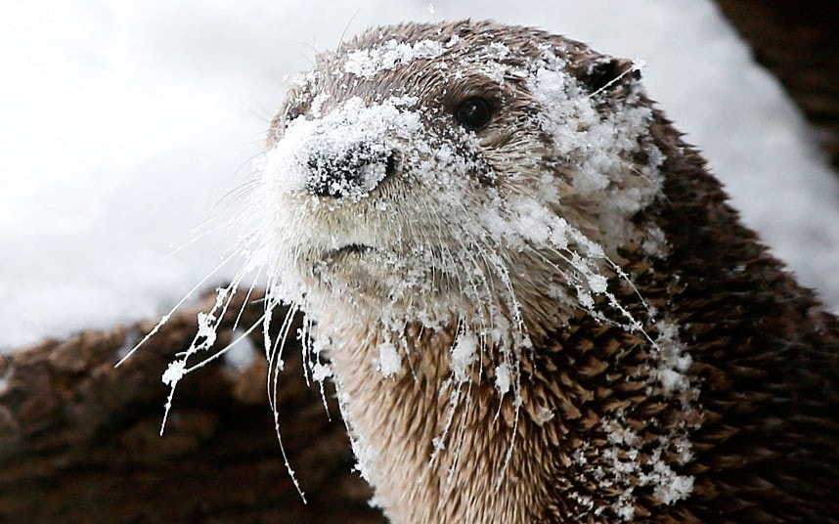
Baby snow otter
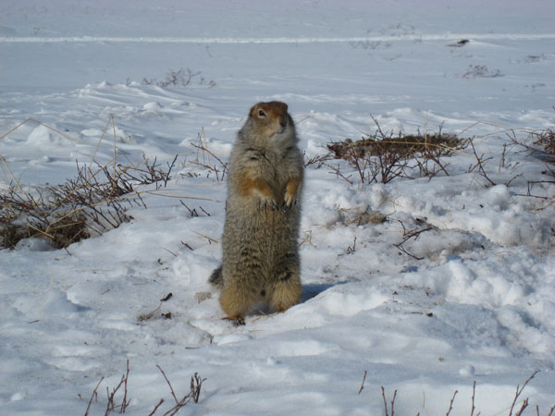
Otters usually live in the sea but baby ones shockingly do not! Otters have no blubber (a warm layer of skin that can be up to 10 cm thick!) so over the years they have adapted the thickest fur coat in the world! There outer layer is made of waterproof hairs and the under layer is short and dense.

Bob cats
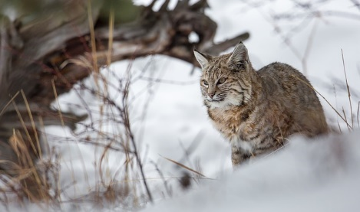
Bob cats eat off of rabbits and hairs. There softly padded ears allow them to hear the faintest sounds beneath what seems like silent snow. The shade of their smooth, fluffy fur lets them to look like a tall tree standing in the middle of nowhere. Also, when it advances its prey, every time its paws hit the ground they would make no noise what so ever. Although these species live in the snow, they adore climbing mountains and hills. It is there hobby.

Artic ground squirrels
Strangely, males come out into the cold, beautiful snow a few days before the females. Unfortunately, scientists have not found an explanation for this yet. When 5 days have passed of the males being alone on the snow, the females are in the cool again with the males. For the past 5 days the males have been looking there best because female Artic ground squirrels can only get pregnant 12 hours every single year (around the time they stop hibernating)! FUN FACTS
There are less than 4000 snow leopards left in the world The smug nosed monkey is the highest living animal Chipmunks can store 165 acorns in there pouches at once

