 | Monday | Tuesday | Wednesday | Thursday | Friday
9-11 | WORD OF THE DAY;  pharaoh - a ruler in ancient Egypt.  Reading  Tutankhamun Reading Comprehension  PE  Joe Wicks  Maths  Build your own analogue clock. Label with the hours. Which is the hour hand and which is the minute hand?  Recap o’clock and half past times.  Complete ‘Telling the time O’clock and half past’ worksheet | WORD OF THE DAY;  mummification – an old fashioned method of preserving someone’s body when they had died  sarcophagus - a stone coffin, typically adorned with a sculpture or inscription and associated with the ancient civilizations of Egypt, Rome, and Greece.  Reading  Read about the Pharaohs of Ancient Egypt.  PE  Just Dance – Walk like an Egyptian  https://www.youtube.com/watch?v=iacS9EnsepM  Follow with more Just Dance  Maths  Use your analogue clock to recap half past and o’clock times. Colour in your clock blue for ‘past’ times and red for ‘to’ times.  Where would the minute hand be for quarter past? Quarter to?  Show different quarter past and quarter to times on your clock | WORD OF THE DAY;  hieroglyphics – the writing system used in ancient Egypt, using symbols and images  Reading  Survival in Ancient Egypt reading comprehension  PE  Choreograph your own dance to – Walk like an Egyptian  Maths  Use your clock to recap o’clock, quarter past, half past and quarter to times.  Telling the time O’clock, half past, quarter to and past worksheet | WORD OF THE DAY;  pyramid - a monumental structure with a square or triangular base and sloping sides that meet in a point at the top, especially one built of stone as a royal tomb in ancient Egypt  Reading  Egyptian Cinderella Reading comprehension  PE  Skills practise; throwing and catching, throwing at a target, dribbling a ball  Maths  Count round the minutes on a clock. Each section = 5 minutes. Use your 5 times table.  Show different times, using your five times table to help you show the minutes correctly. | WORD OF THE DAY;  scarab - a large dung beetle of the eastern Mediterranean area, regarded as sacred in ancient Egypt  Reading  Read a book of your choice  PE  Team games  Maths  Purple Mash – Telling the time quiz
11-11:15 | Break | Break | Break | Break | Break
11:15-12:15 | Writing  Choose a writing activity from the list | Writing  Choose a writing activity from the list | Writing  Choose a writing activity from the list | Writing  Choose a writing activity from the list | Writing  Choose a writing activity from the list
12:15-1:15 | Lunch | Lunch | Lunch | Lunch | Lunch
1:15-2:50 | Theme Work  Choose an activity from the list | Theme Work  Choose an activity from the list | Theme Work  Choose an activity from the list | Theme Work  Choose an activity from the list | Theme Work  Choose an activity from the list
2:50-3:15 | Reflecting Roxy 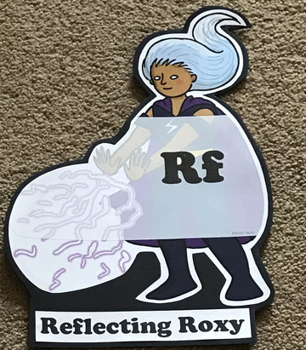  What have you learnt today and how could you have improved any of your work? | Making Links Molly 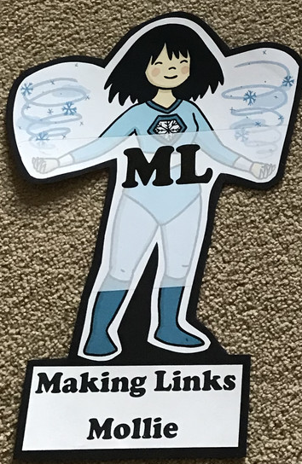  Can you use any learning that you have done today, in other parts of your life? | Resilience Rex 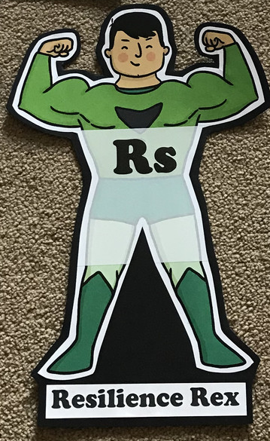  Have you found anything challenging today? How did you over come the challenges? | Collaborating Carlos 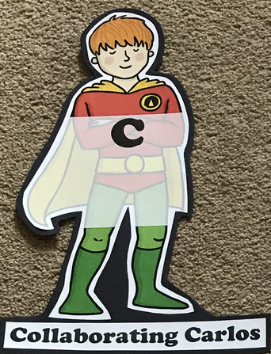  Did you work alone today or with someone else? How did that go? | Motivating Melinda 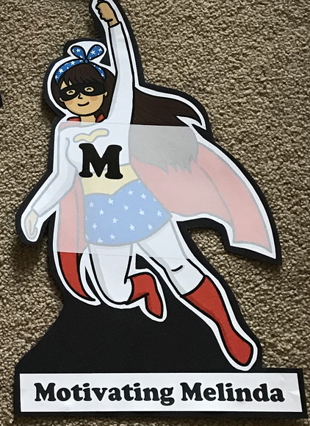  Have you encouraged someone else today? How did you motivate yourself today?

Writing
- Research the Ancient Egyptians. https://www.bbc.co.uk/bitesize/topics/zg87xnb
- Write your own message in hieroglyphics
- Write about your most prized possessions. What would you put in your pyramid and why?
- Examine an image of an Ancient Egyptian artefact and answer the questions on the worksheet.
- Watch Horrible Histories – How to make a mummy. https://www.youtube.com/watch?v=nf4vlYh9bJk Write instructions on how to make a mummy
- Research Tutankhamun https://www.bbc.co.uk/bitesize/topics/zg87xnb/articles/zvmkhbk/ and create a fact file
Theme
- Order the timeline of Ancient Egypt
- Make a papier mache Sarcophagus. Decorate fit for a Pharaoh
- Crack the hieroglyphics
- Create 3D nets of pyramids and mummies
- Dress up as a Pharaoh
- Make yourself into a toilet paper mummy
- Decorate a Scarab beetle biscuit
- Learn to draw an Ancient Egyptian Scarab beetle

