 | Monday | Tuesday | Wednesday | Thursday | Friday
9-11 | WORD OF THE DAY;  note - a note is a symbol denoting a musical sound.  quaver, semiquaver, crotchet, minim, semibreve, treble clef, bass clef  See rhythm notation poster  Reading  Read about Tchaikovsky and the story of the Nutcracker  PE  STOMP dancing. Can you use rhythms, body percussion and household objects to create music? https://www.youtube.com/watch?v=CZSTFAWfQEg  Maths  Use the beats of each musical note to create number sentences (additiona, subtraction, multiplication and division)  Eg. Crotchet + Semibreve = 5 | WORD OF THE DAY;  rhythm - a strong, regular repeated pattern of movement or sound.  Reading  Ed Sheeran reading comprehension  PE  Joe Wicks  Maths  Musical note fractions. If a semibreve is a whole, what fractions do the other notes represent? | WORD OF THE DAY;  pitch – how high or low the tone of a sound is  Reading  Read a book of your choice out loud to someone else. Can you use body percussion to create a soundtrack to important parts of your book?  PE  Body Percussion  Maths  Adding fractions. Can you use the musical notes to represent fractions and add them together?  Crotchet = ¼  Minim = ½ = 2/4  Crotchet + Minim = ¾ | WORD OF THE DAY;  compose – to write or create a work of art, especially a piece of music  Reading  Jazz Reading Comprehension  PE  Cosmic Kids Yoga  Maths  Adding Fractions Worksheet | WORD OF THE DAY;  orchestra - a group of instrumentalists, combining string, woodwind, brass, and percussion sections and playing classical music  Reading  Read a book of your choice.  Write a book review for your book.  PE  Team games  Maths  Fractinio’s Pizza – Purple Mash
11-11:15 | Break | Break | Break | Break | Break
11:15-12:15 | Writing  Choose a writing activity from the list | Writing  Choose a writing activity from the list | Writing  Choose a writing activity from the list | Writing  Choose a writing activity from the list | Writing  Choose a writing activity from the list
12:15-1:15 | Lunch | Lunch | Lunch | Lunch | Lunch
1:15-2:50 | Theme Work  Choose an activity from the list | Theme Work  Choose an activity from the list | Theme Work  Choose an activity from the list | Theme Work  Choose an activity from the list | Theme Work  Choose an activity from the list
2:50-3:15 | Reflecting Roxy 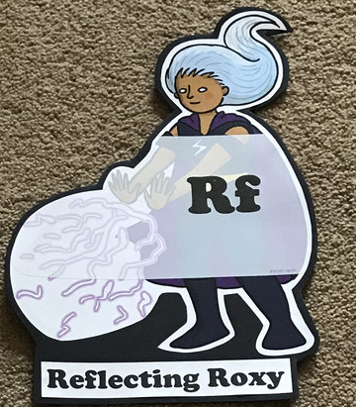  What have you learnt today and how could you have improved any of your work? | Making Links Molly 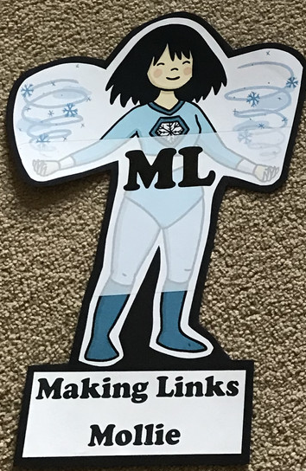  Can you use any learning that you have done today, in other parts of your life? | Resilience Rex 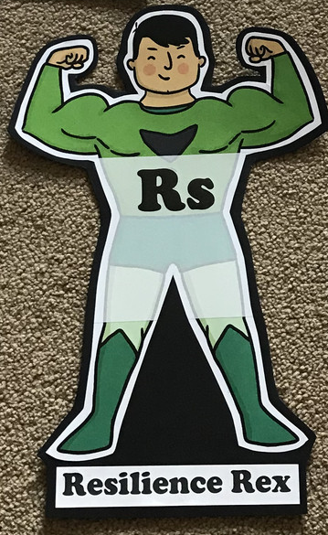  Have you found anything challenging today? How did you over come the challenges? | Collaborating Carlos 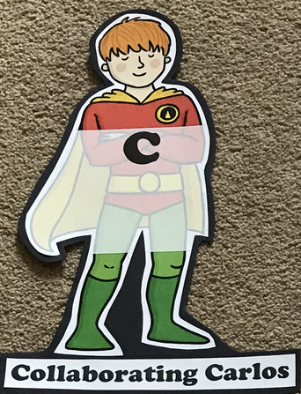  Did you work alone today or with someone else? How did that go? | Motivating Melinda 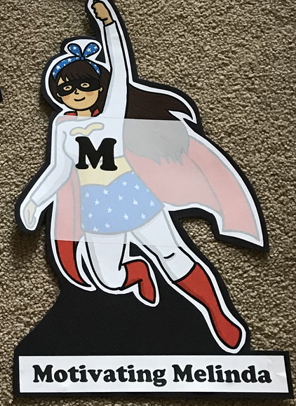  Have you encouraged someone else today? How did you motivate yourself today?

Writing
- Write your own mnemonic to remember the notes on the lines of the stave (EGBDF) and the notes in the space (FACE). Use the Musical Notes on a Stave powerpoint to help you.
- Listen to https://www.youtube.com/watch?v=-bTpp8PQSog Indiana Jones theme song. This is the music to your movie. Write the scene that would be happening while this music is playing. Describe the characters, the movement, the tension. What does the music make you feel/imagine?
- Compose your own lyrics/rap to your favourite song
- Create a comic strip for Tchaikovsky’s nutcracker.
Theme
- Make a musical instrument
- Clap the rhythms of the notes with the ‘Rhythm of Musical Notes’ Powerpoint. Write and perform your own rhythm using the musical notation.
- Listen to https://www.youtube.com/watch?v=-bTpp8PQSo Indiana Jones again. As you’re listening draw a picture that represents the music. You could also use different mediums eg. Paint, sketching, colouring pens, collage.
- Match the musical instruments game https://www.twinkl.co.uk/resource/musical-instruments-interactive-matching-activity-tg-408
- Sort the musical instruments into the correct instrument families
- Play hot or cold with humming. Pick an object in the room and when your partner gets close to it, increase the volume of your hum.
- Use the body percussion sheets to create your own body percussion rhythms.
- Music Note Codebreaker

