Community Theme – Week 10 25.05.20
Don’t forget to take photos of all the different things you are doing. If you have a scrapbook, notebook or folder you can keep all your work and photos together. Remember to email pictures of your learning into school so we can see what fun you are having!
 | Monday | Tuesday | Wednesday | Thursday | Friday
9-11 | Reading  Read ‘Mary Seacole’ and answer comprehension questions.  Writing  Choose an activity from the list. | Reading  Read ‘Florence Nightingale’ and answer comprehension questions.  Writing  Choose an activity from the list. | Reading  Read ‘What Does a Nurse Do’ and answer comprehension questions.  Writing  Compare nursing then and now. | Reading  Reader’s choice- Complete 15 minutes of reading  Writing  Choose an activity from the list. | Reading  Visit the Mary Rose website  maryrose.org  Read information on this famous ship.  Writing  Write a letter, postcard or email.
 | Movement  https://www.youtube.com/user/CosmicKidsYoga  Cosmic Yoga  (YouTube) | Movement  PE with Joe Wicks, The Body Coach | Movement  Go outside for a walk, run or bike ride. | Movement  PE with Joe Wicks, The Body Coach | Movement  Go outside for a walk, run or bike ride.
11-11.15 | Break | Break | Break | Break | Break
11.15-12.15 | Maths  Number gym  http://www.numbergym.co.uk/  Fractions | Maths  Number gym  http://www.numbergym.co.uk/  Fractions | Maths  Number gym  http://www.numbergym.co.uk/  Fractions | Maths  Purple Mash-  Fractonio’s Pizzeria | Maths  Number gym  http://www.numbergym.co.uk/  Fractions
12.15-1.15 | Lunch | Lunch | Lunch | Lunch | Lunch
1.15-2.50 | Theme Work  Choose an activity from the list. | Theme Work  Choose an activity from the list. | Theme Work  Choose an activity from the list. | Theme Work  Choose an activity from the list. | Theme Work  Choose an activity from the list.
2.50-3.15 | Reflecting Roxy 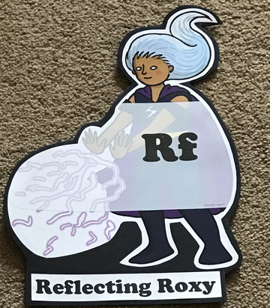  What have you learnt today and how could you have improved any of your work?  STORY TIME | Making Links Molly 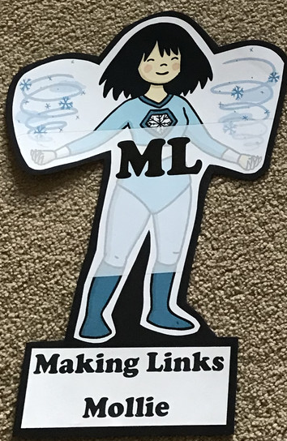  Can you use any learning that you have done today, in other parts of your life?  STORY TIME | Resilience Rex 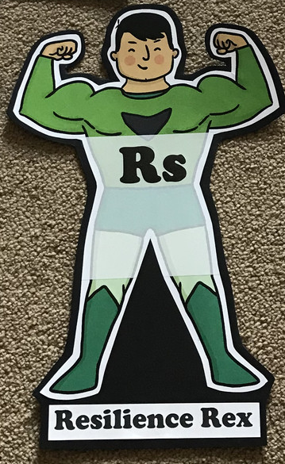  Have you found anything challenging today? How did you overcome the challenges?  STORY TIME | Collaborating Carlos 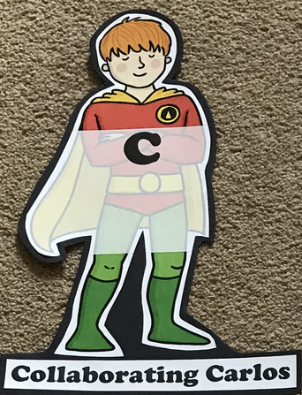  Did you work alone today or with someone else? How did that go?  STORY TIME | Motivating Melinda 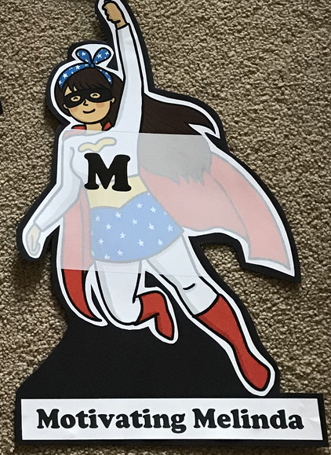  Have you encouraged someone else today? How did you motivate yourself today?  STORY TIME

