THE SOLAR SYSTEM

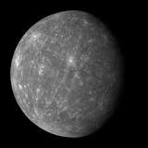

MERCURY
Mercury does not own any moon or rings it is also the 2nd hottest planet in the solar system. Mercury is by far the smallest planet you should also know that mercury is the closest planet to the sun! Mercury is a rocky planet with a huge iron core which makes up a lot of its interior.

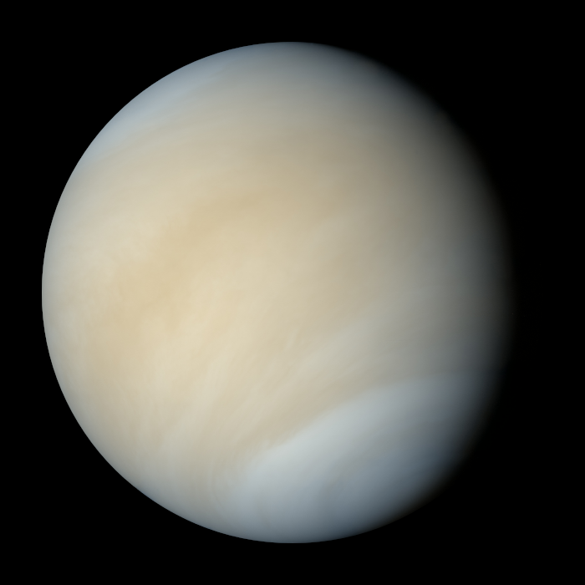
VENUS
Venus is named after the Goddess of love and beauty. Venus is made out of central iron core and a rocky mantle, similar to the composition of Earth. Venus was founded by a man called Galileo Galilei in 1610, with a microscope he also found out that Venus goes through the same changes as the Moon. Did you know Venus is the hottest planet [because the sun is a star not a planet] also covering the surface of the planet are volcanoes!!

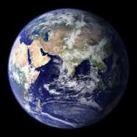
EARTH
Our home [planet Earth] is the third planet from the sun and is full of oxygen and life because we live there, we have rocky hills and polluted oceans we care for animals or they care for themselves. The earths surface is made up of 71% of ocean. Keep the world clean

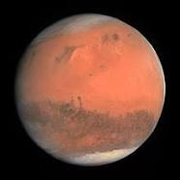
MARS
Mars has two moons [called Phobos and Deimos] it is known as the red planet. Did you know it takes Mars 687 days to orbit the sun? It’s called the Red Planet because its iron rich-dust gives it landscape a rusty red colour. United States of America and Soviet America are the only country to land on mars [probably only robots though]. Did you know only 18 missions to Mars have been successful.

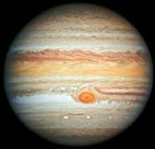
JUIPITER
Did you know that the planet was named after the Greek god [also known as Zeus].Also, this planet has rings made up from small rocks and dust and ice.

