 | Wellbeing Theme – Week 6 27.04.20
 | Monday | Tuesday | Wednesday | Thursday | Friday
9-9.30 | Movement  The Body Coach – Youtube on the day | Movement  https://www.youtube.com/user/CosmicKidsYoga  Cosmic Yoga  (YouTube) | Movement  BBC Move it Dance Programme  https://www.bbc.co.uk/programmes/b03g64pk/episodes/player | Movement  Go outside for a walk. | Movement  The Body Coach – Youtube on the day
9.30-10 | Phonics | Phonics | Phonics | Phonics | Phonics
10-10.30 | Reading  Younger readers can read or share a text with someone. Can they write or draw what they read about? Can they answer questions about the text?  https://www.oxfordowl.co.uk/for-home/find-a-book/library-page/  username- SJGreading  password- SJGreading | Reading  Younger readers can read or share a text with someone. Can they write or draw what they read about? Can they answer questions about the text?  https://www.oxfordowl.co.uk/for-home/find-a-book/library-page/  username- SJGreading  password- SJGreading | Reading  Younger readers can read or share a text with someone. Can they write or draw what they read about? Can they answer questions about the text?  https://www.oxfordowl.co.uk/for-home/find-a-book/library-page/  username- SJGreading  password- SJGreading | Reading  Younger readers can read or share a text with someone. Can they write or draw what they read about? Can they answer questions about the text?  https://www.oxfordowl.co.uk/for-home/find-a-book/library-page/  username- SJGreading  password- SJGreading | Reading  Younger readers can read or share a text with someone. Can they write or draw what they read about? Can they answer questions about the text?  https://www.oxfordowl.co.uk/for-home/find-a-book/library-page/  username- SJGreading  password- SJGreading
11-11.15 | Break | Break | Break | Break | Break
11.15-12.15 | Maths  Number gym  http://www.numbergym.co.uk/  Appropriate calculation activity linked to year group e.g. add and subtract  See EYFS and Year 1 daily sheet. | Maths  Purple Mash  https://www.purplemash.com/login/  Shape focus – recap names of shapes. Creating your own Colour Monster shape picture.  See EYFS and Year 1 daily sheet. | Maths  Number gym  http://www.numbergym.co.uk/  Appropriate calculation activity linked to year group. EYFS/Yr1 looking at number bonds/numbers to 10  See EYFS and Year 1 daily sheet. | Maths  Purple Mash  https://www.purplemash.com/login/  See EYFS and Year 1 daily sheet. | Maths  Number gym  http://www.numbergym.co.uk/  Calculation focus – addition and subtraction  See EYFS and Year 1 daily sheet.
12.15-1.15 | Lunch | Lunch | Lunch | Lunch | Lunch
1.15-2.50 | Theme Work  See daily plan | Theme Work  See daily plan | Theme Work  See daily plan | Theme Work  See daily plan | Theme Work  See daily plan
2.50-3.15 | Reflecting Roxy 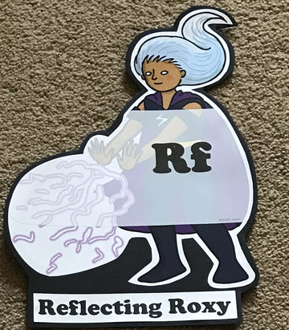  What have you learnt today and how could you have improved any of your work?  STORY TIME | Making Links Molly 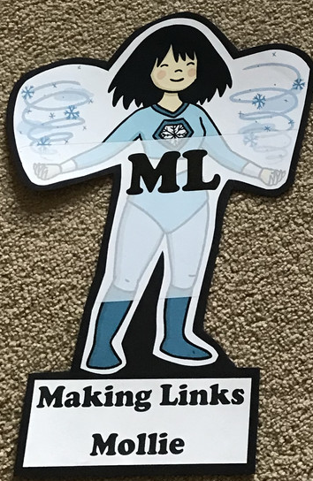  Can you use any learning that you have done today, in other parts of your life?  STORY TIME | Resilience Rex 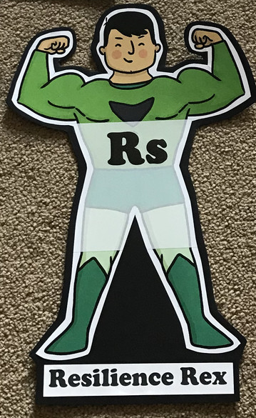  Have you found anything challenging today? How did you overcome the challenges?  STORY TIME | Collaborating Carlos 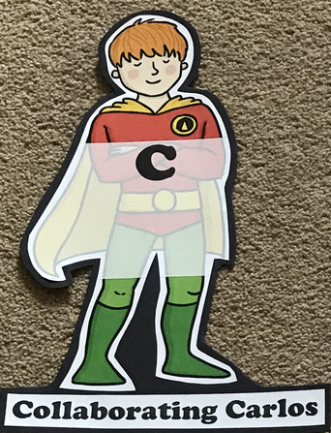  Did you work alone today or with someone else? How did that go?  STORY TIME | Motivating Melinda 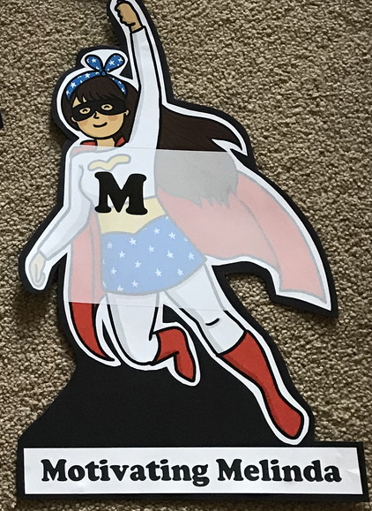  Have you encouraged someone else today? How did you motivate yourself today?  STORY TIME

EYFS/YEAR 1- WEEK 6- Well-being
Monday
Phonics
EYFS
Tricky words
I, of, my, to
Words to practise
Shop, ship, fish, shell, hush, rush, bash, cash

Challenge
Can you write some sentences with these words in?
Phonics
Sound of day-
Sh
Sh she’s sleeping

YEAR 1
Words to practise
Play, fray, sway, clay, pray
Alien words-
sclay, glay, flayon, draysh

Tricky words
I, of, my, to
Challenge
Can you write some sentences with these words in?
Phonics
Sound of day-
Ay
May I play?

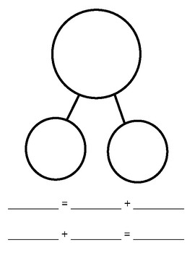
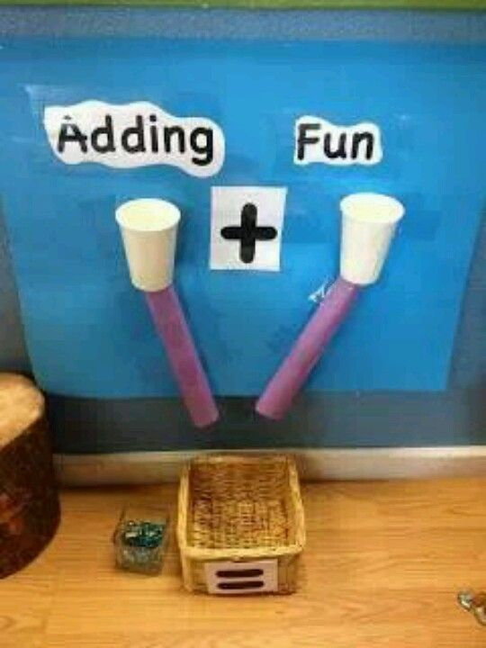
Maths
Addition
Make an adding machine with your children, this can simply be two tubes of paper or card. Model and start with saying the sentences out loud with your child (more aimed at EYFS) For a challenge or Year 1 children, they can record the number sentences and support with a whole/part model below.

Theme
Discuss what/who we are thankful for in the present time. Could make a mind map with the children or they could draw these people. Write ‘I am thankful for…….’ On the tag and the person or thing they are thankful for. Children can tie these in a special place.
We have attached some wellbeing craft activities at the back of the pack.

Tuesday
Phonics
EYFS
Tricky words
Want, you, my
Words to practise
Chop chick much
Munch crunch
Challenge
Can you write some sentences with these words in?
Phonics
Sound of day-
Ch
Ch ch chicken

YEAR 1
Words to practise
Flea, beat, beach, teach,
Alien words- fleab, pleam, sleag, dreach

Tricky words
Want, you, my
Challenge
Can you write some sentences with these words in?
Phonics
Sound of day-
Ea
Ea ea cup of tea

Maths
Continue to use the adding machine that was made on Monday with a variety of numbers. You could then practise these new adding skills when on your daily walk. Year 1 children should be recording their number sentences using + and =.

Theme
Discuss who we are missing, think about friends or family members they are looking forward to seeing. Write a letter to a friend or family member. Can they include what they have been up to and ask them questions too? Hopefully they will get a reply.

Wednesday
Phonics
EYFS
Tricky words
We, me, she, he, be
Words to practise
Think, with, thin, filth, bath

Challenge
Can you write some sentences with these words in?
Phonics
Sound of day-
Th
Th th think a thought

YEAR 1
Words to practise
Pie, lied, tied, and fried
Alien words
Flieb, slieg, blied, spliev

Tricky words
We, me, she, he, be

Challenge
Can you write some sentences with these words in?
Phonics
Sound of day-
Ie

Ie ie terrible

Maths
Collect 10 objects and split the number into parts. Put each part into the adding machine to find different ways of making 10.
Challenge: repeat and find ways of making 20.

Theme
Discuss if you know any key workers or people who are helping us keep safe and healthy in this different time. Think about family, friends, people in the community or a well-known person e.g. Joe Wicks. Children could write a thankyou letter or card showing their appreciation to one of the chosen people.

Thursday
Phonics
EYFS
Tricky words
We, me, she, he, be
Words to practise
Fling, wing, string, finger

Challenge
Can you write some sentences with these words in?
Phonics
Ng

Thing on a string

YEAR 1
Words to practise
Cloud, proud, out, scout, noun
Alien words
Flouk, sproun, croub, rouch

Tricky words
We, me, she, he, be

Challenge
Can you write some sentences with these words in?
Phonics
Sound of day-
Ou
Shout it out

Maths
https://fusion.webfusion-secure.co.uk/~numbergym.co.uk/hosting/NGS/EM_TurtleRace.html
Play this game on numbergym
Username: sjg
Password: welovemaths

Theme
Draw a picture of themselves and around their picture can they write positive words about themselves.
Challenge: draw a picture of someone special to them and write positive words around the outside.

Friday
Phonics
Phonics play
https://new.phonicsplay.co.uk/resources

Maths
Suggested games
https://www.ictgames.com/mobilePage/funkyMummy/index.html
https://www.ictgames.com/mobilePage/whackAMole/index.html
https://www.ictgames.com/mobilePage/partPartWhole/index.html

Theme
Watch the story about the Colour Monsters
https://www.youtube.com/watch?v=Ih0iu80u04Y
Then complete the sheets in the pack that discusses the different feelings.

