Arithmetic questions
Try and answer as many questions as you can. Don’t forget to draw sticks and stones or circles to help. Only spend 30 minutes on these questions, no more.
Tip: When adding, start with the biggest number.

1) 3 + 4 =

2) 48 + 6 =

3) 40 + 30 =

4) 64 - 4 =

5) 76 - 5 =

6) 7 x 10 =

7) 5 + 50 + 5 =

8) 11 x 10 =

9) 100 - 40 =

10) 3 + 61 =

11) 5 x 2 =

12) + 6 = 20

13) 18 ÷ 2 =

14) 31 + 42 =

15) 51 - 4 =

16) 63 – 20 =

17) 97 + 10 =

18) 45 + 55 =

19) 79 – 34 =

20) 1 of 10 =
2

21) 1 of 16 =
4

22) 45 + 28 =

23) 66 - = 36

24) 100 ÷ 10 =

25) 93 - 37 =

Reading challenge
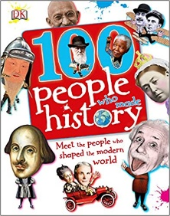
Read a book about a famous person

1) Whom did you read about?
__________________________________________________
2) What did you learn?
____________________________________________________________________________________________________
3) Why did you choose this person?
____________________________________________________________________________________________________

Drama
https://classroom.thenational.academy/lessons/what-happens-when-bad-things-happen-in-stories-64w34e

PE – Yoga

https://www.youtube.com/watch?v=j_3weVPH0-U

