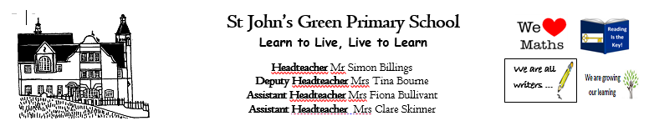

**Week 15 (W.B. 22/06/2020)**

**Theme: Jump into the Past**

**Year 2/3/4**

* **Research the Ancient Egyptians.**
* **Write your own message in hieroglyphics**
* **Write about your most prized possessions. What would you put in your pyramid and why?**
* **Examine an image of an Ancient Egyptian artefact and answer the questions on the worksheet.**
* **Watch Horrible Histories – How to make a mummy. Write instructions on how to make a mummy**
* **Research Tutankhamun and create a fact file**
* **Order the timeline of Ancient Egypt**
* **Make a papier mache Sarcophagus. Decorate fit for a Pharaoh**
* **Crack the hieroglyphics**
* **Create 3D nets of pyramids and mummies**
* **Dress up as a Pharaoh**
* **Make yourself into a toilet paper mummy**
* **Decorate a Scarab beetle biscuit**
* **Learn to draw an Ancient Egyptian Scarab beetle**
* **Build an analogue clock and label**
* **Show half past and o’clock times**
* **Identify and write o’clock and half past times**
* **Show and write quarter past and quarter to times**
* **Count the minutes on an analogue clock in 5 minute intervals**
* **Begin to show times with 5 minute intervals**
* **Tutankhamun reading comprehension**
* **Read Egyptian Cinderella and answer questions about the text**
* **Choreograph a dance to ‘Walk like an Egyptian’**
* **Learn the meanings of vocabulary relating to Ancient Egypt**