

St John’s Green Primary School
Learn to Live, Live to Learn
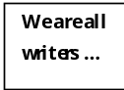

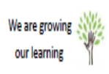
Headteacher Mr Simon Billings
Deputy Headteacher Mrs Tina Bourne
Assistant Headteacher Mrs Fiona Bullivant
Assistant Headteacher Mrs Clare Skinner

Telephone: 01206 762884 Email: admin@st-johnsgreen.essex.sch.uk Website: http://st-johns-green.eschools.co.uk

Assessment Period 2 Reports (March 2024)

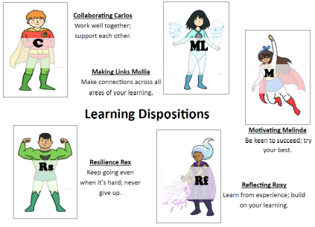

Learning Targets

The first three targets are linked to reading, writing and maths and are the next steps your child needs to take in their learning.

Early Years Foundation Stage Pupils

Children in The Foundation Stage are assessed against the ‘Statutory Framework for the Early Years Foundation Stage.’ Four principles shape practice in the Early Years setting. These are:

1, Every child is a Unique Child, who is constantly learning and can be resilient, capable, confident and self assured;
2, Children learn to be strong and independent through Positive Relationships;
3, Children learn and develop well in Enabling Environments, in which their experiences respond to their individual needs and there is a strong partnership between practitioners and parents;
4, Children develop and learn in different ways and at different rates.

In Foundation children are working towards achieving their Early Learning Goals. The Early Learning Goals are on the school website in ‘Assessment Period Reports.’

Your child’s report includes ways in which parents can support their child’s learning at home and also the things the children need to specifically work on.

Attainment

AT

The way we report back to you on your child’s attainment has changed. This is because the assessment system that the school now uses has changed.

Below, At, Above is how we are assessing the attainment of your children.

Each of Below, At and Above needs to be considered against the year group your child is working in. Your child’s development against the year group national curriculum requirements also progresses through the course of the year.

At St John’s Green we have three assessment periods, each one of approximately 12 weeks.

The first assessment period runs from September to December, the second assessment period from January to March and the third assessment period from April to July. Children are expected to progress through the year group curriculum, gaining a deeper and deeper level of understanding and increasing their reasoning, fluency and the application of their skills.

A child’s attainment through an academic year should look like this:

Assessment Period 1 (September to December) – ‘At’, this means that your child is working ‘At’ the right level of attainment within their year group

Assessment Period 2 (January to March) – ‘At’, this means that your child has made good progress since the first assessment period and is still working ‘At’ the right level of attainment.

Assessment Period 3 (April to July) – ‘At’, this means that your child has continued to make good progress over the assessment period and is still working ‘At’ the right level of development.

So for a Year 3 child. The attainment progress should look like this for the Year.
AP1 (Autumn) – Year 3 At
AP2 – (Spring) - Year 3 At
AP3 – (Summer) - Year 3 At

If a Year 3 child has Year 3 Below. It means they are working within the Year groups curriculum but ‘Below’ the expected level of attainment.

If a Year 3 child has a Year 3 Above. It means they are working within the year groups curriculum and ‘Above’ the expected level of attainment.

If a Year 3 child had a Year 2 At. It means that they are working ‘At’ the right academic level for a Year 2 child. In other words, they are about a year behind where we’d want them to be.

The same would apply for every year group – Year 1 to Year 6.

No child though totally conforms to a set standard of development. Children are unique and individual, which is what makes them and us so special.

Therefore, some of our children will be shown as working at a different level, at a different year group’s curriculum.

Attendance

Attendance and punctuality are key to all children’s learning, as each time they are absent from school, children miss out on important parts of their education and then have to spend time catching up. The school’s attendance policy gives far more details about the schools’ strategies and ethos with regards to attendance and a copy of this is available from the schools’ website.

Reading
Reading is the cornerstone to children’s learning and it is one of the areas where parents can have the biggest impact on their children’s learning development. If children/parents are not engaging with and using ‘Boom Reader’ to log and record their child’s reads, then the school doesn’t know how much reading the child is doing at home. Please utilise this resource to support your child’s learning and keep the school informed.

Please also see the school website – ‘Curriculum Information’ ‘Reading and Phonics’ for ways that parents can support their children’s learning at home.

Article 28: You have the right to a good quality education. You should be encouraged to go to school to the highest level you can.

