Week 6 | WEEK 7 | Week 8 | Week 9 | Week 10
Theme;  WELLBEING | Theme; SPACE | Theme;  DISCOVERY | Theme; ANIMAL PLANET | Theme; COMMUNITY
- Yoga (cosmic yoga/children’s mindful poses) https://www.kidsyogastories.com/kids-yoga-poses/  - https://www.youtube.com/user/CosmicKidsYoga  - Happiness journals  - Rainbow of happiness  - Positivity tree  - Wellbeing calendar of daily activities  - SOLO taxonomy linked to vocabulary of wellbeing and resilience. Rate selves at the beginning and then again at the end of the week, reflecting on their progress with their understanding of the terms and the activities/techniques that can be used to support wellbeing  - Breathing techniques  - Decorate a rock with a positive message. Go on a walk to leave the rock in a special place for someone to find. Whilst on the walk, have a look around for things that make you happy and fill a discovery jar with interesting and beautiful things  - Resilience challenges  - Sort word cards/use a thesaurus to improve the chosen vocabulary linked to the emotions discussed in the Colour Monster – when do you feel these emotions? How does your body feel? What do you do when you feel these? How can you combat the more negative emotions?  - Write a story or diary entry based on the Colour Monster  - Write gratitude cards celebreating the people and things they are thankful for  - Create a hug to send to a family member or friend they are missing  - Write a letter to a family member or friend they are missing or thanking a Key Worker for their efforts  - Write a letter of thanks/draw a picture for a Key Worker or inspiration person (eg Joe Wicks)  - Design a peaceful reflection area for home or school  - Create a talking stick that can be used to communicate worries etc.  - Sports activities (red watch – assult course, blue watch – rounders match)  - Gardening  - Nature walks  - How I can use my learning powers to help me  - Learning outside the classroom day (red watch) | - Papier mache a balloon to create one of the planets  - Research information to create a fact file about the planets  - Learn about the moon landings in 1969  - Write a diary in role as an astronaut from Apollo 11  - Design and build a rocket from junk modelling/recycling/lego  - Imagine meeting an alien – what does it lok like  - Create an alien language and write a short conversation/joke in the language  - Learn about constellations and the pattern of the moon – keep a ‘sky diary’ for a week  - Create a spacesuit for your doll/teddy using recycled resources  - Draw the solar system, learning the order of the planets – learn a mnemonic to remember the order/make up your own  - Write a story about meeting an alien/going in to space  - Write a space themed poem  - Make a sundial  - Marshmallow and spaghetti constellations https://playteachrepeat.com/marshmallow-constellations/  - Design a ‘space meal’ thinking about the challenges of eating without gravity https://www.giftofcuriosity.com/how-do-astronauts-eat-in-space/  - Investigate the changes in length and position of shadows during the day  - Measure your shadow at different times of the day – when is it longest? Shortest? The same as your height?  - https://spaceplace.nasa.gov/menu/do/  - https://www.twinkl.co.uk/resources/topics/places/space  - Design a newly discovered planet  - Imagine life has been discovered on one of the planets in our solar system – write a news report  - What is important to you? What would you take to space in you had to go? | - Map work –continents, oceans, 7 Wonders of the World, famous landmarks.  - Where have you been in the world? Where would you like to go? How would you get there?  - Famous explorers (WHO, WHERE, WHY, WHEN?)  - Science experiments; https://fun-science.org.uk/top-5-science-activities-home/  - Discovery Walks: https://home.oxfordowl.co.uk/blog/discovery-walks-fun-outdoor-learning-ideas/ | - There are many activites, learning ideas, PowerPoints and links on this website, linked to Animals…https://www.stem.org.uk/resources/community/collection/277241/animal-magic  - Steve Backshall lessons/live leanring https://www.youtube.com/channel/UCm-URP49TgSgyIU1rgh2m7A/videos  - Catergoring animals – mammals, birds, reptiles, insects, fish, amphibians…  - Habitats- where do animals live and why?  - Adaptation http://www.primaryhomeworkhelp.co.uk/adaptation.htm  - Food chains, create one using craft materials…  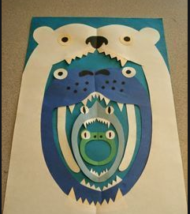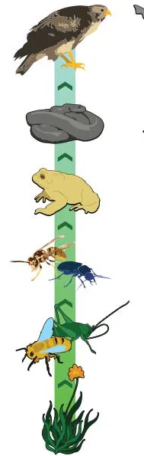  - Find out about herbivores, carnivores and omnivores  - How to look after an animal… (Wild or domesticated!)  - Lookat camouflage – art work linked to this, patterns printing … | - Piece of land for sale locally – what would you build there and why? Could it be used to support our community?  - People who help us  - Thanking NHS and Key Workers helping in our community (linking to children’s own experiences and families where possible) – Community heroes  - Nurses through time – Florence Nightingale, Mary Seacole – compare to jobs today  - Make superheroes based on the members of our community  - Beebots – programme to deliver food, medicines etc. around the local area  - Favourite place in our local area and why  - Saving and supporting Colchester Zoo  - Writing postcards to care homes  - Compare past and present Colchester  - If you were Mayor for the day, what would you do?  - Posters to encourage people to look after nature areas  - Make bird feeders etc. to support local wildlife  - Create a community newsletter  - Create and build a new park for the community – what would you put in there and why?  - Design a poster telling of life in your local area to an alien that has landed here  - (Linking to the alien) – why is our local community special to you? What makes it important?

