 | Monday | Tuesday | Wednesday | Thursday | Friday
9-11 | WORD OF THE DAY;  carnivore - an animal that feeds on other animals.  Reading  Sharks reading comprehension  PE  Joe Wicks  Maths  Crack the Codes under the sea | WORD OF THE DAY;  ocean - a very large expanse of sea, in particular each of the main areas into which the sea is divided geographically.  Reading  Read Starry-Eyed Stan Ebook. Create an advertisement for Stan’s Star Fish singing school.  https://www.twinkl.com/resource/t-l-54210-starry-eyed-stan-ebook-english  PE  Cosmic Yoga – Popcorn the Dolphin https://www.youtube.com/watch?v=YR1OxBk8BF4  Maths  Starry Eyed Stan Maths mosaics, symmetry, grid references, | WORD OF THE DAY;  conservation - prevention of wasteful use of a resource  Reading  Read a book of your choice and discuss with an adult. Choose 2 Reading Comprehension challenge cards and complete them using what you have read  PE  Team games (football, netball, basketball)  Maths  BBC Bitesize Daily Lesson https://www.bbc.co.uk/bitesize/tags/zmyxxyc/year-3-and-p4-lessons/1 | WORD OF THE DAY;  ecosystem - a biological community of interacting organisms and their environment.  Reading  Layers of the Ocean Reading comprehension  PE  Team games  Maths  Numbergym | WORD OF THE DAY;  marine - relating to or found in the sea.  Reading  Read ocean creatures fact cards and complete reading comprehension  PE  Joe Wicks  Maths  Purple Mash – Fractions  Fractonio’s Pizzeria
11-11:15 | Break | Break | Break | Break | Break
11:15-12:15 | Writing  Choose a writing activity from the list | Writing  Choose a writing activity from the list | Writing  Choose a writing activity from the list | Writing  Choose a writing activity from the list | Writing  Choose a writing activity from the list
12:15-1:15 | Lunch | Lunch | Lunch | Lunch | Lunch
1:15-2:50 | Theme Work  Choose an activity from the list | Theme Work  Choose an activity from the list | Theme Work  Choose an activity from the list | Theme Work  Choose an activity from the list | Theme Work  Choose an activity from the list
2:50-3:15 | Reflecting Roxy 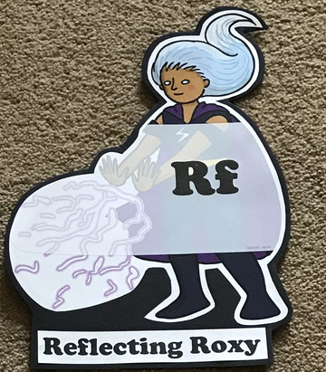  What have you learnt today and how could you have improved any of your work? | Making Links Molly 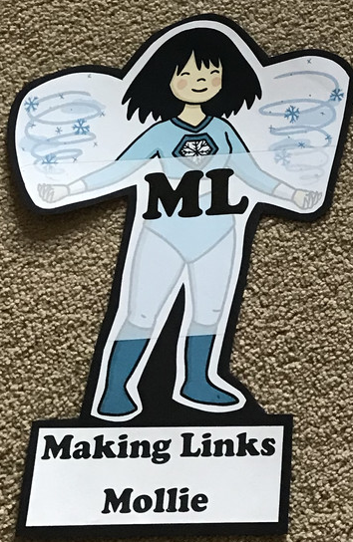  Can you use any learning that you have done today, in other parts of your life? | Resilience Rex 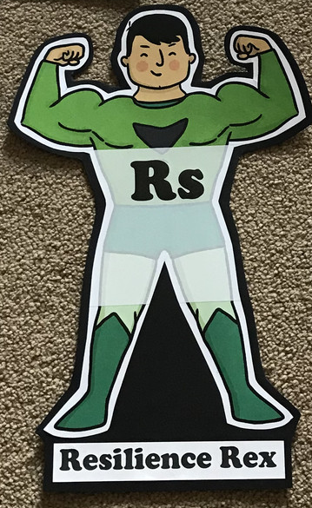  Have you found anything challenging today? How did you over come the challenges? | Collaborating Carlos 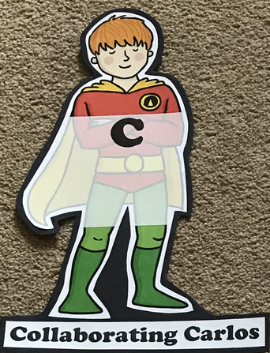  Did you work alone today or with someone else? How did that go? | Motivating Melinda 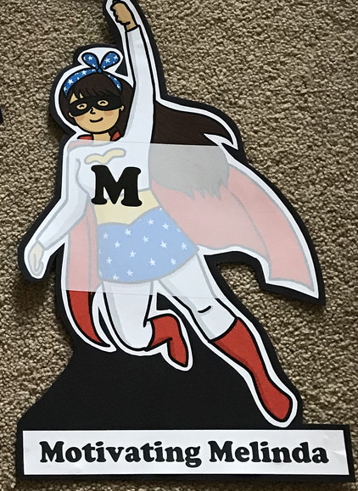  Have you encouraged someone else today? How did you motivate yourself today?

Writing

- Watch https://www.youtube.com/watch?v=0qn7HI32tlU Dan the Shark Man Ted Talk (5mins onwards) Create an information poster about what you have learnt.
- Write a fact file on sharks
- Write a persuasive speech to persuade people to start recycling to save the oceans
- Read through Plastic Pollution powerpoint and research how a certain country is dealing with plastic pollution. Record it in the plastic pollution booklet.
- Write a diary entry as a marine explorer who has just discovered a new marine creature.
- Research a sea creature from the Starry-Eyed Stan story and fill in the research sheet
Theme
- Label the oceans of the world and draw some of the marine animals you would find in those oceans
- Create a ‘Save the Ocean’ picture with any recycling you have eg. Old bottle tops, milk cartons.
- Film a David Attenborough style nature documentary. Can you find some nature to film or create your own with pictures and models
- Watch the Blue Planet Live Lesson on BBC https://www.bbc.co.uk/teach/live-lessons/blue-planet-live-lesson/zn7tkmn. Complete 3 activity sheets along with it.
- Draw your discovered marine creature
- Watch clips from BBC’s Blue Planet.
- Create Blue Planet Top Trumps
- Make a papier mache octopus with a balloon

