Our Rubric for a Suspense Story
Audience: 9-10 year olds Purpose: Create suspense and excitement
 | Objective | Towards | At | Above
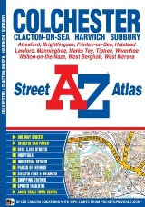 | Spellings  Year 5/6 spelling words  Suffixes –ance, -ence, -ancy, -ency | I can use one word from the Year 5/6 list or using 5/6 spelling patterns  I can include a word with the suffixes -ance, -ence, -ancy, -ency | I can use two words from the Year 5/6 list or using 5/6 spelling patterns  I can include two words with the suffixes ance, -ence, -ancy, -ency | I can use a range of words from the Year 5/6 spelling list and using 5/6 spelling patterns in the right context  I can use a range of words with the suffixes- ance, -ence, -ancy, -ency
 | Punctuation | I can use capital letters and full stops accurately throughout my text
 |  | I can use direct speech with inverted commas | I can use direct speech and include inverted commas and punctuation correctly | I can use a range of direct speech and reported speech using the correct punctuation.
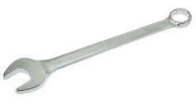 | Grammar  Adverbials  Relative clauses | I can use fronted adverbials at the start of every paragraph  I can use the relative pronoun ‘who’ | I can use fronted adverbials throughout my work  I can use the relative pronouns ‘who, ‘which’, ‘that’ | I can use a range of adverbial phrases in a range of places in my sentence  I can use a variety of similes and metaphors to create an image in the readers’ mind
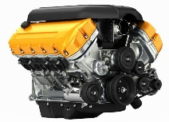 | Genre  First person (I, me, my)  Past tense | I can use the same person and tense for most of my text | I can consistently use the correct person and tense throughout my text
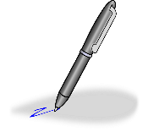 | Handwriting | I can write legibly and join some of the time | I can write in legibly, joined and with increasing speed throughout my whole text

